Numerical evaluation of the Hilbert transform used to better understand and solve the Kramers-Kronig relations in nonlinear optics

Dedication
To my Family.
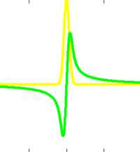

Abstract
The motivation for this work comes from the real world problem stated by physicists and chemists employing theoretical models to describe the interaction between light and matter due to both low-level and intense light irradiation. The starting point is the fundamental physical law - the causality principle - which states that the effect cannot precede the cause. This simple assumption leads us to the Titchmarsh theorem about the Hilbert Transform - and together with advanced signal response-theory we can investigate the properties of the medium response to the periodic input signal - both in time and frequency domain. Modifications of the Hilbert Transform for the optical susceptibility are known as the Kramers-Kronig relations - which are defined for both real and imaginary part of susceptibility in the frequency-domain:
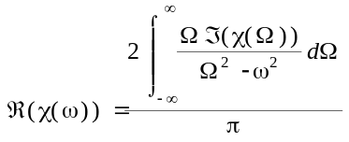
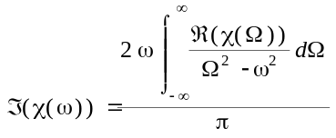
where the integration uses the Cauchy principal value method. In this thesis we handle two problems. The first concerns numerical problems with calculation of such a singular and improper integral. The second problem concerns the questions stated by physicists - how to properly use these mathematical tools in a typical experiment and construction of a model useful in optical research. We present comparison of several implementations of numerical calculations of the Hilbert transform:
- numerical trapezoidal rule mixed with the Simpson's rule and the cubic interpolation;
- Newton-Cotes quadrature of sixth degree;
- Clenshaw-Curtis quadrature;
- Hilbert transform based on fast Hartley transforms;
- a method based on approximation with the orthonormal Hermite polynomials and Hermite functions;
- a method based on approximation with the Fourier series
We also test the out-of-the-box MATLAB-implemented routines:
- quadgk()
- hilbert() - based on FFT
The given physical models for both linear and nonlinear optics are analyzed and validated. We formulate hints for good practices for scientists interested in the subject of optical experiments. Finally we make conclusions about the numerical stability, advantages and disadvantages of the developed implementations in further research in nonlinear optics.

Keywords
numerical analysis, nonlinear optics, Hilbert transform, Kramers-Kronig relations, optical dispersion relations

Promotors

Nonlinear optics:
Professor Marek Samoć
Institute of Physical and Theoretical Chemistry
Wroclaw University of Technology, PL-50-370 Wroclaw
Wybrzeze Wyspianskiego 27, Poland
+48-71-320-4466 | E-mail: Marek.Samoc@pwr.wroc.pl

Numerical analysis:
Paweł Keller PhD
Group of Numerical Methods
Institute of Computer Science
University of Wroclaw, PL-50-383 Wroclaw
Joliot-Curie 15, Poland
+48-71-375-7813 | E-mail: Pawel.Keller@ii.uni.wroc.pl

Reviewer
Professor Stanislaw Lewanowicz
Group of Numerical Methods
Institute of Computer Science
University of Wroclaw, PL-50-383 Wroclaw
Joliot-Curie 15, Poland
+48-71-375-7813 | E-mail: Stanislaw.Lewanowicz@ii.uni.wroc.pl

Author
Krzysztof Parjaszewski
Institute of Computer Science
University of Wrocław, PL-50-383 Wrocław
Joliot-Curie 15, Poland
+48-660-070-043 | E-mail: krzysztof.parjaszewski@gmail.com

1. Introduction to nonlinear optics

1.1 What is this thesis about?
This thesis is a small step towards a better understanding the nature of light interaction with matter. The main motivation and subject of this thesis is the application of numerical methods for better modeling and understanding the physical models in nonlinear optics. The main experiment used during the work on this thesis has been conducted with the so-called Z-Scan technique using a high-power femtosecond laser system consisting of a Quantronix Integra-C regenerative amplifier operating at 800 nm and a Quantronix-Palitra-FS BIBO crystal-based optical parametric amplifier which allows one to obtain the output wavelength in range of ~450nm up to ~2000nm. The laser pulses are of ~130 fs length and are delivered at 1kHz repetition rate. The experiments were performed at the Wroclaw University of Technology at the Institute of Physical and Theoretical Chemistry. Numerical calculations were performed on a simple personal laptop within MATLAB and Maple environments.
The main numerical results concern the usage of the Kramers-Kronig relations and the discussion about their application in nonlinear optics. Firstly the simple linear Kramers-Kronig relation is derived and reviewed, then it is developed into a simple nonlinear case. Next the perturbative approach and other modifications of the discussed model are reviewed. In each of these examples, attention is paid to the numerical issues. The constructed numerical calculations are compared and discussed and further good practices for physicists and chemists are formulated.
The subject of this thesis is not only an academic exercise - in last twenty years the global interest in photonics, and especially application of light in modern devices for information transfer, storage and processing - including the construction of super-fast all-optical computers – is steadily increasing. Recent years have seen much focus on the science and technology of photonics on nano scale. In Poland - the nanophotonics research is being developed in several scientific centers among them in Wroclaw, which would like to be one of the leading ones.
> To review both with Prof. MS and Dr PK.

1.2 What is nonlinear optics?
In mathematics a linear function f satisfies both of the following properties:
(1.2.1a) + additivity:  : ,
(1.2.1b) + homogeneity:  : .
Sometimes instead of talking of a function one taks about a "system". A nonlinear system is related to a function which does not satisfy both additivity and homogeneity simultaneously. Another definition says that a nonlinear system does not follow the superposition rule. The main area of interest for nonlinear optics is the behaviour of an optical wave in a nonlinear medium. In the nonlinear case the superposition principle no longer holds, and therefore the response of a system/function depends nonlinearly on the input signal. In practice the nonlinear behavior shows only at very high intensities of light, so the theory of nonlinear optical effects is only applied to devices using high intensity light - such as modern lasers or optical fibers. Nonlinear optics has strong links with physics, biology and chemistry but also mathematics and computer science, because modeling the light behaviour is an open problem still being solved - which is schematically shown in Picture 1.2.1:
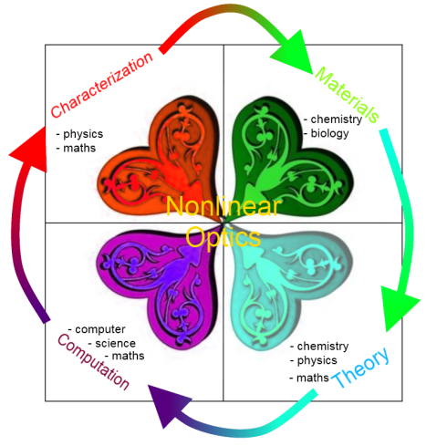
Picture 1.2.1 - Nonlinear optics derives from many fundamental disciplines: biology, chemistry, math, physics and computer science.
A comprehensive, well prepared introduction to nonlinear optics can be found in the book "Nonlinear Optics" written by Robert Boyd [2].

1.3 What are the most important nonlinear optical properties and phenomena?
Experiments, which investigate the nonlinear nature of light interaction with matter, may sometimes be similar to those in classical optics, but they differ in the intensity of the radiation which is used. Modern lasers can routinely produce short pulses of light with the duration of eg from 10 femtoseconds up to several picoseconds and energy per pulse reaching mJ range thus a single pulse from a laser can have power of giga-, tera- or even petawatts. Light intensities in the range of GW/cm² are commonly obtained even with lower powers by focusing of the laser beam. At these huge power of the light beam and the resulting light intensities - matter shows its nonlinear properties. Under the influence of the powerful and ultrafast lasers optical properties of matter and the related phenomena such as refraction, diffraction, interference, dispersion, scattering of light etc. tend to modify.
We define the following classification of the linear and nonlinear optical phenomena:
- linear phenomena;
- second-order nonlinear phenomena;
- third-order nonlinear phenomena;
- nonlinear phenomena of higher orders.
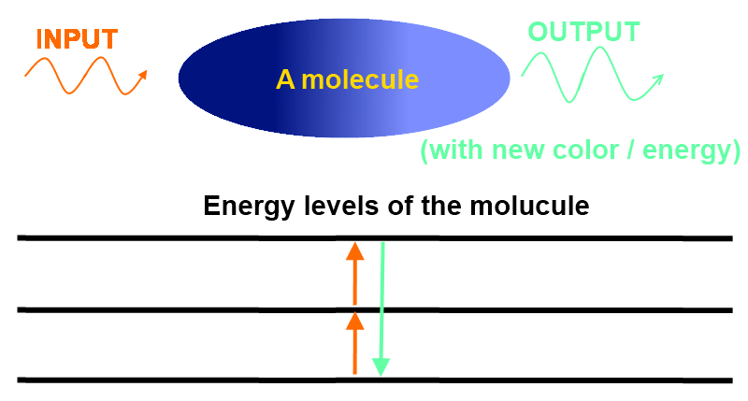
Picture 1.3.1 - schematic diagram of nonlinear optical phenomena - the input wavelength differs from the output signal, which occurs only for strong optical signals.
The basis of such classification is the equation defined for the electric polarization by the classical electromagnetism. The polarization density vector is approximated by the Taylor series:
(1.3.1) + ... for with omission of 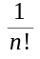 factors in the power expansion, where:
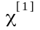 : 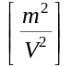 - the linear susceptibility tensor;
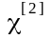 : - the second order nonlinear susceptibility tensor - responsible for phenomena such as optical rectification (OR), second-harmonic generation (SHG), generation of sum and differential frequencies (SFG and DFG) and Pockels electro-optic effect;
: - the third order nonlinear susceptibility tensor - responsible for phenomena such as intensity dependent refractive index (IDRI), third harmonic generation (THG), stimulated Brillouin scattering (SBS), stimulated Raman scattering (SRS), degenerate four waves mixing (DFWM) and nonlinear absorption [3]. The intensity dependent refractive index (IDRI) can be described by the equation:
(1.3.2) , where:
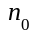 - the weak-field refractive index;
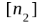 - the nonlinear index of refraction;
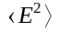 - means the time averaged E²;
is a new optical constant which describes the change of the refractive index in the relation to the strength of the optical signal. Alternatively, the nonlinear refractive index may be related to the light intensity I since I is proportional to the squae of the electric field amplitude.
The intensity-dependent change in the refractive index is sometimes called the optical Kerr effect. It is a similar effect to the Kerr electro-optic effect, which is a modification of the refraction index under the influence of the strong electric field applied to the medium. In the optical case the change of refraction index comes only from the influence of very intense light beam, typically from a laser system. The theory behind this effect has its roots in some quantum mechanics effects (e.g. the dynamic Burstein-Moss effect) and as the nanophotonics is relatively new scientific domain, there are only a few more or less confirmed hypotheses being under investigation.
Several effects come as the result from the intensity dependent refractive index:
a) self-focusing of light - focusing the light beam within the nonlinear medium;
b) two beam coupling - is the energy transfer between two light beams interaction within the nonlinear medium. This effect requires a special type of "nonlocal" refractive index changes typically found in so-called photorefractive phenomena
c) optical phase conjugation - can be used for reversing the typical aberration effects;
d) all-optical switching - is the very interesting effect which allows to control the flow of one beam of light by another. In other words it is a control of light by light.
The nonlinear absorption may concerns the absorption of energy from two or more photons influencing matter in the very same moment of time or the absorption of light under the heavy light intensity. Both linear and nonlinear absorption process has the property of spatial selectivity, which means that with different angle of light beam falling on matter we get different absorption coefficients - which is related to the tensor nature of the optical susceptibility. Also the polarization geometry of the light beam plays important role here [5].
Description of determination the nonlinear optical properties and describing the NLO phenomena in several sentences

1.4 Why is nonlinear optics so important?
Nonlinear optics is the widely investigated area in nanophotonics, because a material with a high nonlinear refractive index will be a key to build an all-optical-transistor and such device should work as an all-optical logic gate. That will lead us to create the ultra-fast optical devices, for instance the photonic computer - where instead of electrons, photons will be used to perform computations with a very high speed. Some scientists suggest that the taming of all-optical-switching phenomenon is the Holy Grail of modern photonics [3].
On the other hand - the nonlinear absorption, which is strongly related to the nonlinear refraction index - is an important obstacle to build such a fast all-optical-device. Despite on that, nonlinear absorption still may be very useful in nanofabrication, biophotonics, microscopy, information storage and other technologies using short laser pulses [4].
The interest in nonlinear optics comes from both the basic research and industry. The basic research and fundamental questions in material research concerns the nature of light, optical properties of molecules, the strength and properties of chemical bonds and theory to determine both linear and nonlinear optical properties instead of performing myriads of experiments. The industrial research interests in nonlinear optics are mostly focused in the area of developing new optical devices (detectors, engines, logic gates, fibers, lasers and more) and the usage of intensive light beams for various types of screening and determining the 3D information about the geometrical of the investigated material.
Description of the most expected results of understanding the nonlinear optics.

1.5 Why should we use Kramers-Kronig relations here?
Kramers-Kronig relations are the fundamental tools in the exploration of the material optical properties and together with other classical physics and quantum mechanics predictions can be used to construct and validate theoretical models. They are originated from the most basic but also very important law in physics - the causality principle. From the philosophical perspective it states that each effect must be preceded by a cause. In computer science this principle is somehow paraphrased in a discussion of formal deterministic and nondeterministic automata. We believe that only deterministic automata really exist.
(1.5.1a) =
(1.5.1b) " t < 0 :
The causality principle looks obvious, but in the field of nonlinear optics - combined together with the application of the inverse Fourier transform of any nonlinear quantity spectrum: , R ' - it states that the time-domain signal calculated with (1.5.1a) from frequency-domain must equal zero for any negative time argument. This statement can be used in validation of any spectrum, R ' - what is important when we only measure the physical quantity in a specific range  : and. We simply cannot measure the whole real spectrum R ' and in this case we need to perform the validation of approximated or assumed spectrum.
Kramers-Kronig relations - which will be derived in the following chapter - connect the real and imaginary part of the Fourier transform of valid response signal. It is said that one can derive the real part of the determined spectrum. What is even more important - this relation is bidirectional - so with the Kramers-Kronig relations one can derive the imaginary part from real. This hypothesis has been formulated in 1948 by Edward Charles Titchmarsh - with the tacit assumption, that both and are the square-integrable functions and more - the holomorphic in the upper-plane. This simple theorem - is widely investigated area in both the nonlinear and linear optics - to connect the refraction index together with absorption coefficient, which are the real and imaginary parts of the optical susceptibility respectively.
Just few words about the hopes of using K-K relations also in nonlinear optics.

Notes
1. "Znajomość pełnej funkcji dielektrycznej 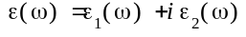 daje nam klasycznie pełny opis zjawisk towarzyszących rozchodzeniu się fali elektromagnetycznej w materii."
2. Teorię fitowania lorentzianów opisuje regresja nieliniowa.
Some notes in both polish and english.

2. Problem definition (understanding)

2.1 Linear model
Basically in the linear optical model we assume, that the response of a medium depends linearly on the input. The similar presumption is made in many fields of physics - for instance in magnetostatics we linearly connect the current density J with the electric field E vector multiplied by a conductivity parameter - which is called the Kirchhoff's reformulation of the Ohm's Law:
(2.1.1) J = E
As it will be shown later, such relations hold for sufficiently small intensities - but the definition of 'sufficiently small' will not be further specified. In the time-domain it is stated that an external sinusoidal electromagnetic radiation of a light beam - the input – is defined by a field vector:
(2.1.2) E(r, t) = 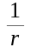 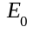cos(k r - t + ), where:
k - wave vector (radians per meter)
r - position vector (meters)
t - time (seconds)
- angular frequency (radians per second)
- phase shift (radians).
The output - response in the form of polarization vector can be described using the linear response theory - which is the simplification of the Volterra series that takes only the leading order term can be described as the following convolution:
(2.1.3) (r, t) = with the inner integral made through the Euclidean space [6], where:
1 - the '1' index states for linear property of any investigated value
- 3x1 real linear polarization tensor (vector) in a space-time domain, ‘i’ stays for chosen spatial coordinate (x, y or z) []
- 3x3 real susceptibility tensor (matrix) defined by a linear Green function in a space-time domain [1]
- 3x1 real electric field tensor (vector) in a space-time domain []
- electric permittivity of free space ~8.854187817620 × []
r - position vector (meters)
t - time (seconds)
Even such linear equation is only the simplification, because we do not assume the local field corrections [7]. It seems to be a reasonable assumption as long as we emphasize the macroscopic character of polarization. Only in case of constructing very small devices or synthesizing small particles - we shall take the local field interaction into account. Investigation of the properties of the susceptibility tensor both in time-domain and frequency-domain will be the main part of considerations in this thesis - it is also widely discussed topic in the literature [2, 8, 9, 10 and 11]. The Fourier transform allows us to change the polarization equation (2.1.3) from time-domain to frequency-domain:
(2.1.4) {F[(r, t)]} = (k, ), where:
- Fourier transform operation in 3D space domain;
F - Fourier transform operation in time domain;
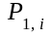(k, ) - 3x1 complex linear polarization tensor (vector) in a wave-frequency domain, ‘I’ stays for chosen spatial coordinate (x, y or z); []
k - 3x1 wave tensor (vector) of the electromagnetic field; []
- angular frequency of the electromagnetic field; [],
Due the convolution theorem [12] the Fourier transform applied to the convolution of two given functions equals the simple multiplication of two Fourier transforms:
(2.1.5) {F[]} =, where:
- Fourier transform operation in 3D space domain;
F - Fourier transform operation in time domain;
(k, ) - 3x3 complex susceptibility tensor (matrix) in a wave-frequency domain [1];
(k, ) - 3x1 complex electric field tensor (vector) in a wave-frequency domain [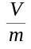];
From (2.1.4) and (2.1.5) we get:
(2.1.6) (k, ) = , which seems to be a simpler equation – so from now we will use the wave-frequency domain. We will not be getting further into the physical details of the optical susceptibility theory. For our interests it is worth stressing, that the - 3x3 real susceptibility tensor (matrix) defined by a linear Green function in a space-time domain follows the following rules:
(2.1.7a) + the causality principle  : (r, t) = 0
(2.1.8a) + the conservation of energy law:  r :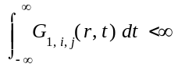
The Fourier transform is defined for integrable functions and after [13, 14] we can assume the asymptotic behaviour of the susceptibility tensor in wave-frequency domain:
(2.1.9) F[(r ,t)] = (k, ) = 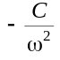 + o(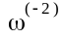)
From the physical point of view such a vanishing is true - because for an input oscillation with a frequency much higher than any resonant frequency - the system will have not enough time to response before the input signal has switched it direction, so for large the susceptibility (k, ) vanishes.
where:
C - is a material specific constant, which does not depend on .
o() - indicates a term with asymptotic decrease strictly faster then 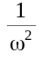.
Also from the conservation of energy law we assume, that:
(2.1.10)   K < : " d, : (k, ) < K
Together with the knowledge of asymptotic behaviour from (2.1.9) we will concluded, that the susceptibility tensor is also square integrable
(2.1.11)
Description of linear model of dispersion

2.2 Derivation of the Kramers-Kronig for linear model
Before we will focus on the final form of the Kramers-Kronig relations - we shall stress that they are the reformulation of the Titchmarsh theorem in area of Fourier analysis. This theorem relates real and imaginary parts of the functions from the upper half-plane of the Hardy space: with the Hilbert transform of a function from.

Titchmarsh theorem:
Let:
(2.2.1) (R) and " t < 0 : a(t) = 0
Then:

(2.2.2) b() = F[a(t)] and 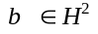(U) ,

where:
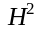 - Hardy space of the holomorphic functions with a norm: sup {y>0} <
U - the upper-half complex plane,
F - Fourier transform functional
(2.2.3a)
(2.2.3.b) ,
where:
- real part of b()
- imaginary part of b()
To omit the singularity - the integral values is calculated using the Cauchy principal value.
What's more - the theorem states that (2.2.1), (2.2.2) and (2.2.3a-b) are mathematically equivalent. Proof with an exhausting review of both the Fourier and Hilbert transforms has been described by Edward Charles Titchmarsh in [15] - the theory is described through all book chapters, but the theorem and its proof has been stated in Chapter 5 about the conjugated integrals also called the Hilbert transforms.
We have nearly state the Kramers-Kronig relations. If we take a closer look into equation (2.1.9) we will see that:

(2.2.4a) 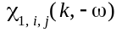 = F[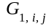(r ,-t)] = = []*
(2.2.4b) *, where:
* - the symbol denoting the complex conjugate.
With such assumption we deduce that:
(2.2.5a) Re { } = Re {}
(2.2.5b) Im { } = -Im {}
Now the previous equation (2.2.3.a-b) can be written in a new form:
(2.2.6a)
(2.2.6b)
We will further forget about the (2.2.4b) assumption, because firstly there is no difference in the computation complexity between (2.2.3a-b) and (2.2.6a-b). What is more - this assumption has sense only from the mathematical point of view, we suppose that it should be dismissed in any further calculations as an "artifact" - because in all experimental fitting we suppose that the absorption peak has Gaussian or Lorentzian distribution - which is a not an odd nor an even function and we would have artificially assume that should tends to zero near the zero frequency - which not always must be true.
For the first look the relations (2.2.6a-b) may look not so impressive, but we must have in our mind that the real and imaginary part of susceptibility describes two completely different optical phenomena - the refraction of light and the absorption of light. If we like to measure them - in most cases - we will need to perform two different experiments. Kramers-Kronig relations allows us to imply - that for now we only need to properly measure one of this two values - and the other can be calculated on the basis of its results. This is of course the half-true. Taking into consideration many in uncertainties and experimental errors it is also an good idea to measure both values - and then check if the theoretical model in which we describe the optical properties of investigated material - is valid and therefore we can proof its self-consistency.
Derivation of the Kramers-Kronig relation for linear optics

2.3 Simple nonlinear model
It is true that our knowledge about the linear interaction between the light and matter has been investigated in recent several decades quite well. We shall even say that this scientific area has been described almost completely. The really interesting and important from the scientific point of view is the area of nonlinear optics - when more than a one light wave interact with matter in a definite, extremely short period of time with a length of femto- or even attoseconds. When two or more photons 'shoot' an atom or a molecule - we may observe many new kinds of physical phenomena. From the quantum physics point of view - each photon transports some amount of energy depending on its frequency. More energy in a short time period - means a higher chance for the molecule to modify its spatial structure, electron energy or some other property.

Pump-and-probe process
In a typical pump-and-probe process we observe two laser beams. One of them is a strong signal - called the 'pump' - the second signal - the 'probe' - is much less intensive. We try to synchronize this two laser beams in a following way - firstly a pump signal hits the sample with its strong intensity - causing modifications in the sample properties. Shortly after that - within a time period t - a low-intensive probe signal hits the modified sample and runs through the detector. In a typical experiment the t time period should be adjustable. There are usually much more detectors, but we are mostly interested in the polarization amplitude of the probe response signal. An important assumption for both pump and probe beams is for them to be in the same polarization. The schematic diagram of a pump-and-probe process has been described on the Figure 2.3.1.

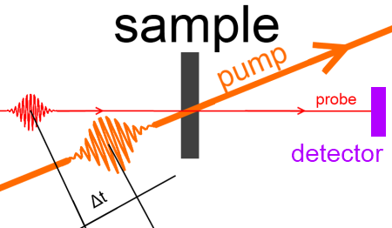
[Figure 2.3.1] - The pump-and-probe process
The key assumption in the pump-and-probe process is that separated and independent probe signal cannot saturate the response of atomic system alone [2]. The probe signal shall be that weak - it will not cause any more nonlinear effects in the investigated medium. It is important that investigated molecule has for both the pump and the probe signal two different relaxation times: and respectively. A complicated model is defined by H. N. Yum et al. [16] for the nonlinear susceptibility in case of pump-probe process:
(2.3.1a) = x [ ],
where:
= (), G = G(), = 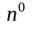(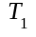), 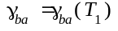, 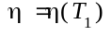
- probe frequency
- pump frequency,
where particular parameters depend on the complicated derivation with a usage of quantum-mechanics and classical-mechanics approach. Here the important thing to consider is that the susceptibility of the probe depends on the relaxation time of pump signal - which in other words means that:
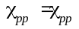(, ) and 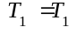(t)
In sense of the response theory this observation leads us to the conclusion, that the susceptibility of the nonlinear process depends not only on the input signal frequency (energy) - but also on the time delay between the moments, when two or more photons shots the molecule. The literature we have found is in lack of advanced model - so here we are talking about the cutting edge problem in nonlinear optics and the constructing of the valid model for the pump-and-probe process - so the Kramers-Kronig relations should be applied here. We also deduce from the response theory, that the output signal in the pump-and-probe process does not shows instantly, but after the last photon shots the investigated molecule - so we have some type of pause - which observation should expand the linear response theory.
In [20] we can found results that proofs that the probe signal absorbance depends not only on the pump signal properties, but also on the delay time between the pump and probe - see Figure 2.3.2
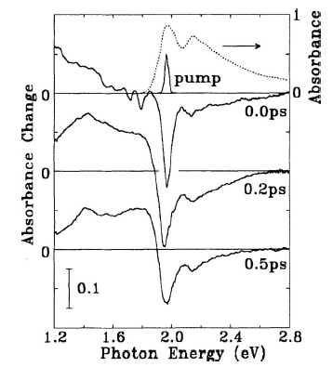
[Figure 2.3.2] - The pump-and-probe absorption change dure to time delay between the pump and probe signal. Figure is taken from [20].
The more interesting results come when we assume, that susceptibility is a complex function of two parameters, both the pump and probe signal frequency:
(2.3.1b)
Therefore we obtain such a three dimensional plots:
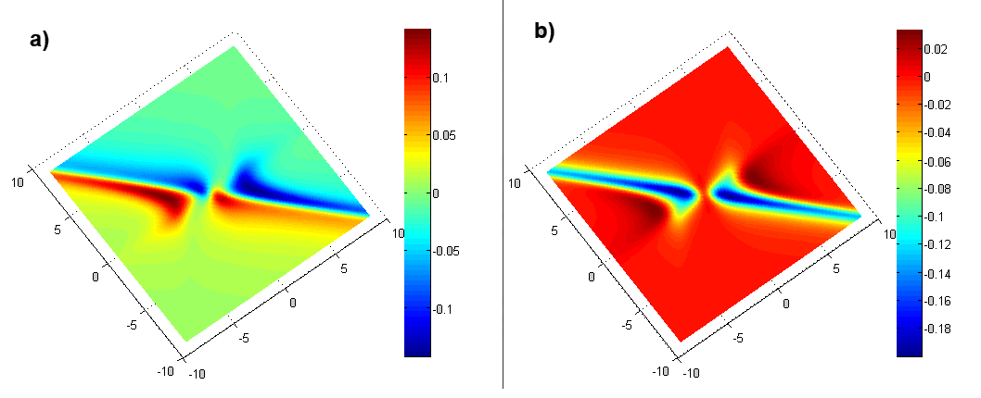
[Figure 2.3.1a, 2.3.1b] 2-Dimensial plots of both a) real and b) imaginary parts of nonlinear susceptibility threated as a bi-argumental function, where the color means the function value
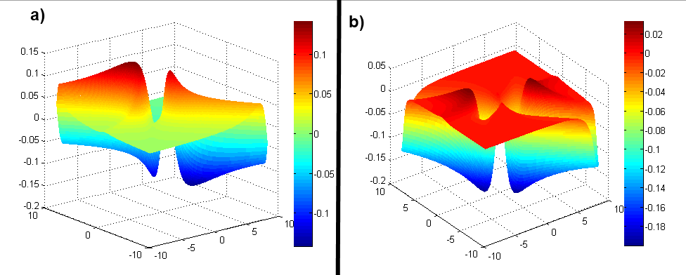
[Figure 2.3.2a, 2.3.2b] 3-Dimensial plots of both a) real and b) imaginary parts of nonlinear susceptibility threated as a bi-argumental function, where the color means the function value

Frequency Mixing Process
The frequency mixing is a general class of processes when we have two or more input photons with their frequencies: , ... and we receive one or more output photons with their frequencies: 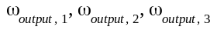, .... In chapter 6.6 of Boyd [2] we can find the description of process in which we observe the strong signal 'pump' with frequency and the weak signal 'probe' with the frequency nearly co-propagating, as has been shown on the figure [2.3.3]
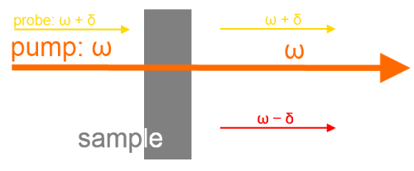
[Figure 2.3.3] - The pump-and-probe frequency mixing process from chapter 6.6 Boyd [2]
For such process a model for the linear susceptibilities hase defined by Boyd for both and frequencies:
(2.3.2a) 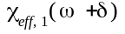 = 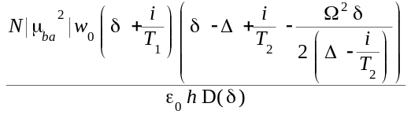
(2.3.2b) =
Boyd also derives the third-order nonlinear susceptibilities for both and frequencies:
(2.3.3a) =
(2.3.3b) = ,
where:
- detuning of the pump wave;
h - dashed Planck constant;
N - number density of atoms;
- relaxation times;
- conjugate function of D;
D - a complex pump-probe function described with (2.3.2c)
(2.3.4c)
It is also found [2] that the total response in frequency domain is stated by the following polarization equations:
(2.3.5a) *
(2.3.5b) *,
where:
- electric field of pump; (with frequency )
- electric field of probe; (with frequency )
- electric field of probe; (with frequency )
* - denotes the complex conjugate;
- dielectric constant;
The test 3-Dimensional plot has been presented on the Figures below:

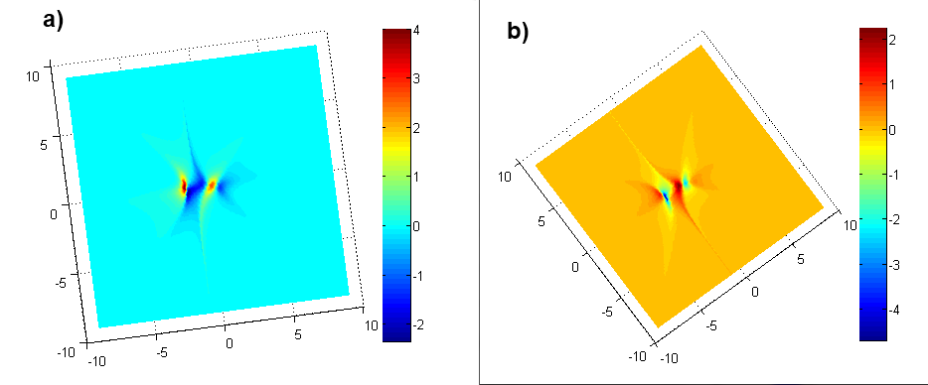
[Figure 2.3.4a-b] 2-Dimensial plots of both a) real and b) imaginary parts of nonlinear susceptibility threated as a bi-argumental function, where the color means the function value

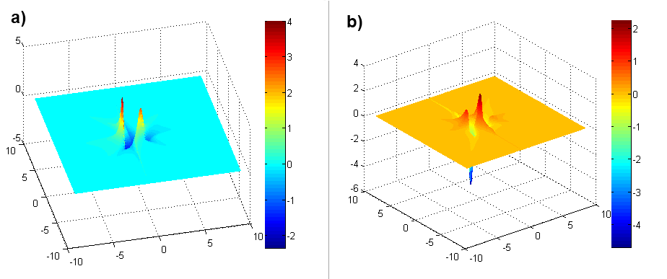
[Figure 2.3.5a-b] 3-Dimensial plots of both a) real and b) imaginary parts of nonlinear susceptibility threated as a bi-argumental function, where the color means the function value
There are dozens of models for the nonlinear optical phenomena. What is important in their derivation is to have in mind that the frequency domain is connected with time domain with the Fourier transform. We also must remember that to build a valid model - it must obey the causality principle in the time domain. Here from now we also will observe that the advanced models of susceptibility does not obey the rule, that it's real (imaginary) part is an even (odd) function - we will discuss this in the next chapter.
Description of simple modification in linear model to obtain the nonlinear model

2.4 Derivation of the Kramers-Kronig relations for simple nonlinear model
As mentioned in equation (2.1.3) in time domain polarization tensor is calculated using the leading order term of Volterra-series. Now - when calculating the response of the system under the influence of many monochromatic light sources - we can formulate the nonlinear multiple convolution:
(2.4.1) ,
where:
- the casual n-th order Green function in time domain
After applying the Fourier transform to the (2.4.1) together with the convolution theorem we obtain:
(2.4.2) ,
where:
- Dirac delta function
The causality principle can be now assumed for each variable of the nonlinear Green function in time domain. We therefore can again apply the Titchmarsh theorem to obtain:
(2.4.3)
The equation (2.4.3) was taken from Lucarini [14]. At the moment we are not sure about the symmetry rule in case of nonlinear optics - so we propose carefully, more general that in [14]:
(2.4.4a)
(2.4.4b) 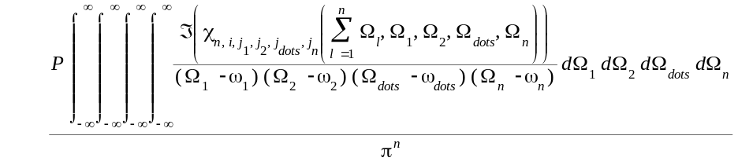
We stress that by the moment we are not sure about the symmetry rule for (2.4.3) because in a typical nonlinear process a response is not the instant reaction for input - and both the saturation and reflection processes takes time. When taking into consideration only one frequency - we conclude that:
(2.4.5a)
(2.4.5b)
If we focus on the equations (2.4.4a-b) and (2.4.5a-b) it can be seen, that they lead to the different results. In the latter equations we are performing only one Hilbert transform for the N-dimensional array of 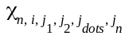. In first equation we evaluate the Hilbert transform N times and also the variables are bound within the most inner integrand, so from the numerical point of view, this multi-integral is harder to evaluate, because we need to take into consideration the rules of calculating the multiple-level integral. In further multi-dimensional evaluations we will use the (2.4.5-ab) equations, because they seem to be valid. In all equations (2.4.4a-b) and (2.4.5a-b) - we forget about the symmetry rule despite of the uncertainty how to combine it with the time-varying saturation and reflection processes. It means that the signal response does not only depend on the input frequencies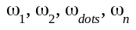, but also on the time delays between them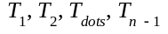:
(2.4.6)
Automatically we expand (2.4.5a-b) into (2.4.7a-b)
(2.4.7a) 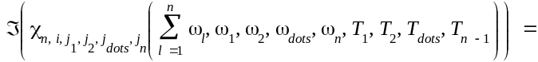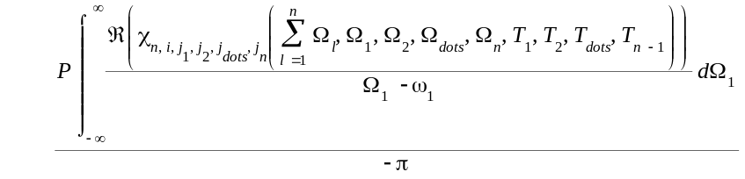
(2.4.7b) 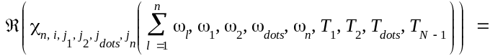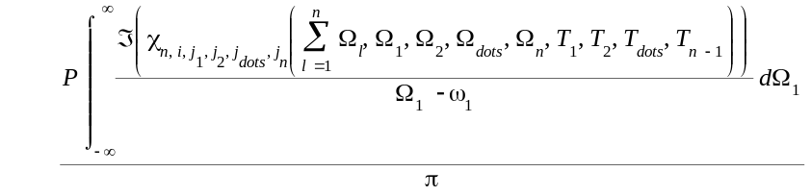

One might say that these equations are to general to practically use them - but for our point of view it is important that in the nonlinear case we do not need to integrate from zero to plus infinity but through the full real line - we will keep this assumption in all further nonlinear calculations.
Mathematical derivation of the Kramers-Kronig relations for simple nonlinear model

2.5 Overview of the simple quantum-perturbative model
We are interested in derivation of the first-order linear susceptibility and the second-order and third-order nonlinear susceptibility using the quantum mechanical approach and by solving the Schrödinger equation. While this is the cutting edge, most investigated area of modern physics and a difficult mathematics area - we will only try to do the hand-waving introduction into this matter. What is important in this model, by Boyd [2] that in case of nonlinear optics the important relaxation process is not taken into account? As we have written before, the nonlinear susceptibilities depend not only on the input wave frequency but also on the time between those impulses - we should try the quantum-perturbative model as not yet finalized.
The general assumption in the quantum mechanics applied for nonlinear optics is that the whole material properties can be described using the time-dependent Schrödinger equation:
(2.5.1) 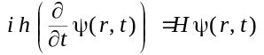,
where:
H - Hamiltonian operator;
- atomic wave-function;
The H Hamiltonian can be split:
(2.5.2),
where:
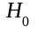 - Hamiltonian for free atom;
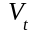 - Hamiltonian for interaction of an atom with electromagnetic field.
Hence the (2.5.1) equation is hard to solve exactly, we replace the H Hamiltonian with:
(2.5.3)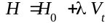,
where:
[0, 1], perturbative parameter that describes the strength of interaction
Not jumping into details, we may now try to find a solution to Schrödinger’s equation with power the following power series:
(2.5.4)
With such a perturbative assumption we can now modify the initial (2.5.1) equation into a form:
(2.5.5a) 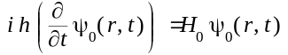
(2.5.5b) 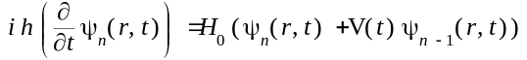
We call the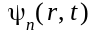 eigenvector. They can be expanded in terms of unperturbed states as following:
(2.5.6) 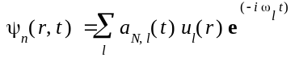,
where:
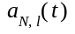 - amplitude of the probability that the atom is in energy eigenstate l at time t to the Nth order in perturbation
We next find that:
(2.5.7) 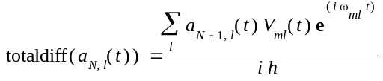
where:
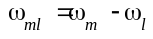
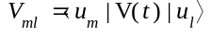
When we integrate (2.5.7) we get:
(2.5.8) 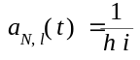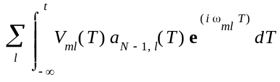
From such probability amplitude we will extract the explicit form for the linear, second-order and third-order optical susceptibilities. Here we will provide two more physical representations:
(2.5.9a) 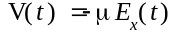 ( - electric dipole moment operator)
(2.5.9b) 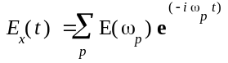 (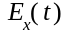 - total optical field)
Now it is possible to assume that the linear, second-order and third-order of the probability amplitude equals:
(2.5.10a) 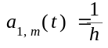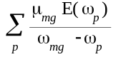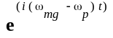
(2.5.10b) 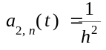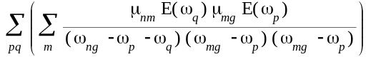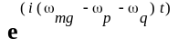
(2.5.10c) 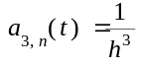
respectively. These results will lead us to the following results about the optical susceptibilities:
(2.5.11a) 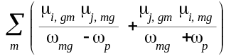
(2.5.11b) where 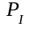 denotes the intrinsic permutation operator
(2.5.11c) 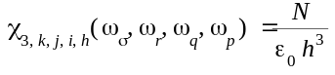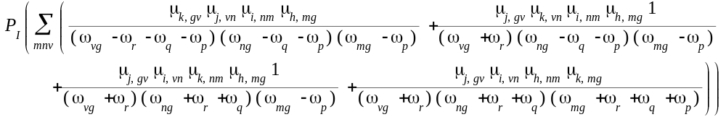
Derivation and equation details may be found in Kuzyk [21] and Boyd [2]. The (2.5.11b-c) equations are sometimes called the sum-over-states equations, because we are performing the sum over all possible excited states of the atom. Using another physical model - called the density matrix operator, we can obtain another set of equations which are slight modifications of (2.5.11a-c):
(2.5.12a) 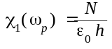
(2.5.12b) 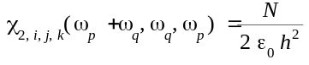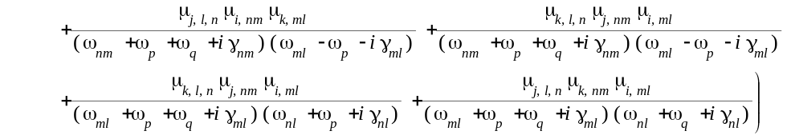
(2.5.12c) 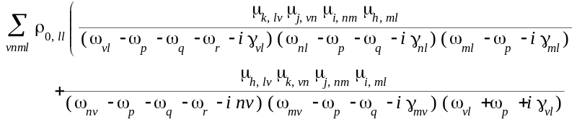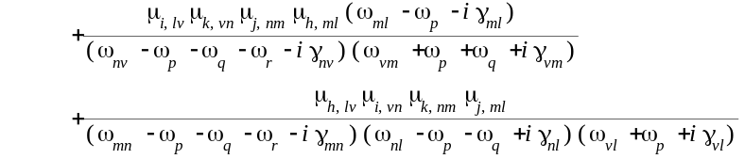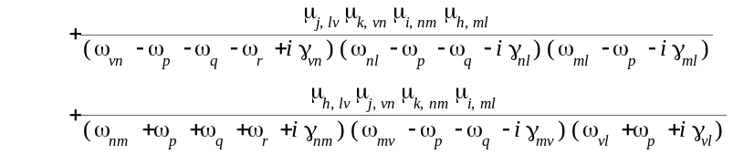
What is interesting that after expanding all the permutations in (2.5.12c) we will get the 48 different summands - which shows how the quantum mechanical approach is hard to understand. The important difference between (2.5.11a-c) and (2.5.12a-c) equations are that we add the imaginary element which describes the damping rate of 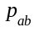 - which is an element of an density matrix, describing the coherence between states a and b:
,
where:
- density operator.
In further calculations we will use the both the (2.5.11a-c) and (2.5.12a-c) equations in simplified version - for instance with few summands.
Typical results obtained with equations (2.5.12a-b) are shown below:
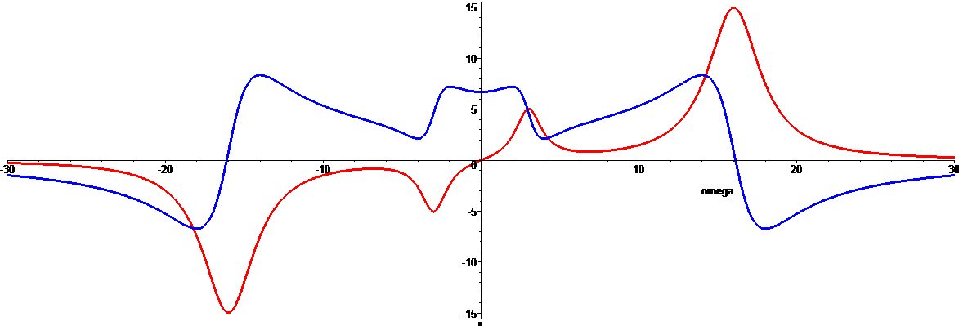
[Figure 2.5.1a] Quantum-perturbative plot for 3-level model of with arbitrary (non-physical) parameters. Red plot is for the imaginary and the blue plot is for the real part on linear susceptibility.
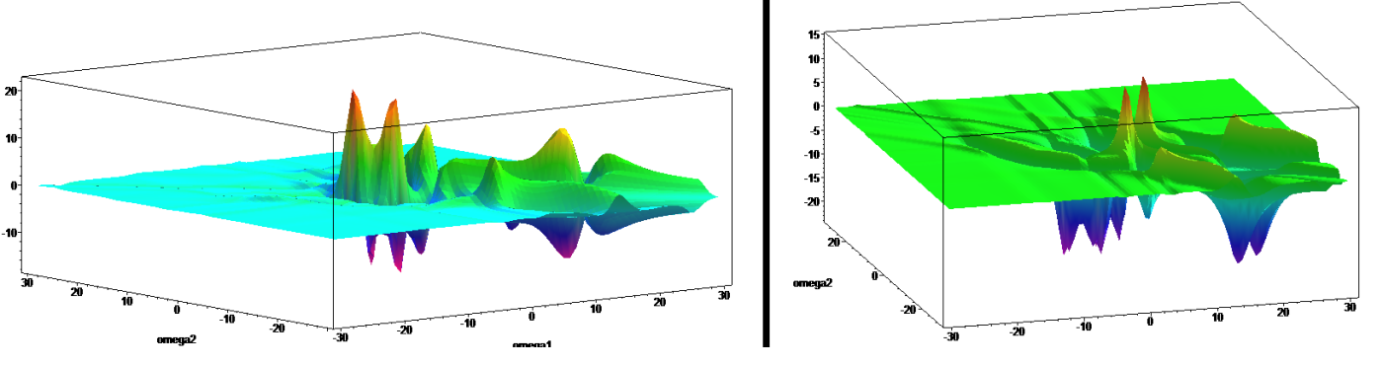
[Figure 2.5.1b] Quantum-perturbative plot for 3-level model of with arbitrary (non-physical) parameters. Red plot is for the imaginary and the blue plot is for the real part on second-order susceptibility.
Brief overview of the perturbative model

2.6 Derivation of the Kramers-Kronig relations for simple quantum-perturbative model
Using the (2.4.4a-b) equations for the just showed model - we will connect the real and imaginary part of the quantum-perturbative derived optical susceptibilities using the Hilbert transform form:
(2.6.1a) 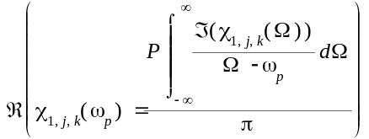
(2.6.1b) 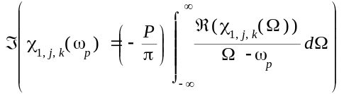
(2.6.2a) 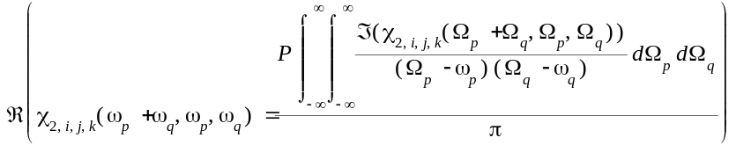
(2.6.2b)
(2.6.3a)
(2.6.3a)
In further chapters we will put these equations into some numerical evaluations.
Mathematical derivation of the Kramers-Kronig relations for simple perturbative model

2.7 Overview of the other models
D. C. Hutchings et al. [23] have proposed the models for particular nonlinear absorption processes as following:
Here we would like to state - only from the physical point of view - without formulating advanced mathematical models - that the theory of K-K relations - or to say it precisely - the conjugated pairs of Hilbert transforms - need to be structured and defined generally for both the linear and nonlinear case - there must be on valid theory - it is not a good situation - when we start from one theory and then "modify" it for some extra case - because it leads to misunderstanding in general. As the title of this thesis contains the word - understanding - we should at least try to express a new, general theory of optical phenomena - because it is "only and even" - the interaction of a chemical molecules with incoming photons in short or long period of time.
(2.7.1) Two-photon absorption:
(2.7.2) Raman: 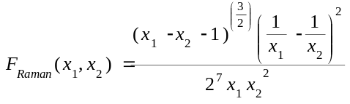
(2.7.3) Linear stark: 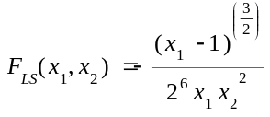(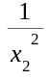)
(2.7.4) Quadratic stark: 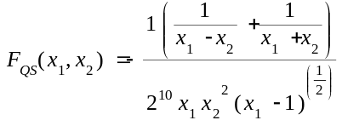
Where in all (2.7.1-4) equations we assume that:
(2.7.5) 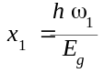, 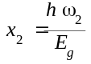,
where:
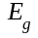 - the edge absorption energy, a non-constant parameter
Introduction into variety of other models available in physics of the nonlinear optics
> Should I write more on particular models?

2.8 Derivation of the Kramers-Kronig relations for other models
D. C. Hutchings et al. [23] have also proposed the analytical equations based on (2.7.1-4) acquired with Hilbert transform
(2.8.1) 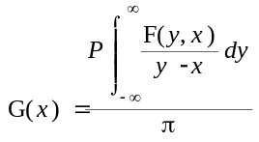
And they obtained the following results:
(2.8.2) Two-photon absorption: 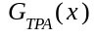 = [1/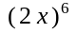)[-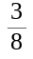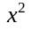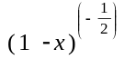 + 3x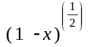-2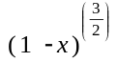+2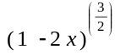] ( where - Heaviside function )
(2.8.3) Raman: 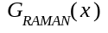 = [1/][-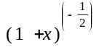 - 3x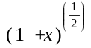-2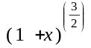+2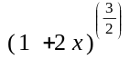]
(2.8.4) Linear Stark: 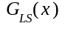 = [1/][2 - - ]
(2.8.5) Quadratic Stark: 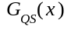 = [1/(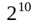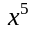)][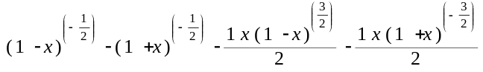]
In further chapters we will put these equations into a try. There can be other models found in literature - but our the approach will remain the same - check if the model assumed is valid.
The derived models using the Hilbert transform are presented

3. Z-scan Measurements (understanding)

3.1 Overview of the z-scan technique
One of the most important questions being the major motivation of this thesis is how the theory of Hilbert transform or the Kramers-Kronig relations can be applied to the data measured with the standard "open aperture" and "closed aperture" z-scan technique. In this chapter we will describe the process of data collection and its translation into the nonlinear absorption coefficient spectra and nonlinear refraction index spectra. As mentioned before, since summer 2010 we have set up the femtosecond z-scan system using a Quantronix Integra regenerative amplifier operating at 1 kHz and providing approximately 1 mJ, 100 fs, 800 nm pulses. It is used as a pump to the Palitra optical parametric amplifier, which, using several different frequency mixing schemes, can provide the coverage of the 450 - 2000 nm wavelength range. The best way to describe this set up will be to use Figure 3.1.1a and Figure 3.1.1b.
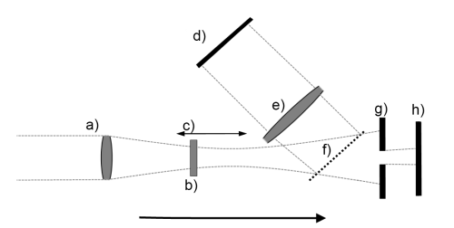

[Figure 3.1.1a] The schematic diagram of the main measurement part of the z-scan experiment
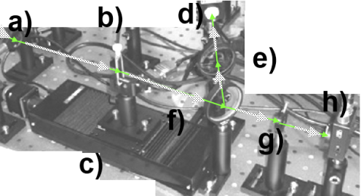
[Figure 3.1.1b] The photographic diagram of the main measurement part of the z-scan experiment
[Legend for 3.1.1a-b]
Overview of the main measurement part of the z-scan set-up built at the Wroclaw University of Technology and being under usage since summer 2010.
a) FOCUSING LENSE - A laser beam goes through focusing a lens.
b) SAMPLE IN A QUEVETTE - Investigate sample is put into a silica cuvette.
c) DYNAMIC (MOBILE) STAGE - During experiment the sample changes its relative position from the lens.
d) DETECTOR 1 - Finally the beam reaches the "Open-aperture" detector
e) DEFOCUSING LENSE - "Open-aperture" defocusing lens before detector
f) BEAM SPLITTER - Laser beam is split to pass both through "open-aperture" and "closed aperture" with a beam splitter
g) APERTURE - This is the aperture before the "Closed-aperture" detector
h) DETECTOR 2 - Finally the beam reaches the "Closed-aperture" detector
The inventor of the z-scan technique was the Dr. Mansoor Sheik-Bahae in 1989 [24] and since then many variants of this technique have been deployed “EZ-Scan”, “White Light z-scan”, “Excite-Probe z-scan"[23]. In a short description - the z-scan technique uses a single laser beam, a mobile stage and two detectors - for the open and closed aperture. Using physical model - we can relate the open-aperture results with the nonlinear absorption and the closed-aperture with the nonlinear refraction index. The mobile stage moves the sample through the position focal point of the focusing lens. We therefore obtain two diagrams - shown on the Figures 3.1.2a-b.

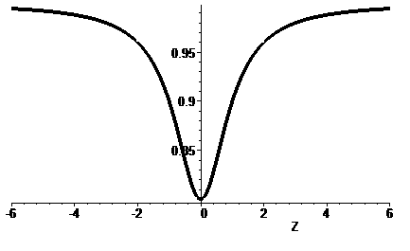
[Figure 3.1.2a] A typical open-aperture transmittance plot in a z-scan experiment,
where:
Z - the position of the stage/sample, where 0 position - the focal point of focusing lens
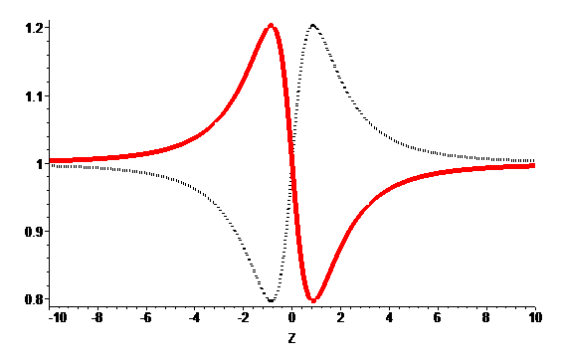
[Figure 3.1.2b] A typical closed-aperture transmittance plots in a z-scan experiment, where:
Z - the position of the stage/sample, where 0 position - the focal point of focusing lens
red (dashed) plot is for material with a positive (negative) refractive index
We must hereby stress that what we obtain with one z-scan measurement is only half a way to calculate one point in the nonlinear spectrum plot - because a typical sample is held inside a silica cuvette and is soluted in some solution (for example chloroform or toluene). So firstly we must measure the solution and an empty silica cuvette z-scan transmittance plots for each monochromatic wavelength and after so - perform the z-scan experiment on the investigated sample.
Description of the z-scan technique, description of the z-scan experiment built in Wroclaw, since summer 2010

3.2 Overview of the derivation

Calculation of the nonlinear absorption coefficient:
As shown of the Figure 3.1.2a the open-aperture transmittance can be described with the approximation equation:
(3.2.1) 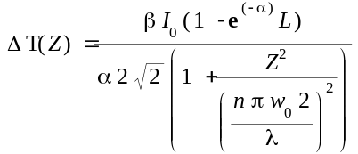
where:
- normalized transmittance of the sample at Z
- two-photon absorption coefficient
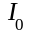 - peak on-axis irradiance at focus
L - sample length
- absorption coefficient
n - index of refraction
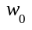 - spot size at focus (radius at 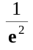)
- laser wavelength
Z - position of sample with respect to the focal position
We obtain the two-photon absorption coefficient while standard (e.g. least squares) fitting the measured open-aperture plot. This is of course also not the complete truth, because with some advanced models we can also obtain other absorptive nonlinearities. In a short description - the multiphoton absorption can be assumed when the closed-aperture peak is suppressed, but unfortunately the absorption saturation has got just the opposite effect. So the z-scan technique gives only the simple information about the nonlinear absorption processes.

Calculation of the nonlinear refraction index:
On the Figure 3.1.2b we can see the closed-aperture transmittance plot with respect to the sample position Z. It has a characteristic shape of peak trailing the valley or the valley trailing the peak if the 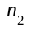 sign is negative. What now interest us is the difference between the peak and valley amplitude - we will call it 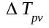. From this difference we can calculate the on-axis peak nonlinear phase shift with sample at focus 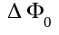
(3.2.2) 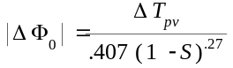
where:
S - fraction of beam transmitted by the aperture
- change in normalized transmittance between peak and valley.
Now we can estimate the refraction index from equation:
(3.2.3) 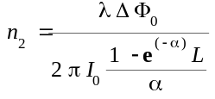
where:
- on-axis peak nonlinear phase shift with sample at focus
- peak on-axis irradiance at focus
L - sample length
- absorption coefficient
- laser wavelength
With data points collected for each wavelength we may obtain the full spectral plot for both nonlinear absorption coefficient and nonlinear refraction index - due to the z-scan measurements.
Description how the gathered data is transformed into final chart with some mathematical derivations

3.3 Definition of the main problems
A typical z-scan experiment consists of the measurement routines with number more or less around 15-20 different wavelength. One z-scan measurement usually takes between 5 to 10 minutes and together with:
a) long laser calibration process after each change of wavelength
b) silica and empty-solution measurement
c) measurement of a typical set of 10-20 measured cuvette samples
it may take many days or even weeks to complete one measurement - so even such a simple routine is rather time-demanding. Therefore we are interested in optimizing the method, the physical theory understanding and the numerical precision, because the general error cumulates with the laser non-stability, method approximation error, fitting and numerical calculations error.
A typical plot containing the z-scan measurement for the close aperture, open aperture and the laser reference is shown in the Figure 3.3.1:
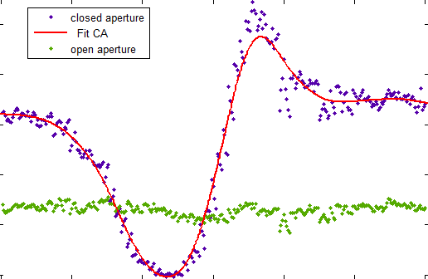
[Figure 3.3.1] A typical plot for both close and open aperture with respect to the sample position Z and with the fit spline line
Discussion about the z-scan technique, its advantages and disadvantages for determination both real and imaginary part of nonlinear susceptibility
> 1. Is it not to short? Need to ask Prof. Samoc. Maybe we should also describe the "White-Light or time-resolved ZScan"?
> 2. Is there any model for z-scan experiment?

4. Simpson and trapezoidal quadrature combined with cubic interpolation - HTRAN (solving)

4.1 Overview of the HTRAN
We define the tabular-based function HTRAN and show its theoretical fundaments here. It has been implemented in MATLAB environment, and its source code is available in Appendix A.1
We shall start from the simplest possible numerical calculation of integral - so the Simpson and trapezoidal quadrature. The algorithm is based on report by I. J. Weinberg [18] written for CDC 6600 supercomputer, but the difference is that it does not require the input function to be even. We first start from the modification of the main Hilbert transform equation:
(4.1.1) 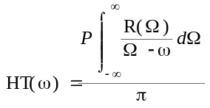 = 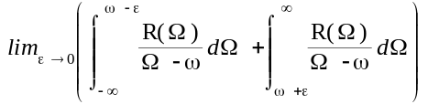 as the integral uses the Cauchy Principal Value
We firstly observe, that:
(4.1.2) " : 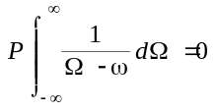
Making any number of multiplications of (4.1.2) does not change the fact it will equal zero - so we may obtain a new form of the (4.1.1) integral:
(4.1.3) 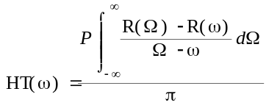
As the proposed HTRAN method will take two arguments:
F[] - the tables of abscissas and R[] - the tabular ordinates
- we will assume that the function vanishes anywhere else - namely it equals zero:
(4.1.4) " ( < and > 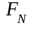) :
From (4.1.3) and (4.1.4) we obtain:
(4.1.5) 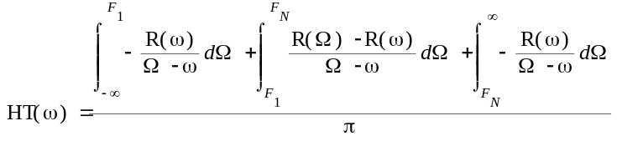
We shall also remember, that:
(4.1.6) " :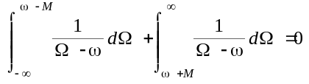
As 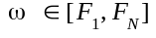 we will now consider two conditions - that takes into account the position of in relation to and . We have two possibilities:
(4.1.7a) , which means that is placed closer to 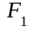 on the real axis
(4.1.7b) 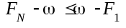, which is the opposite case and it is closer to .
Each of these two cases leads to results obtained in (4.1.8a-b) we have:
(4.1.8a) 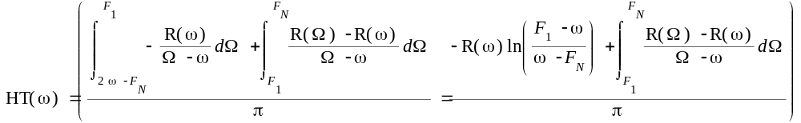
(4.1.8b) 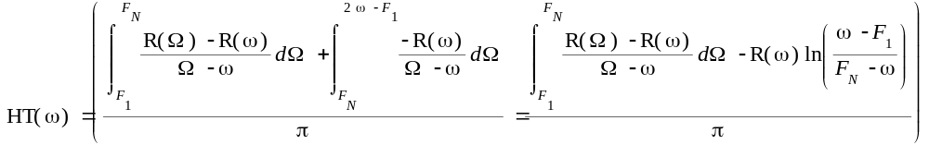
And we can see that both the (4.1.8a-b) derivations lead to the same result:
(4.1.9) 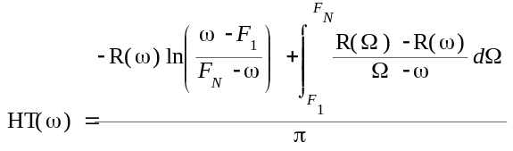
We also observe that:
(4.1.10) => => => 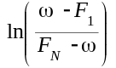 will have real value.
What now interest us the most is the integral:
(4.1.11) 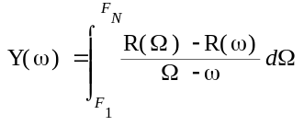
As the integrand in (4.1.11) never explodes - we will calculate it numerically. We will need to prepare ourselves to omit some difficulties - as when denominators equals zero. In algorithm we are preparing a new set of 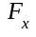 values, which are just simple midways of defined:
(4.1.12) 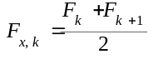 for k =
We will also need to obtain the values of a new 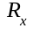 table in these new 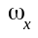 values. We will do this by a simple cubic interpolation:
(4.1.13a) 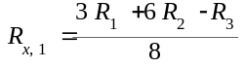
(4.1.13b) 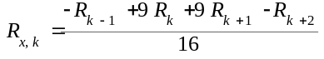 for
(4.1.13c) 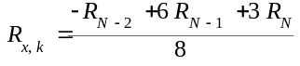
By now the calculation of (4.1.11) will be performed by a simple quadrature integration:
(4.1.14) 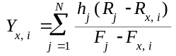 for
To do such a integration we will hire both the trapezoidal rule and the Simpson's rule, depending on the evenness of N. If N is odd only the Simpson's rule is used:
(4.1.15a) 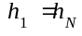 = 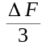 = 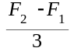
(4.1.15b) 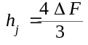 for
(4.1.14b) 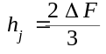 for
Where N is even, the last interval should be obtained using the trapezoidal rule:
(4.1.16a) 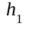 = =
(4.1.16b) for
(4.1.16c) for
(4.1.16d) 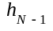 =
(4.1.16e) 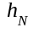 = 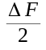
Next we calculate the Hilbert transform in the points:
(4.1.17) 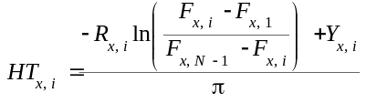
Finally we need to undo the cubic interpolation. To do so, we perform the following calculations:
(4.1.18a) 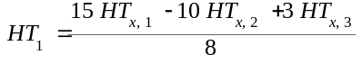
(4.1.18b)
(4.1.18c) for
(4.1.18d) 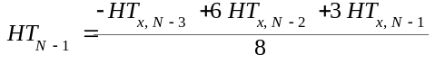
(4.1.18e)
In following chapters (or in Appendices) we will show the results obtained with this method.
Overview of the HTRAN method (originated by Weinberg, with our modification for non-even functions)

4.2 HTRAN for simple linear model - results
In linear model we will assume that the susceptibility is calculated as the inverse Fourier transform of a decreasing, sinusoidal and casual signal:
(4.2.1) resp(t) = 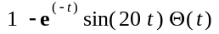 (the absorbance response signal - altogether with transmittance signal it should sum up to 1)
With a following plot:

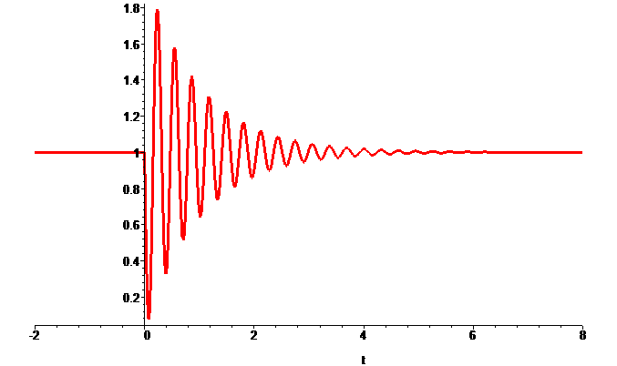
[Figure 4.2.1] A typical linear response signal in time domain
First we need to calculate the Fourier transform of such signal:
(4.2.2)F[] = 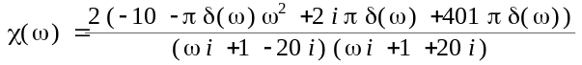 ~= 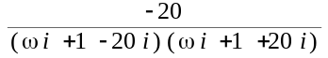, where - Dirac delta function can be omitted from the numerical point of view.
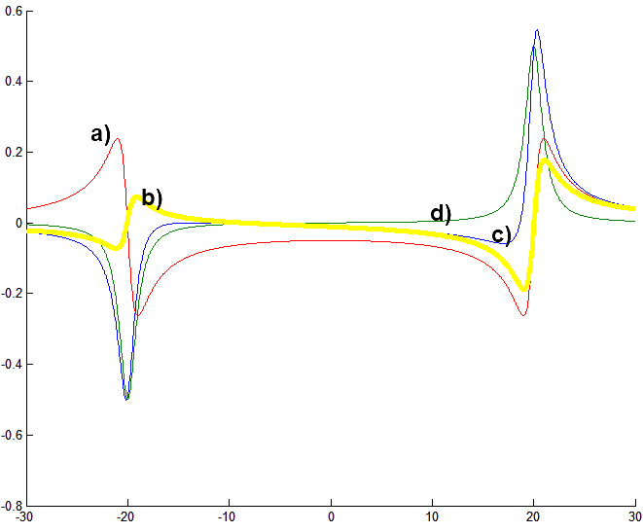
[Figure 4.2.2] Result plotted together a) The plot of the real part of b) absolute error plot (c-plot minus d-plot) c) imaginary part of obtained with the Hilbert transform of a-plot d) imaginary part of calculated analytically.
Example cases for solving the Kramers-Kronig relations in linear model using HTRAN - with short conclusions

4.3 HTRAN for simple nonlinear model - results
We get the equation for pump-and-probe susceptibility equation (2.3.1) and assume some values for the function parameters:
(4.3.1) 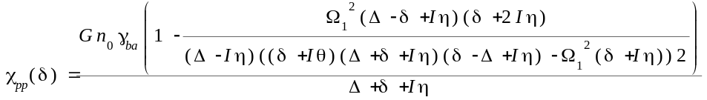
where:
, 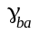 = -0.1, = 1, , , , 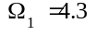
The results for such set of arbitrary parameters are shown on the Figure 4.3.1.
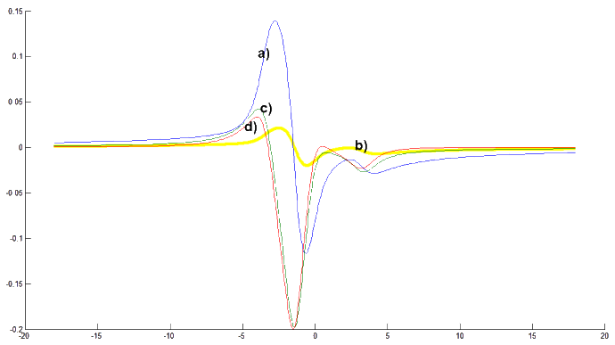
[Figure 4.3.1] Result plotted together a) The plot of the real part of 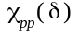 b) absolute error plot (c-plot minus d-plot) c) imaginary part of obtained with the Hilbert transform of a-plot d) imaginary part of calculated analytically.
The resulted b-plot seems to be a not-so-bad introduction into the Hilbert transform evaluation, as we have only employed the simple Simpson's rule. We would also like to perform the 3-Dimensional analysis of the assumed pump-probe susceptibility, so we employ the (2.4.5a-b) equations for each frequency, which require performing two integrations (one, for each frequency-domain argument). Unfortunately, only the obtained 3-Dimensial shapes are similar to the original ones, but the relative error is huge:

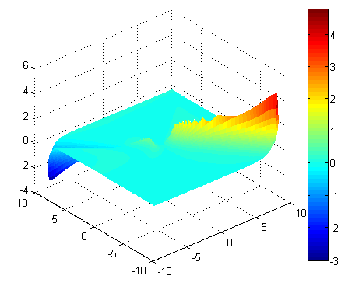
[Figure 4.3.2] Combined relative error of 3-Dimensial calculations: The light-cyan color shows the area of error below 100%, which is not very bad, but there are areas with error more above 100%.
Let's now perform the evaluation for the wave-mixing model as stated in the model described by (2.3.2a). We expand this equation to resolve the complex conjugate of D function and the resulting function is:
(4.3.3)
With such an complex function we obtain the following two and three dimensional results:
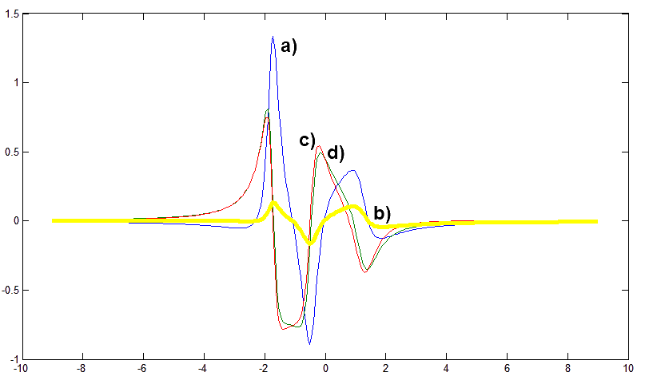
[Figure 4.3.3] Results plotted together a) The plot of the real part of b) absolute error plot (c-plot minus d-plot) c) (red) imaginary part of obtained with the Hilbert transform of a-plot d) (green) imaginary part of calculated analytically.
As the obtained 3-Dimensial shape looks very similar to those obtained analytically, the relative error still remains huge for some areas:

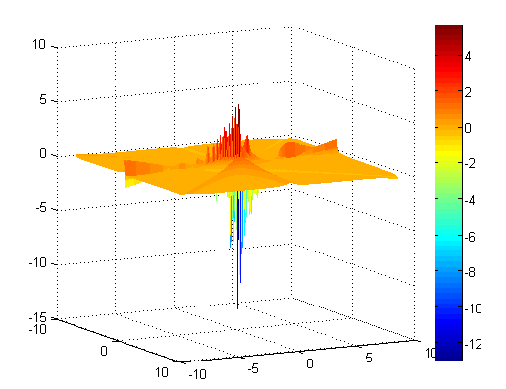
[Figure 4.3.4] Combined relative error for the real part of nonlinear susceptibility describing the wave-mixing process..
Example cases for solving the Kramers-Kronig relations in simple nonlinear model using HTRAN - with short conclusions

4.4 HTRAN for simple quantum-perturbative model - results
We will use the models already prepared for both linear and second-order nonlinear susceptibilities defined in Chapter 2.5.
(4.4.1) = ,
where:
= , , , ,
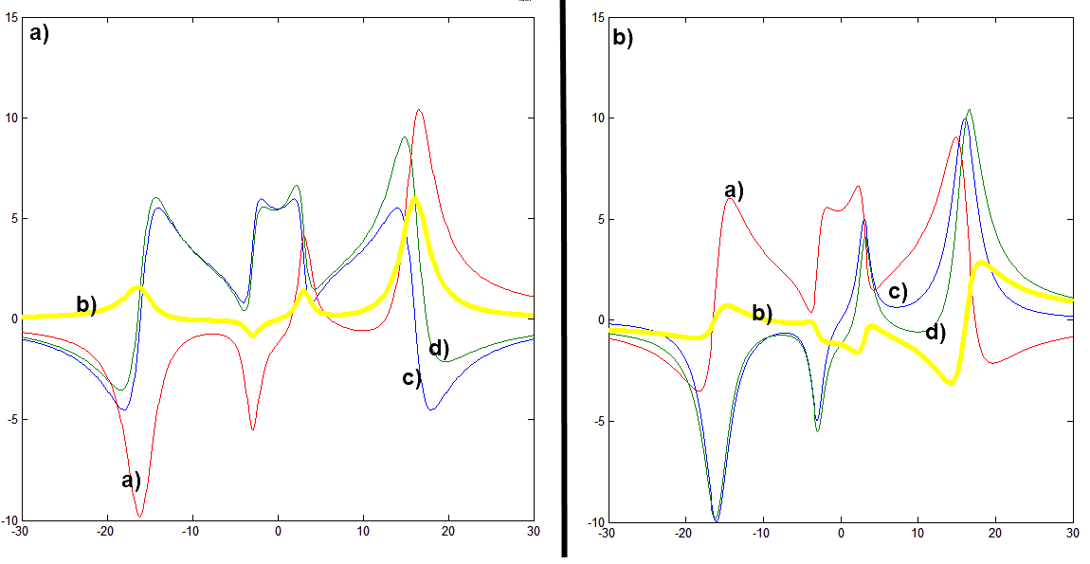
[Figures 4.4.1a-b] Result plotted together
[4.4.1.a] a) The plot of the imaginary part of b) absolute error plot (d-plot minus c-plot) c) real part of calculated analytically d) real part of obtained with the Hilbert transform of a-plot
[4.4.1.b] a) The plot of the real part of b) absolute error plot (d-plot minus c-plot) c) imaginary part of calculated analytically d) imaginary part of obtained with the Hilbert transform of a-plot
(4.4.2) 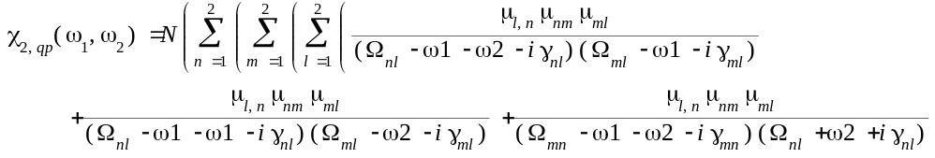
where:
= , , , ,
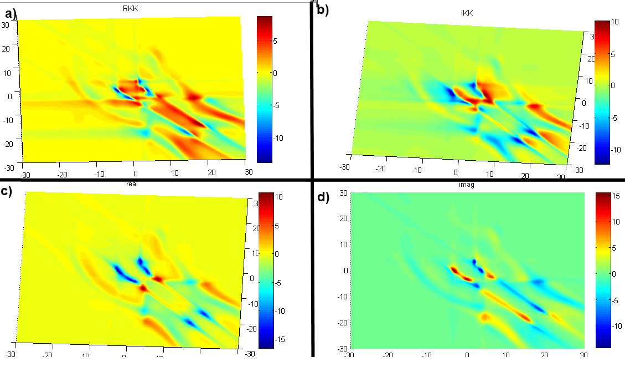
[Figures 4.4.2a-d] Results of the HTRAN 3-Dimensional method plotted together. a) - The calculated real part of b) The calculated imaginary part of c) The real part of nonlinear susceptibility calculated analytically d) The imaginary part of the nonlinear susceptibility
We can see, there is a similarity in obtained plots, but both the relative and absolute error do not satisfy us at all. Results obtained with 2-Dimensional model were more satisfying.
Example cases for solving the Kramers-Kronig relations in simple quantum-perturbative model using HTRAN - with short conclusions

4.5 HTRAN for other models - results
Unfortunately the results obtained for the equation (2.8.1) were far from accurate, so we will not show them for HTRAN method.
Example cases for solving the Kramers-Kronig relations for other models using HTRAN - with short conclusions

5. Newton-Cotes quadrature (solving)

5.1 Overview of the NC quadrature of arbitrary degree
Newton-Cotes formula for numerical integration is taken into consideration. We compare formula for an arbitrary degree - having in our mind that the choice between formulas of high and low degree must be undertaken with the awareness of numerical errors that may arise. Newton-Cotes quadrature is a method for numerical integration with equispaced vertices. As we would like to integrate function f = f(x) within the range we introduce the following calculations
(5.1.1a) 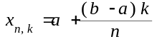 for
(5.1.1b)
(5.1.1c) for
(5.1.1d) 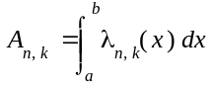 = 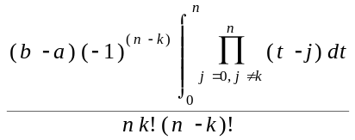 for
With such defined parameters the quadrature in sense of Newton-Cotes is defined as following:
(5.1.2) 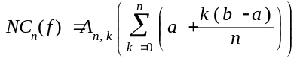
The numerical algorithm for the Newton-Cotes quadrature of an arbitrary degree has been prepared in Appendix A.2. It has been modified to omit the singularity and to estimate the number of mini-steps needed to partition the integration range - see the source code and comments. The function parameters are defined below:

Input arguments:
fun - the real-valued function we will like to integrate (function-handle), mandatory argument;
a - integration starting point, mandatory argument;
b - integration ending point, mandatory argument;
tol - required tolerance, default value 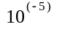;
n - degree of the Newton-Cotes quadrature, default value 8;
cs - how close (in absolute value) we would like to get near the singularity, default value 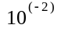;
pts - number of points in which user would like to perform the Hilbert transform, default value 200;

Output arguments:
F - an array of points, abscissas;
H - calculated Hilbert transform values, ordinates.
The description of the Newton-Cotes algorithm

5.2 NC for simple linear model - results
As the prepared numeric method depends on many input parameter arguments, we have tried to perform the evaluation in many different cases, some of those results are stated below. We are calculating the same model as in 4.2
(5.2.1) ~=
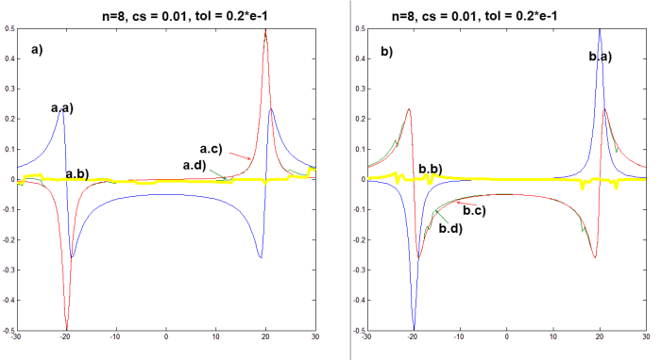
[Figure 5.2.1a-b] Calculations for parameters ( a.a) The plot of the real part of a.b) absolute error plot (a.d-plot minus a.c-plot) a.c) imaginary part of calculated analytically a.d) imaginary part of obtained with the Hilbert transform of a.a-plot, b.a) The plot of the imaginary part of b.b) absolute error plot (b.d-plot minus b.c-plot) b.c) real part of calculated analytically b.d) real part of obtained with the Hilbert transform of b.a-plot
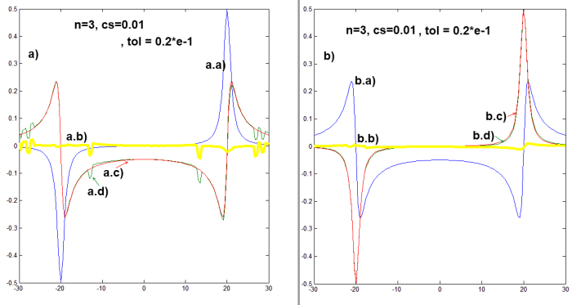
[Figure 5.2.2a-b] Calcuations for parameters () a.a) The plot of the imaginary part of a.b) absolute error plot (a.d-plot minus a.c-plot) a.c) real part of calculated analytically a.d) real part of obtained with the Hilbert transform of a.a-plot, b.a) The plot of the real part of b.b) absolute error plot (b.d-plot minus b.c-plot) b.c) imaginary part of calculated analytically b.d) imaginary part of obtained with the Hilbert transform of b.a-plot
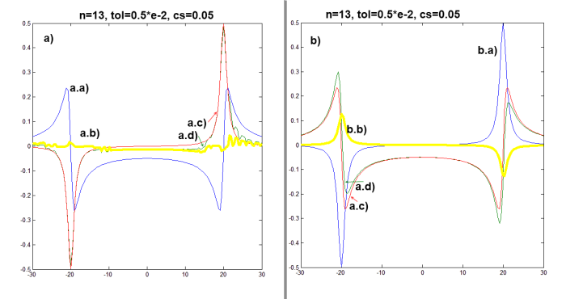
[Figure 5.2.3a-b] Calcuations for parameters () a.a) The plot of the real part of a.b) absolute error plot (a.d-plot minus a.c-plot) a.c) imaginary part of calculated analytically a.d) imaginary part of obtained with the Hilbert transform of a.a-plot, b.a) The plot of the imaginary part of b.b) absolute error plot (b.d-plot minus b.c-plot) b.c) real part of calculated analytically b.d) real part of obtained with the Hilbert transform of b.a-plot
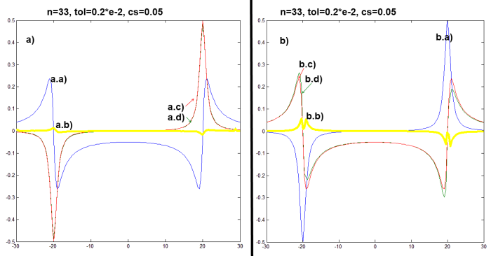
[Figure 5.2.4a-b] Calcuations for parameters () a.a) The plot of the real part of a.b) absolute error plot (a.d-plot minus a.c-plot) a.c) imaginary part of calculated analytically a.d) imaginary part of obtained with the Hilbert transform of a.a-plot, b.a) The plot of the imaginary part of b.b) absolute error plot (b.d-plot minus b.c-plot) b.c) real part of calculated analytically b.d) real part of obtained with the Hilbert transform of b.a-plot
We cannot tell with hundred percent confidence which set of parameters will fit the best any given function and the user will need to try many combinations before obtaining the final plot, but what we gave is the opportunity to set each one parameter manually, which may lead to better results in the particular cases.
Example cases for solving the Kramers-Kronig relations in linear model using modified Newton-Cotes method - with short conclusions

5.3 NC for simple nonlinear model - results
We have performed calculations for the same both nonlinear pump-probe and wave-mixing model as in 4.3. Results for 1-Dimension and 2-Dimensions have been presented below:
(5.3.1)
where:
, = -0.1, = 1, , , ,
(5.3.2) 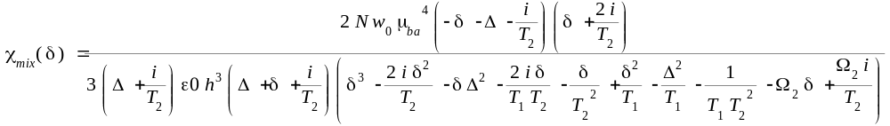
where:
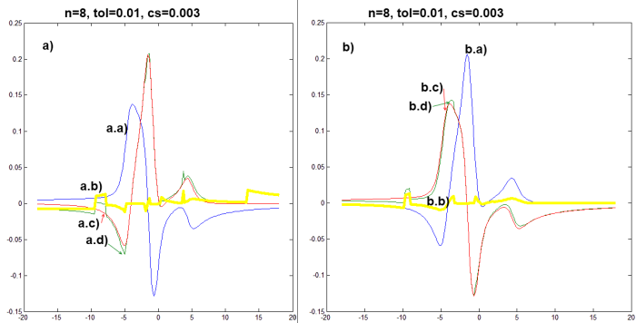
[Figure 5.3.1a-b] Calcuations for parameters ( a.a) The plot of the real part of a.b) absolute error plot (a.d-plot minus a.c-plot) a.c) imaginary part of calculated analytically a.d) imaginary part of obtained with the Hilbert transform of a.a-plot, b.a) The plot of the imaginary part of b.b) absolute error plot (b.d-plot minus b.c-plot) b.c) real part of calculated analytically b.d) real part of obtained with the Hilbert transform of b.a-plot
Example cases for solving the Kramers-Kronig relations in simple nonlinear model using NC - with short conclusions

5.4 NC for simple quantum-perturbative model - results

Linear model - results:
For the linear susceptibility we have used the model from the chapter 2.5:
(5.4.1) 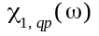 = 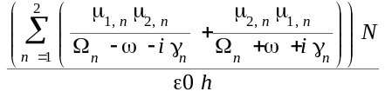
This time we have used the following parameters:
= , , , , 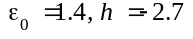
Evaluation time of two plots given in the Figures (5.4.1a-b) was 615 seconds.
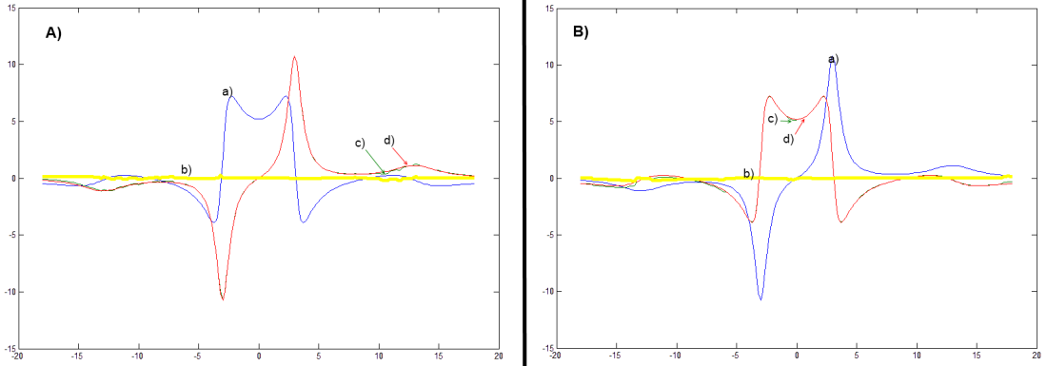
[Figures 5.4.1a-b] Results plotted together
[5.4.1.a] A: a) The plot of the imag part of 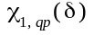 b) absolute error plot (d-plot minus c-plot) d) real part of obtained with the Hilbert transform of a-plot d) real part of calculated analytically
[5.4.1.b] B: b) The plot of the real part of b) absolute error plot (d-plot minus c-plot) c) imaginary part of obtained with the Hilbert transform of a-plot d) imaginary part of calculated analytically

Second-order model - results:
For the linear susceptibility we have used the model from the chapter 2.5:
(5.4.2) 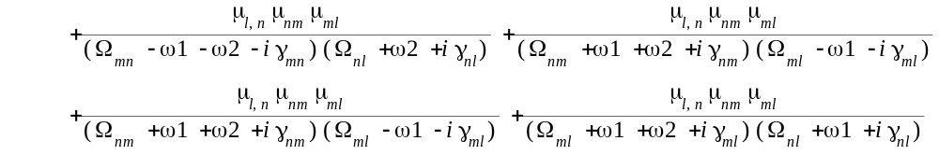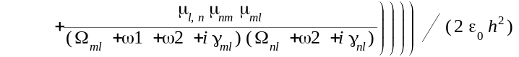
where:
= , , , , 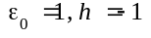

Example cases for solving the Kramers-Kronig relations in simple quantum-perturbative model using NC - with short conclusions

5.5 NC for other models - results
Text and graphs here...
Example cases for solving the Kramers-Kronig relations for other models using NC - with short conclusions

6. Hilbert Clenshaw-Curtis iterations (solving)

6.1 Overview of the Hilbert Clenshaw-Curtis iterations
The adaptive and iterative algorithm for obtaining the Hilbert transform of a given regime of abscissas is presented.

Clenshaw Curtis quadrature:
The heart of the calculation is based on the typical Clenshaw-Curtis quadrature of function that has been expanded into a form of Chebyshev polynomials. We define the quadrature problem as follows: For a given function f(x) find a value of the integral:
(6.1.1) CCI = 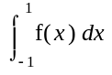
The first step in solving this quadrature, after the idea of C.W. Clenshaw and A.R. Curtis [25] is to do the following change of variables:
(6.1.2a)
(6.1.2b) CCI = 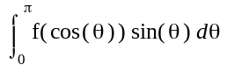
By using the Discrete Cosine Transform of I-type, we can estimate the integral (6.1.2b) with following series:
(6.1.3a) ~=
(6.1.3b)
Now we perform the simple approximation of (6.1.3b) with:
(6.1.4) ~=
And while in the (6.1.3a) equation we need only , the (6.1.4) equation can be simplified:
(6.1.5) 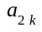 ~= 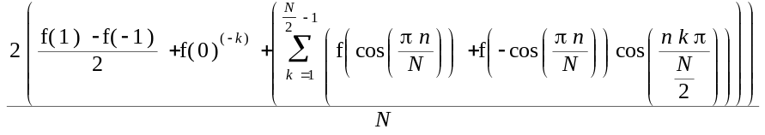
We can now simplify the (6.1.5) equation using the matrix notation:
(6.1.6a) 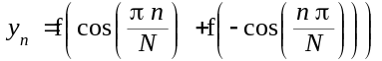
(6.1.6b) 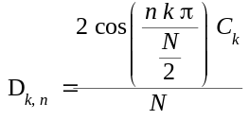
where:
for k = 0, N/2 and otherwise
We can observe, that both (6.1.5) and (6.1.6a-b) describes the DCT-I transform. Now we use the statement, that DCT-I is equivalent to a DFT of 2N - 2 real numbers with even symmetry. So we state:
(6.1.7a) 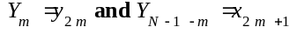 for (m=0,1,...,N/2-1)
(6.1.7b) FY = DFT(Y)
(6.1.7c) [a] = DCT-I(y) = 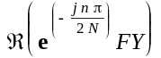
Now as we got the vector of the coefficients (6.1.7c) we can perform the final calculation by multiplying with vector d:
(6.1.8) 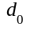 = 1, 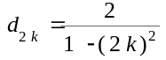, 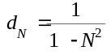
And we get the final conclusion:
(6.1.9) 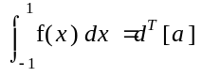

Hilbert transform using the Clenshaw-Curtis quadrature:
While the Clenshaw-Curtis quadrature is defined for finite range [-1,1], the Hilbert transform uses the definite and improper integral over the range [-infinity, infinity]. What must now be done is to change the range of integrations without changing the value of the Hilbert transform:
(6.1.10a) x = 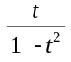
(6.1.10b) Hil(f)(s) = 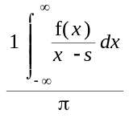 =
Our simple algorithm uses the implementation of Clenshaw-Curtis quadrature with the inner function:
(6.1.11) g(t,s) =
In our implementation is adaptive - we compare two results for number of points N and 2*N - if the result is satisfactory, the loop ends, if not - we continue with doubling the number of points in the Clenshaw-Curtis quadrature implementation - so the step and tolerance must be selected wisely.

Our implementation of the Hilbert Clenshaw-Curtis iterations:
So far we have presented the overview of procedures responsible for evaluation of the Clenshaw-Curtis quadrature and the Hilbert transform using the Clenshaw-Curtis quadrature in one point. But in the typical situation we have the whole vector of function values for a given range of abscissas - so what is left - we perform the single-point Hilbert transform based on the Clenshaw-Curtis quadrature for each given point. But to omit problems with singularities, we will add some post- and pre-calculations - using the cubic interpolation. The whole procedure is now:
INPUT:
X, Y - given N-length abscissas and related ordinates
PRE-CALCULATIONS:
From N points of Y we calculate the cubic interpolation having N-1 inner points:
(6.1.12a) 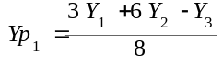

(6.1.12b) 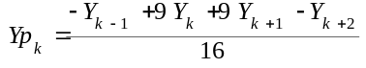
(6.1.12c) 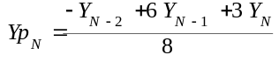
MAIN CALCULATIONS:
With desired tolerance we calculate the N-1 values for each on of inner points:
(6.1.13) 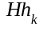 ~= Hil(f)(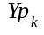)
POST-CALCULATIONS:
From N-1 points of Hh we calculate N points using the reverse cubic interpolation
(6.1.14a) 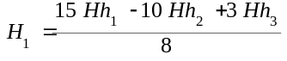
(6.1.14b) 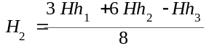
(6.1.14c) 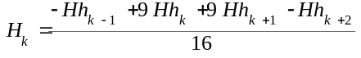
(6.1.14d)
(6.1.14e) 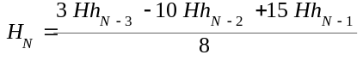
OUTPUT:
H - N-length Hilbert transform for given function values at X abscissas
The algorithm source has been presented in the Appendix A.3
Overview of the Clenshaw-Curtis iterations method

6.2 HCCI for simple linear model
Text and graphs here....
Example cases for solving the Kramers-Kronig relations in linear model using CCI - with short conclusions

6.3 HCCI for simple nonlinear model
Text and graphs here....
Example cases for solving the Kramers-Kronig relations in simple nonlinear model using CCI - with short conclusions

6.4 HCCI for simple quantum-perturbative model
Text and graphs here....
Example cases for solving the Kramers-Kronig relations in simple quantum-perturbative model using CCI - with short conclusions

6.5 HCCI for other models
Text and graphs here....
Example cases for solving the Kramers-Kronig relations for other models using CCI - with short conclusions

7. Fast Hartley transform approach (solving)

7.1 Overview of the FTHA
The Fast Hartley Transform approach for the Hilbert transform is based on two efficient O (n log n) discrete Hartley transforms and was well described by Soo-Chang Pei in [26]. This approach is faster than another discrete Hilbert transform based on two Fourier transforms, because the whole computation are carried using only real numbers, which is faster than Fourier computation carried using time consuming complex numbers.
Discrete Hartley Transform
For a given N-length vector X both the discrete Hartley transform and inverse discrete Hartley transform are defined as follows:
(7.1.1a) 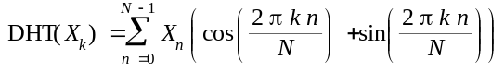
(7.1.1b) 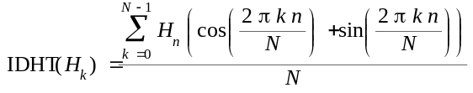
Hartley transform convolution theorem
Now we will introduce the Hartley transform convolution theorem. We define the N-length vector x as convolution of two N-length vectors 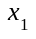, 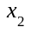 as follows:
(7.1.2) 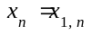 * 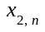 = 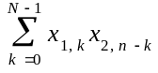
For a given convolution, the following theorem is stated:
(7.1.3)
where:
The proof of the Hartley transform convolution theorem can be found in [26].
Relation between discrete Fourier and discrete Hilbert transform
Now we will derive the discrete Fourier transform of the Hilbert transform for a given N-length vector x:
(7.1.4a) = 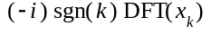
where:
(7.1.5a) 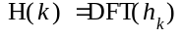
(7.1.5b) 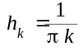 discrete Hilbert kernel
and also:
(7.1.6a) H(k) = i for 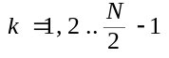
(7.1.6b) H(k) = 0 for 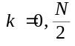
(7.1.6c) H(k) = -i for 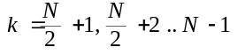
Application of the discrete Hartley transform to calculate the discrete Hilbert transform:
Using the Hartley transform convolution theorem (7.1.3) for a given N-length vector x we obtain:
(7.1.7)
where:
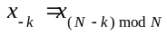 (time reversal)
Now we should notice, that the discrete Hilbert transform kernel defined in (7.1.5b) is an odd function, so its even part equals zero. So (7.1.7) simplifies now into a product of two separate Hartley transforms:
(7.1.8) = 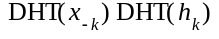
By [26] the second transform is defined:
(7.1.9a) 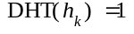 for
(7.1.9a) 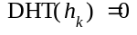 for
(7.1.9a) 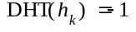 for
If order to calculate the Hilbert of a given N-length vector x the last thing to do is apply the inverse discrete Hartley transform on the very right side of (7.1.8) equation.

Fast Hartley Transform algorithm
Ronald F. Ullmann has showed the fast algorithm for the discrete Hartley transform in [27]. The important assumption is that - as for the fast Fourier transform algorithm, the fast Hartley transform algorithm is defined for a K-length vector x, where K is the power-of-two:
(7.1.10)  :
The (7.1.10) condition for the algorithm and the further possibilities to modify it are discussed further. We will start with the very same thing as in the fast Fourier algorithm - we split the x vector into two smaller vectors:
(7.1.11a) 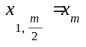 for
(7.1.11b) 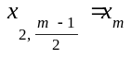 for
Taking into account the initial definition of the discrete Hartley transform (7.1.1a), we obtain:
(7.1.12) 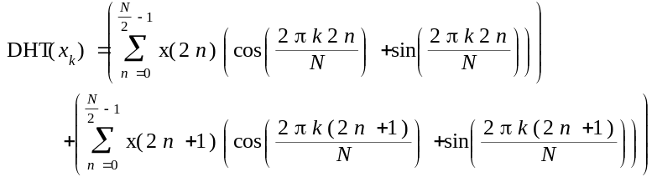
In [27] the following "shift rule" for the discrete Hartley transform is stated :
(7.1.13)
If we apply the Hartley shift rule (7.1.13) to the split equation in (7.1.12) we obtain:
(7.1.14) for 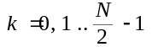
The rule (7.1.14) can be applied only for the half of the possible k values (k < N/2). Now we will use the periodic properties of the discrete Hartley transform kernel:
(7.1.15a)
(7.1.15b) 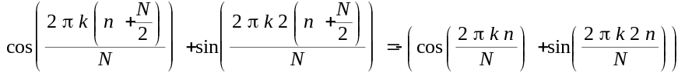
The rule (7.1.14) using the periodicity property from (7.1.15a-b) can be now used for all k indices:
(7.1.16a) for
(7.1.16b) 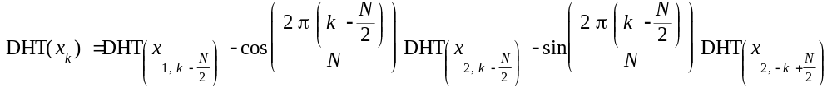 for 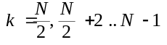
The remaining definition for the negative index, need to be explained:
(7.1.17) 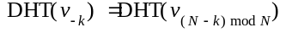
Of course this is a typical divide-and-conquer approach, where the complexity is reduced from 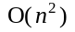 to , very similar to the approach used in the Cooley–Tukey FFT algorithm [28].

Non-power-of-two case
There are several approaches when calculating the fast Fourier transform for a non-power-of-two case length of the input x vector. One approach (PFA) is the Good–Thomas / prime-factor algorithm for a vector length K defined:
(7.1.18) 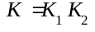
Where 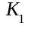 and 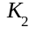 are relatively prime numbers. Another approach was presented by Leo Bluestein, called also the chirp z-transform algorithm is presented in [30]. Another author: Georg Bruun - has invented the approach based on the recursive polynomial-factorization in [31]. Rader has prepared the special FFT algorithm especially for vectors of prime size in [32]. But we will use the simplest possible approach - called the zero-padding. So in case of input vector with the size of non-power-of-two, we add the suffix vector filled with vectors to fit the next possible power-of-two size. In the worst case, there input vector size will be doubled, which has no influence on the asymptotic complexity, which remains O(n log n). While the discrete signal analysis is the domain of scientists, we will end with conclusion stated by M. Lamb in [33] that he is uncertain if zero padding has an influence on the spectral resolution, but in most cases it has a little influence on the results obtained in the discrete transforms.
The source code of the discrete Hilbert transform using both the fast Hartley transform and inverse fast Hartley transform has been presented in Appendix A.4
Overview of the fast Hartley transforms, the algorithm is in O(n log n).

7.2 FTHA for simple linear model
Text and graphs here....
Example cases for solving the Kramers-Kronig relations in linear model using FTH with short conclusions

7.3 FTHA for simple nonlinear model
Text and graphs here....
Example cases for solving the Kramers-Kronig relations in simple nonlinear model using FTH - with short conclusions

7.4 FTHA for simple quantum-perturbative model
Text and graphs here....
Example cases for solving the Kramers-Kronig relations in simple quantum-perturbative model using FTH - with short conclusions

7.5 FTHA for other models
More texts and graphics come shortly....
Example cases for solving the Kramers-Kronig relations for other models using FTHA - with short conclusions

8. Hermite-Hilbert transform (solving)

8.1 Overview of the HHT
Hermite-Hilbert transform approach is based on the pre-calculation of already-known Hermite polynomials and Hermite base of orthogonal functions. The algorithm is based on the master thesis of Mathias Johansson [34].
Hermite polynomials and Hermite functions:
Hermite polynomial of an arbitrary n degree is defined as follows:
(8.1.1) 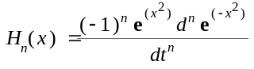
There is also an recursive equation for Hermite polynomials:
(8.1.2a)
(8.1.2b) 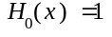
Using the Hermite polynomial we would like to derive a set of orthogonal polynomials in 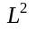. Therefore we introduce the weight function and the norm function:
(8.1.3a) 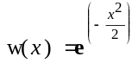
(8.1.3b) 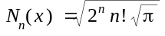
If we multiply the nth Hermite polynomial with the weight function w(x) and divide it by the nth norm function 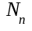 we obtain the nth orthogonal Hermite function:
(8.1.4) 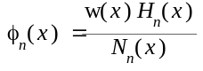 = 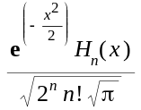
Based on the recursive equation (8.1.2a-b) we also obtain:
(8.1.5a) 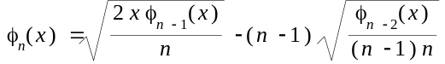
(8.1.5b) 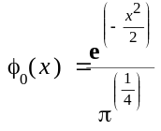

Hilbert transform of Hermite functions:
Johansson after polish mathematician Stefan L. Hahn [35] states that for any f(x) and belonging to 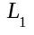 we have:
(8.1.6) 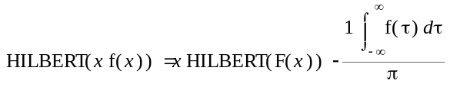
The proof of the Theorem stated in (8.1.6) is short:
(8.1.7) = 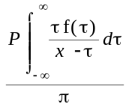 = 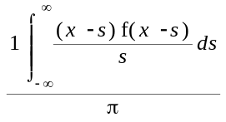 (where s = ) = 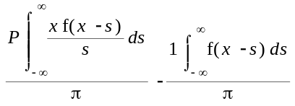 = 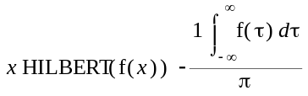
From both equations (8.1.6) and (8.1.5a-b) we now obtain the important result:
(8.1.8a) 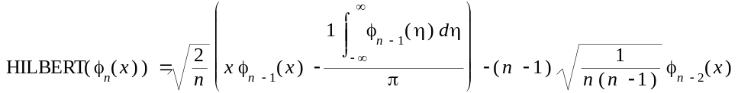
(8.1.8b) 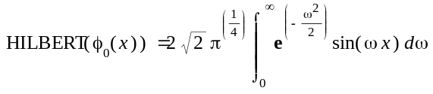

Hilbert transform based on the Hermite functions:
Now we can derive the Hilbert transform of an arbitrary function. We start with expanding f = f(x) into a series sum:
(8.1.9a) 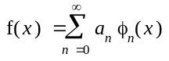
(8.1.9b) 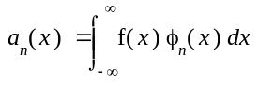
For each function that has a limited series expansion at infinity we can provide estimation used in further numerical algorithm:
(8.1.10a) f(x) ~= 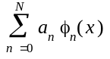
(8.1.10b) ~= 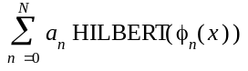

Short description of the numerical algorithm:
Taking a look on the (8.1.10b) equation we can see, that the only difficulty is to calculate the 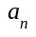 coefficients, while both the 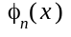 and 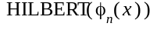 can be precalculated once. The integral in (8.1.9b) is now much easier because there is no singularity. The algorithm is given in Appendix A.5 and it consists of three main parts:
1. PRECALCULATION of Hermite function coefficients - done once using Maple Toolbox
MAIN LOOP with:
2. ESTIMATION OF COEFFICIENTS
3. CALCULATION OF THE HILBERT TRANSFORM (using 8.1.10b)
Overview of the Hermite-Hilbert transforms and overview of the precalculation of the Hermite polynomials in a possibly short time/memory

8.2 HHT for simple linear model
Text and graphs here....
Example cases for solving the Kramers-Kronig relations in linear model using HHT with short conclusions

8.3 HHT for simple nonlinear model
Text and graphs here....
Example cases for solving the Kramers-Kronig relations in simple nonlinear model using HHT - with short conclusions

8.4 HHT for simple quantum-perturbative model
Text and graphs here....
Example cases for solving the Kramers-Kronig relations in simple quantum-perturbative model using HHT - with short conclusions

8.5 HHT for other models
Text and graphs here....
Example cases for solving the Kramers-Kronig relations for other models using HHT - with short conclusions

9. Fourier-series (solving)

9.1 Overview of the Fourier-series baser method
The concept of the Hilbert transform evaluation based on the Fourier series also comes from the master thesis by Mathias Johansson [34]. There is an important drawback in this approach - in general it should be applied to the periodical functions, but we will further assume they have relatively long period. Although, the numerical results

Fourier series:
Each periodical function can be decomposed into infinite Fourier series. For a given periodic function f with a given period 2*P, we will introduce the Fourier coefficients:
(9.1.1a) 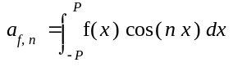
(9.1.1b) 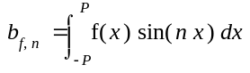
Not getting deeply into harmonic analysis - we will assume that a series of partial sums:
(9.1.2) 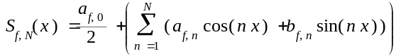
for a function 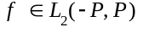 converges at almost every point to the f, which can be written as:
(9.1.3) if S = {t : 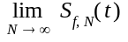 != } then |S| <= 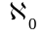

Hilbert transform based on the Fourier series:
After Johansson [34] we state that for any given function we can calculate the Hilbert transform using the form of Fourier series for this function. All we need to do is to make a swap in the (9.1.2) equation - the coefficients should be swapped with 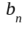 coefficients.
(9.1.4) HILBERT(f(x)) = 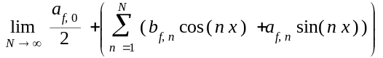 [at almost every point x]

Algorithm overview:
As mentioned before we will prepare the algorithm as for the periodic function, but we will try to imply that the period is much longer than the area of interest. We would like to calculate the Hilbert transform for the both periodical and non-periodical function f. The first step is to calculate the properties of the input X interval, which is the region in which we are interested of both input function f values and the values of its Hilbert transform. The second step is to calculate the Fourier coefficients in a main loop. In the same loop we calculate the next partial sum values. The last step is to extract the inner interval from the extended interval, to omit the numerical errors near the interval edges.
The full source code of this algorithm has been presented in the appendix A.6.
The algorithm is ready, results will be generated - results are quite well for finite signals/spectra.

9.2 Fourier-series for simple linear model
Text and graphs here....
Example cases for solving the Kramers-Kronig relations in linear model using Fourier-series - with short conclusions

9.3 Fourier-series for simple nonlinear model
Text and graphs here....
Example cases for solving the Kramers-Kronig relations in simple nonlinear model using Fourier-series - with short conclusions

9.4 Fourier-series for simple quantum-perturbative model
Text and graphs here....
Example cases for solving the Kramers-Kronig relations in simple quantum-perturbative model using Fourier-series - with short conclusions

9.5 Fourier-series for other models
Text and graphs here....
Example cases for solving the Kramers-Kronig relations for other models using Fourier-series - with short conclusions

10. MATLAB ® out-of-the-box functions (solving)

10.1 Overview of the MATLAB ® interior functions
Why not take into consideration the already built-in numerical methods from MATLAB. We compare the results obtained with:
- quadgk() - adaptive Gauss-Kronrod quadrature;
- hilbert() - fast Hilbert transform based on both FFT and IFFT

Adaptive Gauss-Kronrod quadrature - theory:
The source code of the adaptive Gauss-Kronrod quadrature has been published in the popular Fortran 77 numerical integration QUADPACK library and has been also translated into the MATLAB core language. It is also based on the "quadva" routine described by Lawrence F. Shampine in [37]. The fundamental idea of this numerical integration algorithm is the nested quadrature rule - the more accurate quadrature approximation is calculated from the less accurate one. The algorithm is adaptive and the error estimation is based on the (G-K 7, 15) pair of the quadrature rules - less and more accurate - the 7-point Gauss rule and the 15-point Kronrod rule with a share nodes. For more information about the theory beneath this algorithm - please read D. Calvetti et al [37] or the 5.5 chapter from the book by David Kahaner [38].

Short overview on the Gauss-Kronrod quadrature theory

Adaptive Gauss-Kronrod quadrature - short tutorial:
With the given theory the MATLAB implementation of the Gauss-Kronrod quadrature has been prepared to work as flexible as possible. The user is able to cope with given parameters. Three of them are important for us:
A. 'Waypoints' - the most important parameter when performing the numerical integration with a singularity. As the Hilbert transform already has the singularity by definition, we will need to properly define the waypoint for each calculation;
B. "'AbsTol' and "RelTol" - the absolute and the relative error tolerance, to control the calculation time and its accuracy
The short tutorial MATLAB m-file with examples and more practical explanation has been presented in the Appendix B.1
The short tutorial overview on the MATLAB® quadgk() function usage

Fast Hilbert transform routine - theory:
The discrete Hilbert transform (DHT) is given by definition after [39] - for a given n-length X vector:
(10.1.1) 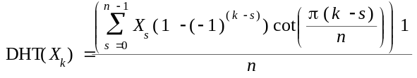
The other definition by [37] uses the convolution:
(10.1.2a) 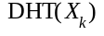 = X[] * h[] = 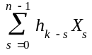
(10.1.2b) 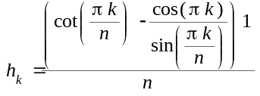
The important issue is that the DHT is closely related to the discrete Fourier transform (DFT). For a given n-length X vector in order to evaluate the DHT(X) we can hire the DFT routine. To start, we must remember that in the continous case:
(10.1.3)
where:
(10.1.4) 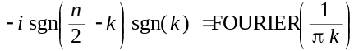
Therefore in the discrete case we find the similar equation to (10.1.3) relating the DHT and DFT:
(10.1.5) 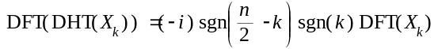
From the equation (10.1.5) we can see, that it is quite easy to operate within the Fourier/frequency domain - because the quite complicate convolution is transformed to a simple algebraic operations. Also - if we have the quick algorithm to perform both the DFT and inverse-DFT - for example with the fast Fourier transform (FFT) and the inverse fast Fourier transform (IFFT) - the DHT operation will be calculated as follows:
(10.1.6) 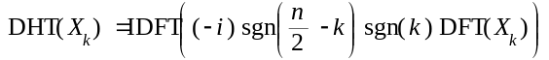
The fundamentals of the discrete Hilbert transform and its relation with the discrete Fourier transform

Fast Hilbert transform routine - short tutorial:
While the hired DFT and IDFT routines are evaluated in complex domain, for a given input n-length X vector we have that:
(10.1.7) ->
In order to obtain the final result we need to take the imaginary part of the MATLAB® hilbert() function output. The other important issue is that the MATLAB® hilbert() function has one optional parameter called N - to computer the N-point Hilbert transform. If the input vector X is too short, it will be padded with zeros, otherwise it will be truncated.
The short tutorial MATLAB m-file with examples and more practical explanation has been presented in the Appendix B.2
The short tutorial overview on the MATLAB® hilbert() function usage.
Overview of the method using MATLAB ® interior functions

10.2 MIF for simple linear model
Text and graphs here....
Example cases for solving the Kramers-Kronig relations in linear model using MIF - with short conclusions

10.3 MIF for simple nonlinear model
Text and graphs here....
Example cases for solving the Kramers-Kronig relations in simple nonlinear model using MIF - with short conclusions

10.4 MIF for simple quantum-perturbative model
Text and graphs here....
Example cases for solving the Kramers-Kronig relations in simple quantum-perturbative model using MIF - with short conclusions

10.5 MIF for other models
Text and graphs here....
Example cases for solving the Kramers-Kronig relations for other models using MIF - with short conclusions

11. General comparison of used numerical methods (understanding)

HTRAN conclusions:
HTRAN method is fast (it employs the full-vector calculation at once) but for most cases is very inaccurate

Newton-Cotes method conclusions:
Newton-Cotes method is extremely time demanding (it takes more than 10 minutes for one model even if we require small tolerance), because it employs the new quadrature routine for each calculation point, as it is the method close to analytical (without any full-vector manipulations).

Comparison:
We can divide methods in two groups.
In the first group numerical methods works on the full vectors and are not so accurate, but very useful for the multidimensional calculations.
In the second group numerical methods works on points, these methods are more accurate and better for one-dimensional evaluation, but may be sometimes time demanding.
Nice charts of numerical comparisons here :)

12. Conclusion (understanding)

12.1 Model conclusion
We have presented both the linear and nonlinear model with comments that arise from the literature. The main question remains - what is the true and valid model for describing the interaction of finite amount of photons with chemical molecules

1. Kramers-Kronig relations in general are false - because they assume that imaginary part must be an odd function and the real part must be an even function. We state, that only in general case - we can talk about the conjugate integral pairs, so the real and imaginary part are connected with Hilbert (not with the K-K) transform.

2. Only linear model - we can assume the even/odd properties being 100% sure.

3. The Lorentz/Gauss discussion

4. Response discussion, relaxation time, extended causality principle, multistep multiphoton absorption
Final discussion about the used models

12.2 Numerical conclusion
We have presented several methods and the comparison of their accuracy, convergency and speed. Which method is the best and why?

1. The FFT-based algorithms cannot be used as-they-are, we need to estimate of the left and right

2. Final discussion about the used numerical methods and their accuracy.

12.3 Z-scan technique conclusion
The Z-scan experiment was the most important motivation for this thesis to be written. It is of course one of many experimental setups in nonlinear optics - but the questions are:
- how both the experimental and numerical accuracy influence on the final results
- how to avoid this problems in the z-scan experiment?

1. We need to correct the error bars
2. We should try to somehow geometrically orient all investigated molecules within a sample (some outer electromagnetic field) to check any susceptibility tensor element - not only to make the so-called averaging, which may lead to not a complete perspective
3. We should correct the data collection in relation to laser instability.
4. We should establish an numerically proper algorithm to some advanced fitting with valid models in complex domain.
5. Maybe it will be possible to combine the Z-scan technique with the pump-and-probe approach?
Final discussion for the building better z-scan experiment (Z-scan 2.0 ? :))

12.4 General conclusion
1. This thesis in only an introduction into an important, but hard interdisciplinary problem concerning the investigation of light and matter interaction in area of nonlinear optics.
2. This topic should be continued and the cooperation between various disciplines is the key role to solve many questions state by nowadays nonlinear optics scientists - so the strong mathematical, numerical, chemical and quantum-mechanical background skills are together required, one person is unable to have it all, so a team should be created (here in Wroclaw).
"A major challenge for researchers working in a multidisciplinary area is the need to learn relevant concepts outside of their expertise. This may require searching through a vast amount of literature, often leading to frustrations of not being able to extract pertinent information quickly. "- P. Prasad [19]
3. We can find many papers in area of Kramers-Kronig for nonlinear optics, but in my opinion - in case of nonlinear optics many of them are false and not properly argued, with wrong or improper mathematical assumptions, numerical errors and sometimes even the tendentious optimism and non- skepticism, which - especially in area of modern physics - is ununderstandable.
4. We are all in a long run for a Nobel Prize :) It's a huge motivation :)
Strong words to motivate new scientific generations :)

12.5 Further questions and research direction
1. Why do we use and when can we use the Fourier transform when translating between the time-domain and the frequency domain.
2. As the linear model in optical research is quite well described, we need to prepare tools for the nonlinear calculations, which involves operating
on the 2-Dimensional data sets. There are algorithms like 2D-FFT, 2D-FHT, maybe there also can be an algorithm for 2D-hilbert transform as described in (2.4.4a-b).
3. And how with higher dimensional data (f.e. third-order or fifth-order nonlinear phenomena)?
4. We need to make a further research on the topic of the harmonic analysis and Fourier analysis and its application to the spectral analysis.
Can we build a model of an optimal molecule for (all-optical-switching) without doing experiments first, or create a class of molecules that we should be interested in?

13. Acknowledgements
Text here...
Final acknowledgements

14. Published Results
K. Parjaszewski, M. Samoć, "Understanding the Kramers-Kronig relations in nonlinear optics", PANIC 2010 Conference, Wroclaw University of Technology

K. Parjaszewski, M. Samoć,"Understanding and solving the Kramers-Kronig relations in nonlinear optics", PANIC 2011 Conference, Wroclaw University of Technology

M. Nyk, D. Wawrzyńczyk, K. Parjaszewski and M. Samoć, "Spectrally Resolved Nonlinear Optical Response of Up-conversion Lanthanide-Doped NaYF4 Nanoparticles", J. Phys. Chem. C, prov. accepted

M. Samoć, K. Matczyszyn, M. Nyk, J. Olesiak-Bańska, J. Szeremeta, L. Mazur, D. Wawrzyńczyk, P. Hańczyc, M. Wielgus, K. Parjaszewski, M. Gordel, R. Kołkowski, "Z-scan with a tunable femtosecond laser: what we can learn", abstract submitted

15. References
[1] G. Tsigaridas, M. Fakis, I. Polyzos, P. Persephonis and V. Giannetas, "Z-scan technique through beam radius measurements", Applied Physics B: Lasers and Optics
Volume 76, Number 1, 83-86, DOI: 10.1007/s00340-002-1067-5
[2] Robert W. Boyd, "Nonlinear Optics, Third Edition", Academic Press, Elsevier, March 2008, ISBN: 978-0-12-369470-6
[3] Marek Samoc, "Third-order nonlinear optical materials: practical issues and theoretical challenges", Journal of Molecular Modeling, DOI: 10.1007/s00894-010-0856-8
[4] Marek Samoc, A. Samoc, B. Luther-Davies, M. G. Humphrey, M. P. Cifuentes, "Nonlinear absorption: materials and mechanisms", Proceedings of the Symposium on Photonics Technologies for 7th Framework Program Wroclaw (2006), Issue: October, Pages: 12–14, ISBN: 83-7085-970-4
[5] Robert W Boyd, John E Sipe, Peter W Milonni, "Chirality and polarization effects in nonlinear optics", 2004 J. Opt. A: Pure Appl. Opt. 6 S14 DOI: 10.1088/1464-4258/6/3/002
[6] A. Novák - "Identification of Nonlinear Systems: Volterra Series Simplification", Acta Polytechnica Vol. 47 No. 4–5/2007
[7] S. T. Chui and Hong-ru Ma - "Local-field correction for nonlinear optical coefficients", Phys. Rev. B 47, 6293–6298 (1993), DOI: 10.1103/PhysRevB.47.6293
[8] Paras N. Prasad, David J. Williams - "Introduction to Nonlinear Optical Effects in Molecules and Polymers" ISBN: 978-0-471-51562-3
[9] M. D. Levenson* and N. Bloembergen - "Dispersion of the nonlinear optical susceptibility tensor in centrosymmetric media", Phys. Rev. B 10, 4447–4463 (1974) DOI: 10.1103/PhysRevB.10.4447
[10] Frank Träger, "Springer Handbook of Lasers and Optics", Springer 2007, ISBN: 0387955798, partially available on Google Books service: http://www.google.com/books?id=YOHJGz-9UNoC
[11] Nicolaas Bloembergen (Nobel Prize for Physics (1981)) - "Nonlinear optics - 4th Edition" - Singapore, World Scientific, 1996, ISBN: 981-02-2599-7 (pbk), partially available on the Google Books service: http://www.google.com/books?id=VdwBT13l05EC
[12] Yitzhak Katznelson, "An introduction to harmonic analysis - third edition" - Cambridge Unviversity Press, 2004, ISBN: 0-521-54359-2 (pbk), partially available on the Google Book servise: http://www.google.com/books?id=gkpUE_m5vvsC
[13] Palffy-Muhoray, Course materials for LC Optics and Photonics, CPHY 6/74495, Spring, 2011, website: http://mpalffy.lci.kent.edu/Optics/
[14] Valerio Lucarini, Jarkko J. Saarinen, Kai-Erik Peiponen, and Erik M. Vartiainen (2005), "Kramers-Kronig relations in Optical Materials Research", Heidelberg: Springer. ISBN 3-540-23673-2.
[15] Edward Charles Titchmarsh, "Introduction to the theory of Fourier integrals - second edition", Oxford at the Clarendon Press, 1948
[16] H. N. Yum, M. S. Shahriar, "Pump–probe model for the Kramers–Kronig relations in a laser", J. Opt. 12 (2010) 104018 (6pp), DOI:10.1088/2040-8978/12/10/104018
[17] H. Tuononen, E. Gornov, J. A. Zeitler, J. Aaltonen, and K.-E. Peiponen, "Using modified Kramers-Kronig relations to test transmission spectra of porous media in THz-TDS", Optics Letters, Vol. 35, Issue 5, pp. 631-633 (2010), DOI:10.1364/OL.35.000631
[18] I. J. Weinberg, "Hilbert transform by numerical integration", In-House Report, January 1979, Rome Air Development Center, United States Air Force Hanscom AFB, Mass. 01731, Report number: RADC-TR-79-3
[19] Paras Prasad, "Nanophotonics", John Wiley & Sons, 2004, ISBN 0-471-64988-0 (cloth)
[20] Demetrios N. Christodoulides, Iam Choon Khoo, Gregory J. Salamo, George I. Stegeman, and Eric W. Van Stryland, "Nonlinear refraction and absorption: mechanisms and magnitudes", Advances in Optics and Photonics 2, 60–200 (2010) DOI:10.1364/AOP.2.000060
[21] Mark G. Kuzyk et al., "Nonlinear Optics", course book from July, 2010, Pullman, WA
[22] D. C. Hutchings, M. Sheik-Bahae, D. J. Hagan, E. W. Van Stryland, Tutorial review, "Kramers-Kronig relations in nonlinear optics", Optical and Quantum Electronics 24 (1992) 1-3
[23] Newport Corporation, Spectra-Physics divistion, Irvine, California, "Application Note 34, Z-Scan for the Characterization of Transparent Optical Materials"
[24] Mansoor Sheik-Bahae, Ali A. Said, Tai-Huei Wei, David J. Hagan, E. W. Van Stryland, "Sensitive measurement of optical nonlinearities using a single beam", IEEE Journal of Quantum Electronics. Vol. 26. no.4., April 1990
[25] C. W. Clenshaw, A.R. Curtis, "A method for numerical integration on an automatic computer", Numerische Mathematik, 2, 197-205 (1960)
[26] Soo-Chang Pei, Sy-Been Jaw, "Computation of Discrete Hilbert Transform through Fast Hartley Transform", IEEE Transactions on Circuits and Systems, Sep 1989, 36 Issue: 9, (1251 - 1252), DOI:10.1109/31.34675
[27] Ronald F. Ullmann, "An algorithm for the Fast Hartley Transform", University of Stanford, Stanford Exploration Project, SEP-38(29), 1984, URL: http://sepwww.stanford.edu/theses/sep38/38_29.pdf
[28] James W. Cooley, John W. Tukey, "An algorithm for the machine calculation of complex Fourier series", Mathematics of Computation 19, 297–301 (1965), DOI: 10.2307/2003354
[29] I. J. Good, "The interaction algorithm and practical Fourier analysis". J. R. Statist. Soc. B 20 (2): 361–372. 1958).JSTOR 2983896. Addendum, ibid. 22 (2), 373-375 (1960) JSTOR 2984108
[30] Leo I. Bluestein, "A linear filtering approach to the computation of the discrete Fourier transform", Northeast Electronics Research and Engineering Meeting Record 10, 218-219 (1968)
[31] Georg Bruun, "Z-Transform DFT filters and FFTs" IEEE Trans. on Acoustics, Speech and Signal Processing (ASSP) 26 (1), 56-63 (1978)
[32] C. M. Rader, "Discrete Fourier transforms when the number of data samples is prime", Proc. IEEE 56, 1107–1108 (1968)
[33] M. Lamb, "Some issues when using Fourier analysis for the extraction of modal parameters", 2009 J. Phys.: Conf. Ser. 181 012007, DOI:10.1088/1742-6596/181/1/012007
[34] Mathias Johansson, "The Hilbert transform", Master Thesis, Växjö University, 1999
[35] Stefan L. Hahn, "Hilbert Transforms in Signal Processing", Boston, 1996, ISBN: 978-0890068861
[36] Lawrence F. Shampine, "Vectorized Adaptive Quadrature in MATLAB", Mathematics Department, Southern Methodist University, Dallas, TX 75275, U.S.A. DOI: 10.1016/j.cam.2006.11.021
[37] D. Calvetti, G. H. Golub, W. B. Gragg, L. Reichel, "Computation of Gauss-Kronrod quadrature rules", Journal: Math. Comp. 69 (2000), 1035-1052
[38] David Kahaner, Cleve Moler, Stephen Nash, "Numerical Methods and Software", Prentice Hall (November 1988), Computer methods for mathematical computations, ISBN: 978-0136272588
[39] Subhash Kak, "The discrete finite Hilbert transform", Indian Journal Pure and Applied Mathematics 8, 1385-1390, 1977
[40-100] Nice positions here...

Appendix

A - Source codes of prepared algorithms in MATLAB using the Maple Toolbox

A.1 HTRAN quadrature
function [F,Orig,HT] = htran(F,R)
%% This algorithm is based on the "Hilbert Transform by Numerical
% Integration" by I.J. Weinbert, RADC-TR-79-3, January 1979
% Rome Aire Development Center

% In the original publication there was an typo error - the Hilbert
% transform is not the
% 1/pi*int(u(tau)/(tau-t),tau=-inf..inf)
% but should rather be:
% 1/pi*int(u(tau)/(t-tau),tau=-inf..inf)

% We also do not assume that the input signal R is even or odd - because
% the original Hilbert Transform was prepared for all type of possible
% functions.

%% [Krzysztof Parjaszewski, University of Wroclaw, 20th June 2011]
% As a part of MSc Thesis - "Understanding and solving the
% Kramers-Kronig relations in nonlinear optics"
% krzysztof.parjaszewski@gmail.com

%% INPUT:
% F - an array of points (abscissas)
% R - an array of values (ordinates)

%% OUTPUT:
% F - an array of points * (abscissas)
% Orig - an array of original values * (ordinates)
% HT - an array of Hilbert Transform values * (ordinates)
% * - corrected, so size(F,1) <= size(F,2)

%% Description:
% This is a fast and quite satisfactory algorithm based on the
% assumption that R disappears out of the F region.

% Correcing the input size:
if(size(R,1)>size(R,2)), R=R';end;
if(size(F,1)>size(F,2)), F=F';end;
N = size(R,2);

% Calculating the F middlepoint array:
Fp(1,1:N-1) = 0.5 .* (F(1,1:N-1)+F(1,2:N));
step = F(2)-F(1);

% Build h array (step array for faster calculation):
h(1) = step/3;
h(1,2:N-1) = 2.*step./3 + mod(1:N-2,2).*2.*step./3;
h(N) = step/3;
if (mod(N,2)==1), h(N-1) = 5*step/6; h(N) = step/2; end;

% Cubic interpolation for the interior values and parabolic interpolation for the end values we obtain
% new set of ordinates, to omit the singularity:
Rp(1) = 0.375*R(1) + 0.75*R(2) - 0.125*R(3);
Rp(1,N-1) = -0.125*R(1,N-2) + 0.75*R(1,N-1) + 0.375*R(1,N);
Rp(1,2:N-2) = -0.0625*R(1,1:N-3)+0.5625*R(1,2:N-2)+0.5625*R(1,3:N-1)-0.0625*R(1,4:N);

% Build Yp array - the heart and first step in integration:
Yp = zeros(1,N-1);
for i=1:N-1, Yp(i) = sum(h.*(R-Rp(i))./(Fp(i)-F)); end;

% Build Xp array - the second step in integrati on:
Xp = Rp./pi .* (log(F(1)-Fp)-log(F(N)-Fp)) + 1./pi.*Yp;

% Build Xres array - translating the Xp array into Xres array (cubic
% interpolation, as previous) - but this time Xp is smaller than Xres:
Xres(1) = 1.875 *Xp(1) - 1.25 *Xp(2) + 0.375 *Xp(3);
Xres(1,2) = 0.375 *Xp(1) + 0.75 *Xp(2) - 0.125 *Xp(3);
Xres(1,3:N-2) = -0.0625*Xp(1,1:N-4) + 0.5625*Xp(1,2:N-3) + 0.5625*Xp(1,3:N-2) - 0.0625*Xp(1,4:N-1);
Xres(1,N-1) = -0.125 *Xp(1,N-3) + 0.75 *Xp(1,N-2) + 0.375 *Xp(1,N-1);
Xres(1,N) = 0.375 *Xp(1,N-3) - 1.25 *Xp(1,N-2) + 1.875 *Xp(1,N-1);

% We take the real/imag separately:
Orig = imag(Xres);
HT = real(Xres);
end

A.2 Newton-Cotes quadrature of an arbitrary degree
function [F,H] = hncX(fun,a,b,tol,n,cs,pts)
%% This algorithm is a simple implementation of the Hilbert transform based on the Newton-Cotes quadrature
%% of an arbitrary degree with getting close, but just omitting the singularity

%% [Krzysztof Parjaszewski, University of Wroclaw, July 2011]
% As a part of MSc Thesis - "Numerical evaluation of the Hilbert transform used to
% better understand and solve the Kramers-Kronig relations in nonlinear optics"
% krzysztof.parjaszewski@gmail.com

%% INPUT:
% fun - the real-valued function we will like to integrate (function-handle)
% a - integration starting point
% b - integration ending point
% tol - required tolerance
% n - degree of the Newton-Cotes quadrature
% cs - how close (in absolute value) we would like to get near the singularity
% pts - number of points in which user would like to perform the Hilbert transform

%% OUTPUT:
% F - an array of points (abscissas)
% H - calculated Hilbert transform values (ordinates)

%% Description:
% A simple algorithm of Newton-Cotes is presented.
% We do not like to use Newton-Cotes of much higher degree, instead we use the
% complex quadrature of lower degree for many small steps

% Preparation of arguments
if nargin < 3, error('QUADNCX:ParamErr', 'Wrong number of parameter given: fun, a ,b are mandatory'); end;
if nargin < 4, tol = 10^(-5); end;
if nargin < 5, n = 8; end;
if nargin < 6, cs = 0.01; end;
if nargin < 7, pts = 200; end;

% We would like to integrate within 5 times bigger region
aMax = a - 4*abs(a); bMax = b+4*abs(b);
F = linspace(a,b,pts);
H = zeros(1,pts);

% Not to make user wait too long, we are showing the waitbar
hBar=waitbar(0,'Please Wait');

% The main hilbert transform loop
for k=1:pts
waitbar(k/pts);
innerfun = @(x) fun(x)./(x-(F(k)));
H(k) = quadncX(@(x)innerfun(x),aMax,F(k)-cs,tol,n) + quadncX(@(x)innerfun(x),F(k)+cs,bMax,tol,n);
end
% finally we are closing the waitbar
close(hBar);

H = H/pi;
end

function res = quadncX(fun,a,b,tol,n)
% While this method does not shows very good accuraccy, a set of
% arbitrary set parameters has been prepared, but they may be changed
% in case of different quadratures.
nosteps = 100; maxNoSteps = 100000;
iterates = 1; maxIterate = 10000;
M = 1.1;
tab = prevaluateNCTab(n,a,b);

while (iterates < maxIterate);
nStep = ceil(nosteps * M);
step1 = doStep(fun,a,b,nosteps,tab);
step2 = doStep(fun,a,b,nStep,tab);
res = (4*step2-step1)/3;
err = abs(step1-res);
if (err<tol), break;
else nosteps = nStep; M = M*1.3;
end;
if (nosteps >=maxNoSteps), break; end;
end

if (iterates >= maxIterate), warning('QUADNCX:MaxIterReached', 'maximum number of iterations reached - the integral seems to be singular');
elseif (nosteps >=maxNoSteps), warning('QUADNCX:MaNoSteps', 'maximum number of steps reached - the integral seems to be singular');
end;
end

function tab = prevaluateNCTab(n,a,b)
% The table of NC coefficient is calculated using Maple:
% Digits:=100;n:=(n);evalf(seq(1/n*(-1)^(n-k)*1/(factorial(k)*factorial(n-k))*int(product(t-j,j=0..n)/(t-k),t=0..n),k=0..n));
maplestr = ['Digits:=40:n:=' num2str(n) ':tab:=evalf(seq(((' num2str(b) ')-(' num2str(a) '))/n*(-1)^(n-k)*1/(factorial(k)*factorial(n-k))*int(product(t-jj,jj=0..n)/(t-k),t=0..n),k=0..n));'];
maple string;
tab = str2num(maple(maplestr))'; %#ok<ST2NM>
end

function res = doStep(fun,a,b,nosteps,tab)
% A simple numerical quadrature for already calculated coefficients if
% performed
nc = size(tab,1);
intervals = linspace(a,b,nosteps);

% Quadrature is divided into small steps
M = zeros(nc,nosteps-1);
M(1,:) = intervals(1:nosteps-1);
M(nc,:) = intervals(2:nosteps);
h = (M(nc,:) - M(1,:))./nc;

% Final calculation in two lines
for k=2:(nc-1), M(k,:) = M(1,:) + (k-1).*h; end;
res = sum(fun(M') * tab)/nosteps;
end

A.3 Clenshaw-Curtis quadrature
function H = htrancc(fun,X,tol)
%% Description:
% Hilbert transform based on the Clenshaw-Curtis quadrature modified
% to work on infinite integral which is used in the Hilbert transform formula

%% INPUT:
% fun - an function_handle (function-handle)
% X - regime of abscissas to operate with (abscissas)
% tol - deserved tolerance (scalar)

%% OUTPUT:
% H - the Hilbert transform on the desired regime (ordinates)

%% Author info:
% [Krzysztof Parjaszewski, University of Wroclaw, July 2011]
% As a part of MSc Thesis - "Numerical evaluation of the Hilbert transform used to
% better understand and solve the Kramers-Kronig relations in nonlinear optics"
% krzysztof.parjaszewski@gmail.com

%% The algorithm:

% We set the default tolerance if not given:
if nargin<3,tol=10^(-3); end;

a = min(X);b=max(X); NX = max(size(X));
Hh = zeros(1,NX-1); Y = linspace(a,b,NX-1);

% Cubic interpolation rutine (N->N-1 points):
Yp(1) = 0.375*Y(1) + 0.75*Y(2) - 0.125*Y(3);
Yp(1,NX-1) = -0.125*Y(1,NX-3) + 0.75*Y(1,NX-2) + 0.375*Y(1,NX-1);
Yp(1,2:NX-3) = -0.0625*Y(1,1:NX-4)+0.5625*Y(1,2:NX-3)+0.5625*Y(1,3:NX-2)-0.0625*Y(1,4:NX-1);

% Main application loop with the waitbar:
h = waitbar(0,'Please wait','Name','Hilbert Transform with Clenshaw-Curtis');
for n = 1:1:NX-1
Hh(n) = hcc(fun,Yp(n), tol);
waitbar(n/(NX-1),h,'Please wait');
end;
close(h);

% Reverce cubic interpolation rutine (N-1->N points):
H = zeros(1,NX);
H(1) = 1.875 *Hh(1) - 1.25 *Hh(2) + 0.375 *Hh(3);
H(1,2) = 0.375 *Hh(1) + 0.75 *Hh(2) - 0.125 *Hh(3);
H(1,3:NX-2) = -0.0625*Hh(1,1:NX-4) + 0.5625*Hh(1,2:NX-3) + 0.5625*Hh(1,3:NX-2) - 0.0625*Hh(1,4:NX-1);
H(1,NX-1) = -0.125 *Hh(1,NX-3) + 0.75 *Hh(1,NX-2) + 0.375 *Hh(1,NX-1);
H(1,NX) = 0.375 *Hh(1,NX-3) - 1.25 *Hh(1,NX-2) + 1.875 *Hh(1,NX-1);

end

function h = hcc(fun, y, tol)
%% Hilbert transform using the Clenshaw-Curtis quadrature

%% INPUT:
% fun - an function_handle (function-handle)
% y - abscissa to operate with (scalar)
% tol - deserved tolerance (scalar)

%% OUTPUT:
% h - the Hilbert transform in the desired point (scalar)

% We need to change variable in the infinite integration x =
% t/(1-t.^2) and we assume limit(fun(t)/t)=0 for +-infinity as should
% be in Hilbert transform
ccFun = @(t) (abs(t)<1.*fun(t./(1-t.^2)).*(1+t.^2)./((t.^2-1).*(t+y.*t.^2-y)));

% We set N to the initial value:
N = 8; lastVal = 0;
while (true)
h = 1/pi*docc(ccFun,N);

% A simple adaptive method - if the relative error is to large - we
% double the points count:
if (abs(lastVal-h)/(abs(h)+tol)<tol),break; end;
N = N*2;
lastVal = h;
end
end
function val = docc(fun, N)
%% Description:
% This is one point algorithm and should be used in algorithms that
% need to determine the full vector values
% Look precisely:
% abcde -> abcdedcb ( there is no second 'a' )

%% INPUT:
% fun - an function_handle
% N - number of points to further operate with tolerance (default value = 256)

%% OUTPUT:
% val - value of integral

%% Based on:
% 1. http://fourier.eng.hmc.edu/e161/lectures/dct/node2.html
% (unfortunatelly this is DCT-II, so another type)
% 2. http://en.wikipedia.org/wiki/Clenshaw–Curtis_quadrature
% The very important quote:
% "For example, a DCT-I of N=5 real numbers abcde is exactly equivalent
% to a DFT of eight real numbers abcdedcb (even symmetry), divided by
% two."

%% Author info:
% [Krzysztof Parjaszewski, University of Wroclaw, July 2011]
% As a part of MSc Thesis - "Numerical evaluation of the Hilbert transform used to
% better understand and solve the Kramers-Kronig relations in nonlinear optics"
% krzysztof.parjaszewski@gmail.com

%% The algorithm:
if nargin<2,N=256;end;

N2 = N/2; % We make this division once, for faster computation
ps = 0:1:N2; % Array of N/2+1 points (where N2 = N/2)
xn = cos(ps.*pi./N); % N2+1 abscissaas from the 0..pi range
yn = fun(xn) + fun(-xn); % N2+1 ordinates for fun(cos(n*pi/N))
yn(isnan(yn)) = 0; % We shall set all NaNs to zero
g = real(fft(yn(1+[0:N2 (N2-1):-1:1])))./2; % Look at quote in the header
cn = [g(1), g(2:N2)+g(N:-1:N2+2), g(N2+1)]; % We take symmetrical values and add them together (ommiting first and last)
dn = [2, 2./(1-(2.*(1:1:(N2-1))).^2), 2./(1-N^2)]; % This is the final vector for multiplying
val = (dn * cn' )/ N; % Final cc integral calculation
end

A.4 Discrete Hartley transform based on the fast Hartley transform:
function HY = hfthilbert(Y)
%% Description:
% This is a standard and efficient algorithm ferforming the discrete
% Hilbert transform based on two discrete Hartley transforms in O(n log
% n) with zero padding

%% INPUT:
% Y - an discrete array of values (ordinates)

%% OUTPUT:
% HY - an array of Hilbert Transform values * (ordinates)

%% Based on:
% 1. Soo-Chang Pei and Sy-Been Jaw - "Computation of Discrete Hilbert
% Transform through Fast Hartley Transform"
% 2. http://en.wikipedia.org/wiki/Discrete_Hartley_transform

%% Author info:
% [Krzysztof Parjaszewski, University of Wroclaw, July 2011]
% As a part of MSc Thesis - "Numerical evaluation of the Hilbert transform used to
% better understand and solve the Kramers-Kronig relations in nonlinear optics"
% krzysztof.parjaszewski@gmail.com

%% The algorithm:

% We perform the zero padding to the next power-of-two length
N = max(size(Y));
M = 2 ^ ceil(log2(N));
Y = [Y,zeros(1,M-N)];

% Discrete Hartley transform boosted-up to O(n log n)
HF = fht(Y);

% Defining the HH vector
O1 = ones(1,floor(M/2)-1);O2 = -ones(1,ceil(M/2)-1);HH = [0, O1, 0, O2];

% Defining the time reversal of HF
TRHF = HF([1, M:-1:2]);

% Based on the convolution theorem we get the Hartley-Hilbert transform
% of X, so in the last step we need to perform the inverse Hartley
% transform
IHX = TRHF .* HH;

% Inverse Hartley transform boosted-up to O(n log n)
HY = 1/M .* fht(IHX);

% The final output ve
HY = HY(1:N);
end

function res = fht(X)
%% Description:
% Fast Hartley Transform algorithm.This algorithm is faster than simple FFT because it works only in
% real domain, which involves half the number of multiplications

%% INPUT:
% X - an discrete array of values (ordinates)

%% OUTPUT:
% HY - an array of Discrete Hartley Transform values * (ordinates)

%% Based on:
% 1. Ronald F. Ullman - "An algorithm for the Fast Hartley Transform"
% 2. Krzysztof Loryś - polish notes to the lecture of "Algorithms and
% Data Structures" held in the Institute of Computer Science,
% University of Wroclaw

%% Author info:
% [Krzysztof Parjaszewski, University of Wroclaw, July 2011]
% As a part of MSc Thesis - "Numerical evaluation of the Hilbert transform used to
% better understand and solve the Kramers-Kronig relations in nonlinear optics"
% krzysztof.parjaszewski@gmail.com

%% The algorithm:
N = length(X);

% We precalculate the CAS table for vectors of length less or equal 8:
CAS = cell(8);
CAS{1} = cas(0);
for k=2:8, CAS{k} = cas(2*pi*((0:(k-1))'*(0:(k-1)))/k); end

% Now we are sure, that X vector is of size M which is a power value of 2.
DHT = dofht(X,N,CAS);

% The final vector must be truncated because it was arbitrary enlarged
% to be with length of power of two
res = DHT(1:N);
end

function HY = dofht(X,N,CAS)
%% Recursive, divide & conquer radix-2 Fast Hartley Transform

%% INPUT:
% X - an discrete array of values (ordinates)
% D - the length of X vector
% CAS - the precalculated cell of 1:8-8 matrix for performing the instant FHT

%% OUTPUT:
% HY - an array of Discrete Hartley Transform values * (ordinates)

% Fast Hartley Trasform for N lower than 8
if N<=8,
HY=X * CAS{N} ; % Instant FHT for 8-element array
return;
end;
% We split the input vector into two equal vectors
X1 = X(1:2:end); X2 = X(2:2:end); % In MATLAB first index equals 1, not 0 - but in literature X1 is called even, X2 - odd indices.

% Divide & conquer approach
HT1 = dofht(X1,N/2,CAS);
HT2 = dofht(X2,N/2,CAS);

% We precalculate the lower and upper part of the output array
low = 1:1:N/2;
revlow = [1, N/2:-1:2];
arg = (2*pi/N).*(low-1);
CS = cos(arg) .* HT2(low) + sin(arg) .* HT2(revlow);
H = HT1(low);

% The lower and upper part of DHT is combined with the following
% radix-2 way
HY = [H + CS, H - CS];
end

function res = cas(X), res = cos(X) + sin(X); end

A.5 Hilbert transform based on the orthonormal Hermite functions:
function [YH, YFun] = herhtrans(fun, X, tol, maxN)
%% Description:
% This is a hilbert transform function based on the orthonormal Hermite polynomials
% and Hermite functions. They have been previously precalculated with
% MATLAB-Maple toolbox

%% INPUT:
% fun - an discrete array of values (function handle)
% X (abscissas)
% tol (scalar)
% maxN (scalar)

%% OUTPUT:
% HY - an array of Hilbert Transform values * (ordinates)
% YFun -

%% Based on:
% 1. M. Johansson - "The Hilbert transform"
% 2. http://en.wikipedia.org/wiki/Hermite_polynomial
% 3. http://en.wikipedia.org/wiki/Hilbert_transform

%% Author info:
% [Krzysztof Parjaszewski, University of Wroclaw, July 2011]
% As a part of MSc Thesis - "Numerical evaluation of the Hilbert transform used to
% better understand and solve the Kramers-Kronig relations in nonlinear optics"
% krzysztof.parjaszewski@gmail.com

%% The algorithm:

if nargin < 3, tol = 10^(-4); end;
if nargin < 4, maxN = 18; end;
% We set the initial multipliers count on 4, but it shall/may rise
MaxN = min(maxN,27);InitN = 4;N = InitN;

sum = 0; val = 0;
% Main loop
i=1; AN = zeros(1,N);
Fval = fun(X);
while (i<=N)
n = i-1; % Select proper Hermite function
AN(i) = getAN(fun,n, tol);
HphiVal = hphin(X,n);
phiVal = phin(X,n);
multiplier = AN(i).*HphiVal;
% figure,plot(X,multiplier),title(num2str(i));display(num2str(AN(i)));
sum = sum + multiplier;
val = val + AN(i).*phiVal;

% If the current multiplier is not negligable - we need to search further
if (i > (N-2)) && (max(abs(val-Fval))>=tol) && (N<MaxN), N = N+1; end;
i = i+1;
end
YH = sum;
YFun = val;
end

function an = getAN(fun, n, tol)
pFun = phiFun(n);
funphi = @(t) (fun(t)).*pFun(t);

% We change the integration range from -inf .. inf to -1 .. 1
ccFun = @(t) ((abs(t)<1).*funphi(-t./(t.^2-1)).*(1+t.^2)./(-1+t.^2).^2);

% Main numerical integration
N = 128;
prev = docc(ccFun, N/2);
while (N < 1024*1024)
an = docc(ccFun, N);
if (abs(an-prev)<tol), break; else N = 2*N; end;
prev = an;
end
end

function PHI = phin(X,n)
% We would not get further than through 30th Hermite function:
if n>30, error('Do you realy mean such large n coefficient? '); end

% We are precomputing the most reduntant element
EXPX = exp(-1./2.*X.^2); EXPX(isnan(EXPX))=0;EXPX(isinf(EXPX))=0;

% Array of precomputed Hermite functions
phi = cell(1,2);
phi{1} = @(t)EXPX./pi.^(1./4);
phi{2} = @(t)EXPX.*t./pi.^(1./4).*2.^(1./2);
phi{3} = @(t)1./2.*EXPX.*(-1+2.*t.^2).*2.^(1./2)./pi.^(1./4);
phi{4} = @(t)1./3.*EXPX.*t.*(-3+2.*t.^2).*3.^(1./2)./pi.^(1./4);
phi{5} = @(t)1./12.*EXPX.*(3-12.*t.^2+4.*t.^4).*6.^(1./2)./pi.^(1./4);
phi{6} = @(t)1./30.*EXPX.*t.*(15-20.*t.^2+4.*t.^4).*15.^(1./2)./pi.^(1./4);
phi{7} = @(t)1./60.*EXPX.*(-15+90.*t.^2-60.*t.^4+8.*t.^6).*5.^(1./2)./pi.^(1./4);
phi{8} = @(t)1./420.*EXPX.*t.*(-105+210.*t.^2-84.*t.^4+8.*t.^6).*70.^(1./2)./pi.^(1./4);
phi{9} = @(t)1./1680.*EXPX.*(105-840.*t.^2+840.*t.^4-224.*t.^6+16.*t.^8).*70.^(1./2)./pi.^(1./4);
phi{10} = @(t)1./2520.*EXPX.*t.*(945-2520.*t.^2+1512.*t.^4-288.*t.^6+16.*t.^8).*35.^(1./2)./pi.^(1./4);
phi{11} = @(t)1./5040.*EXPX.*(-945+9450.*t.^2-12600.*t.^4+5040.*t.^6-720.*t.^8+32.*t.^10).*7.^(1./2)./pi.^(1./4);
phi{12} = @(t)1./55440.*EXPX.*t.*(-10395+34650.*t.^2-27720.*t.^4+7920.*t.^6-880.*t.^8+32.*t.^10).*154.^(1./2)./pi.^(1./4);
phi{13} = @(t)1./332640.*EXPX.*(10395-124740.*t.^2+207900.*t.^4-110880.*t.^6+23760.*t.^8-2112.*t.^10+64.*t.^12).*231.^(1./2)./pi.^(1./4);
phi{14} = @(t)1./4324320.*EXPX.*t.*(135135-540540.*t.^2+540540.*t.^4-205920.*t.^6+34320.*t.^8-2496.*t.^10+64.*t.^12).*6006.^(1./2)./pi.^(1./4);
phi{15} = @(t)1./8648640.*EXPX.*(-135135+1891890.*t.^2-3783780.*t.^4+2522520.*t.^6-720720.*t.^8+96096.*t.^10-5824.*t.^12+128.*t.^14).*858.^(1./2)./pi.^(1./4);
phi{16} = @(t)1./21621600.*EXPX.*t.*(-2027025+9459450.*t.^2-11351340.*t.^4+5405400.*t.^6-1201200.*t.^8+131040.*t.^10-6720.*t.^12+128.*t.^14).*715.^(1./2)./pi.^(1./4);
phi{17} = @(t)1./172972800.*EXPX.*(2027025-32432400.*t.^2+75675600.*t.^4-60540480.*t.^6+21621600.*t.^8-3843840.*t.^10+349440.*t.^12-15360.*t.^14+256.*t.^16).*1430.^(1./2)./pi.^(1./4);
phi{18} = @(t)1./1470268800.*EXPX.*t.*(34459425-183783600.*t.^2+257297040.*t.^4-147026880.*t.^6+40840800.*t.^8-5940480.*t.^10+456960.*t.^12-17408.*t.^14+256.*t.^16).*12155.^(1./2)./pi.^(1./4);
phi{19} = @(t)1./8821612800.*EXPX.*(-34459425+620269650.*t.^2-1654052400.*t.^4+1543782240.*t.^6-661620960.*t.^8+147026880.*t.^10-17821440.*t.^12+1175040.*t.^14-39168.*t.^16+512.*t.^18).*12155.^(1./2)./pi.^(1./4);
phi{20} = @(t)1./167610643200.*EXPX.*t.*(-654729075+3928374450.*t.^2-6285399120.*t.^4+4190266080.*t.^6-1396755360.*t.^8+253955520.*t.^10-26046720.*t.^12+1488384.*t.^14-43776.*t.^16+512.*t.^18).*461890.^(1./2)./pi.^(1./4);
phi{21} = @(t)1./335221286400.*EXPX.*(654729075-13094581500.*t.^2+39283744500.*t.^4-41902660800.*t.^6+20951330400.*t.^8-5587021440.*t.^10+846518400.*t.^12-74419200.*t.^14+3720960.*t.^16-97280.*t.^18+1024.*t.^20).*46189.^(1./2)./pi.^(1./4);
phi{22} = @(t)1./7039647014400.*EXPX.*t.*(13749310575-91662070500.*t.^2+164991726900.*t.^4-125707982400.*t.^6+48886437600.*t.^8-10666131840.*t.^10+1367452800.*t.^12-104186880.*t.^14+4596480.*t.^16-107520.*t.^18+1024.*t.^20).*1939938.^(1./2)./pi.^(1./4);
phi{23} = @(t)1./14079294028800.*EXPX.*(-13749310575+302484832650.*t.^2-1008282775500.*t.^4+1209939330600.*t.^6-691393903200.*t.^8+215100325440.*t.^10-39109150080.*t.^12+4297708800.*t.^14-286513920.*t.^16+11235840.*t.^18-236544.*t.^20+2048.*t.^22).*176358.^(1./2)./pi.^(1./4);
phi{24} = @(t)1./161911881331200.*EXPX.*t.*(-316234143225+2319050383650.*t.^2-4638100767300.*t.^4+3975514943400.*t.^6-1766895530400.*t.^8+449755225920.*t.^10-69193111680.*t.^12+6589820160.*t.^14-387636480.*t.^16+13601280.*t.^18-259072.*t.^20+2048.*t.^22).*2028117.^(1./2)./pi.^(1./4);
phi{25} = @(t)1./647647525324800.*EXPX.*(316234143225-7589619437400.*t.^2+27828604603800.*t.^4-37104806138400.*t.^6+23853089660400.*t.^8-8481098545920.*t.^10+1799020903680.*t.^12-237233525760.*t.^14+19769460480.*t.^16-1033697280.*t.^18+32643072.*t.^20-565248.*t.^22+4096.*t.^24).*676039.^(1./2)./pi.^(1./4);
phi{26} = @(t)1./3238237626624000.*EXPX.*t.*(-19275223968000.*t.^10+7905853580625+38860800.*t.^20-614400.*t.^22+139143023019000.*t.^4-395389209600.*t.^14+4096.*t.^24+29072736000.*t.^16-63246828645000.*t.^2-132517164780000.*t.^6+3459655584000.*t.^12+66258582390000.*t.^8-1360128000.*t.^18).*1352078.^(1./2)./pi.^(1./4);
phi{27} = @(t)1./6476475253248000.*EXPX.*(1205906199498000.*t.^6-7905853580625-1285014931200.*t.^16+8192.*t.^26+91852800.*t.^22+344544628428000.*t.^10+205552193096250.*t.^2-83525970528000.*t.^12+83987904000.*t.^18-3536332800.*t.^20-822208772385000.*t.^4-861361571070000.*t.^8-1331200.*t.^24+12850149312000.*t.^14).*104006.^(1./2)./pi.^(1./4);
phi{28} = @(t)1./29144138639616000.*EXPX.*t.*(845700451596000.*t.^10-213458046676875-4546713600.*t.^20+107827200.*t.^22-4439927370879000.*t.^4+23130268761600.*t.^14-1437696.*t.^24-2040906067200.*t.^16+1849969737866250.*t.^2+8192.*t.^26+4651352483778000.*t.^6-173477015712000.*t.^12-2584084713210000.*t.^8+119351232000.*t.^18).*156009.^(1./2)./pi.^(1./4);
phi{29} = @(t)1./116576554558464000.*EXPX.*(-41439322128204000.*t.^6+213458046676875+80955940665600.*t.^16-3096576.*t.^26+16384.*t.^28-11573452800.*t.^22-14470874393976000.*t.^10-5976825306952500.*t.^2+3946602107448000.*t.^12-6349485542400.*t.^18+334183449600.*t.^20+25899576330127500.*t.^4+32559467386446000.*t.^8+251596800.*t.^24-693908062848000.*t.^14).*44574.^(1./2)./pi.^(1./4);
phi{30} = @(t)1./1690360041097728000.*EXPX.*t.*(-38150487038664000.*t.^10+6190283353629375+461491430400.*t.^20-14592614400.*t.^22+150217542714739500.*t.^4-1341555588172800.*t.^14+291852288.*t.^24+138101310547200.*t.^16-57775977967207500.*t.^2-3325952.*t.^26-171677191673988000.*t.^6+8803958547384000.*t.^12+16384.*t.^28+104913839356326000.*t.^8-9691320038400.*t.^18).*646323.^(1./2)./pi.^(1./4);
phi{31} = @(t)1./16903600410977280000.*EXPX.*(1502175427147395000.*t.^6-6190283353629375-5030833455648000.*t.^16+673505280.*t.^26-7127040.*t.^28+1258612992000.*t.^22+629483036137956000.*t.^10+185708500608881250.*t.^2-190752435193320000.*t.^12+460337701824000.*t.^18-29073960115200.*t.^20-866639669508112500.*t.^4-1287578937554910000.*t.^8-36481536000.*t.^24+37731250917360000.*t.^14+32768.*t.^30).*1077205.^(1./2)./pi.^(1./4);

% We are selecting the current n Hermite function (with indexing shifted by one):
funChoosen = phi{n+1};

% Main calculation - may be very long:
PHI = funChoosen(X); PHI(isnan(PHI))=0; PHI(isinf(PHI))=0;
end

function HPHI = hphin(X,n)
if n>26, error('Do you realy mean such large n coefficient? '); end

% We are precomputing the most reduntant element
EXPX = exp(-1./2.*X.^2).*erfz(1./2.*1i.*X.*2.^(1./2)); EXPX(isnan(EXPX))=0;EXPX(isinf(EXPX))=0;

% Cell Array of precomputed functions
hphin = cell(1,21);
hphin{1} = @(t) -1i./pi.^(1./4).*EXPX;
hphin{2} = @(t) -1./pi.^(3./4).*(2+t.*pi.^(1./2).*2.^(1./2).*EXPX.*1i);
hphin{3} = @(t) -1./2.*1./pi.^(3./4).*(-1i.*pi.^(1./2).*2.^(1./2).*EXPX+2.*1i.*t.^2.*pi.^(1./2).*2.^(1./2).*EXPX+4.*t);
hphin{4} = @(t) -1./3.*3.^(1./2)./pi.^(3./4).*(-2.^(1./2)-3.*1i.*pi.^(1./2).*t.*EXPX+2.*1i.*pi.^(1./2).*t.^3.*EXPX+2.*2.^(1./2).*t.^2);
hphin{5} = @(t) -1./12.*3.^(1./2)./pi.^(3./4).*(3.*1i.*pi.^(1./2).*2.^(1./2).*EXPX+8.*t.^3+4.*1i.*pi.^(1./2).*t.^4.*2.^(1./2).*EXPX-12.*1i.*t.^2.*pi.^(1./2).*2.^(1./2).*EXPX-16.*t);
hphin{6} = @(t) -1./30.*15.^(1./2)./pi.^(3./4).*(7.*2.^(1./2)+4.*1i.*pi.^(1./2).*t.^5.*EXPX+4.*2.^(1./2).*t.^4-16.*2.^(1./2).*t.^2+15.*1i.*pi.^(1./2).*t.*EXPX-20.*1i.*pi.^(1./2).*t.^3.*EXPX);
hphin{7} = @(t) -1./60.*5.^(1./2)./pi.^(3./4).*(-15.*1i.*pi.^(1./2).*EXPX+54.*2.^(1./2).*t-52.*2.^(1./2).*t.^3-60.*1i.*pi.^(1./2).*t.^4.*EXPX+8.*1i.*pi.^(1./2).*t.^6.*EXPX+8.*2.^(1./2).*t.^5+90.*1i.*pi.^(1./2).*t.^2.*EXPX);
hphin{8} = @(t) -1./420.*35.^(1./2)./pi.^(3./4).*(-84.*1i.*pi.^(1./2).*t.^5.*2.^(1./2).*EXPX-152.*t.^4+300.*t.^2+8.*1i.*pi.^(1./2).*t.^7.*2.^(1./2).*EXPX+16.*t.^6+210.*1i.*pi.^(1./2).*t.^3.*2.^(1./2).*EXPX-54-105.*1i.*t.*pi.^(1./2).*2.^(1./2).*EXPX);
hphin{9} = @(t) -1./1680.*35.^(1./2)./pi.^(3./4).*(16.*1i.*pi.^(1./2).*t.^8.*2.^(1./2).*EXPX+840.*1i.*pi.^(1./2).*t.^4.*2.^(1./2).*EXPX+105.*1i.*pi.^(1./2).*2.^(1./2).*EXPX-840.*1i.*t.^2.*pi.^(1./2).*2.^(1./2).*EXPX+32.*t.^7-416.*t.^5-224.*1i.*pi.^(1./2).*t.^6.*2.^(1./2).*EXPX+1328.*t.^3-864.*t);
hphin{10} = @(t) -1./2520.*35.^(1./2)./pi.^(3./4).*(321.*2.^(1./2)-1632.*2.^(1./2).*t.^2+16.*2.^(1./2).*t.^8-2520.*1i.*pi.^(1./2).*t.^3.*EXPX+1272.*2.^(1./2).*t.^4+945.*1i.*pi.^(1./2).*t.*EXPX-288.*1i.*pi.^(1./2).*t.^7.*EXPX-272.*2.^(1./2).*t.^6+16.*1i.*pi.^(1./2).*t.^9.*EXPX+1512.*1i.*pi.^(1./2).*t.^5.*EXPX);
hphin{11} = @(t) -1./5040.*7.^(1./2)./pi.^(3./4).*(-688.*2.^(1./2).*t.^7+5040.*1i.*pi.^(1./2).*t.^6.*EXPX-945.*1i.*pi.^(1./2).*EXPX+32.*1i.*pi.^(1./2).*t.^10.*EXPX+4530.*2.^(1./2).*t-720.*1i.*pi.^(1./2).*t.^8.*EXPX-9240.*2.^(1./2).*t.^3+9450.*1i.*pi.^(1./2).*t.^2.*EXPX+4416.*2.^(1./2).*t.^5-12600.*1i.*pi.^(1./2).*t.^4.*EXPX+32.*2.^(1./2).*t.^9);
hphin{12} = @(t) -1./55440.*77.^(1./2)./pi.^(3./4).*(-27720.*1i.*pi.^(1./2).*t.^5.*2.^(1./2).*EXPX-43920.*t.^4+7920.*1i.*pi.^(1./2).*t.^7.*2.^(1./2).*EXPX+64.*t.^10+14272.*t.^6+41700.*t.^2-880.*1i.*pi.^(1./2).*t.^9.*2.^(1./2).*EXPX-4530+32.*1i.*pi.^(1./2).*t.^11.*2.^(1./2).*EXPX-10395.*1i.*t.*pi.^(1./2).*2.^(1./2).*EXPX-1696.*t.^8+34650.*1i.*pi.^(1./2).*t.^3.*2.^(1./2).*EXPX);
hphin{13} = @(t) -1./332640.*231.^(1./2)./pi.^(3./4).*(10395.*1i.*pi.^(1./2).*EXPX+207900.*1i.*pi.^(1./2).*t.^4.*EXPX-2048.*2.^(1./2).*t.^9+64.*1i.*pi.^(1./2).*t.^12.*EXPX-110880.*1i.*pi.^(1./2).*t.^6.*EXPX+21840.*2.^(1./2).*t.^7+64.*2.^(1./2).*t.^11+143340.*2.^(1./2).*t.^3-124740.*1i.*pi.^(1./2).*t.^2.*EXPX-92496.*2.^(1./2).*t.^5+23760.*1i.*pi.^(1./2).*t.^8.*EXPX-54360.*2.^(1./2).*t-2112.*1i.*pi.^(1./2).*t.^10.*EXPX);
hphin{14} = @(t) -1./4324320.*3003.^(1./2)./pi.^(3./4).*(64.*1i.*pi.^(1./2).*t.^13.*2.^(1./2).*EXPX+75150-2496.*1i.*pi.^(1./2).*t.^11.*2.^(1./2).*EXPX-609120.*t.^2-4864.*t.^10+64032.*t.^8-205920.*1i.*pi.^(1./2).*t.^7.*2.^(1./2).*EXPX+135135.*1i.*t.*pi.^(1./2).*2.^(1./2).*EXPX-540540.*1i.*pi.^(1./2).*t.^3.*2.^(1./2).*EXPX+128.*t.^12+813720.*t.^4+34320.*1i.*pi.^(1./2).*t.^9.*2.^(1./2).*EXPX-356256.*t.^6+540540.*1i.*pi.^(1./2).*t.^5.*2.^(1./2).*EXPX);
hphin{15} = @(t) -1./8648640.*429.^(1./2)./pi.^(3./4).*(-135135.*1i.*pi.^(1./2).*2.^(1./2).*EXPX+2522520.*1i.*pi.^(1./2).*t.^6.*2.^(1./2).*EXPX+181312.*t.^9+1563660.*t-4945080.*t.^3-1280352.*t.^7+4032336.*t.^5+1891890.*1i.*t.^2.*pi.^(1./2).*2.^(1./2).*EXPX-5824.*1i.*pi.^(1./2).*t.^12.*2.^(1./2).*EXPX-11392.*t.^11+128.*1i.*pi.^(1./2).*t.^14.*2.^(1./2).*EXPX-720720.*1i.*pi.^(1./2).*t.^8.*2.^(1./2).*EXPX-3783780.*1i.*pi.^(1./2).*t.^4.*2.^(1./2).*EXPX+256.*t.^13+96096.*1i.*pi.^(1./2).*t.^10.*2.^(1./2).*EXPX);
hphin{16} = @(t) -1./21621600.*715.^(1./2)./pi.^(3./4).*(131040.*1i.*pi.^(1./2).*t.^11.*EXPX-390915.*2.^(1./2)-11351340.*1i.*pi.^(1./2).*t.^5.*EXPX+5405400.*1i.*pi.^(1./2).*t.^7.*EXPX-2027025.*1i.*pi.^(1./2).*t.*EXPX-1201200.*1i.*pi.^(1./2).*t.^9.*EXPX+128.*1i.*pi.^(1./2).*t.^15.*EXPX+9459450.*1i.*pi.^(1./2).*t.^3.*EXPX-8168580.*2.^(1./2).*t.^4-1088400.*2.^(1./2).*t.^8+124704.*2.^(1./2).*t.^10-6720.*1i.*pi.^(1./2).*t.^13.*EXPX+4509960.*2.^(1./2).*t.^6+128.*2.^(1./2).*t.^14-6592.*2.^(1./2).*t.^12+5045670.*2.^(1./2).*t.^2);
hphin{17} = @(t) -1./172972800.*715.^(1./2)./pi.^(3./4).*(-25018560.*t+349440.*1i.*pi.^(1./2).*t.^12.*2.^(1./2).*EXPX+256.*1i.*pi.^(1./2).*t.^16.*2.^(1./2).*EXPX-93159360.*t.^5-32432400.*1i.*t.^2.*pi.^(1./2).*2.^(1./2).*EXPX+94358880.*t.^3-15360.*1i.*pi.^(1./2).*t.^14.*2.^(1./2).*EXPX+669696.*t.^11-60540480.*1i.*pi.^(1./2).*t.^6.*2.^(1./2).*EXPX-3843840.*1i.*pi.^(1./2).*t.^10.*2.^(1./2).*EXPX+75675600.*1i.*pi.^(1./2).*t.^4.*2.^(1./2).*EXPX+21621600.*1i.*pi.^(1./2).*t.^8.*2.^(1./2).*EXPX-7073280.*t.^9-30208.*t.^13+37245120.*t.^7+2027025.*1i.*pi.^(1./2).*2.^(1./2).*EXPX+512.*t.^15);
hphin{18} = @(t) -1./1470268800.*12155.^(1./2)./pi.^(3./4).*(36036960.*2.^(1./2).*t.^8+256.*2.^(1./2).*t.^16-5531904.*2.^(1./2).*t.^10-5940480.*1i.*pi.^(1./2).*t.^11.*EXPX+257297040.*1i.*pi.^(1./2).*t.^5.*EXPX-147026880.*1i.*pi.^(1./2).*t.^7.*EXPX+40840800.*1i.*pi.^(1./2).*t.^9.*EXPX-183783600.*1i.*pi.^(1./2).*t.^3.*EXPX-118739040.*2.^(1./2).*t.^6+8281665.*2.^(1./2)+440320.*2.^(1./2).*t.^12+34459425.*1i.*pi.^(1./2).*t.*EXPX-93240000.*2.^(1./2).*t.^2-17408.*1i.*pi.^(1./2).*t.^15.*EXPX+456960.*1i.*pi.^(1./2).*t.^13.*EXPX+256.*1i.*pi.^(1./2).*t.^17.*EXPX+177876720.*2.^(1./2).*t.^4-17152.*2.^(1./2).*t.^14);
hphin{19} = @(t) -1./8821612800.*12155.^(1./2)./pi.^(3./4).*(512.*2.^(1./2).*t.^17+620269650.*1i.*pi.^(1./2).*t.^2.*EXPX-17821440.*1i.*pi.^(1./2).*t.^12.*EXPX-34459425.*1i.*pi.^(1./2).*EXPX+1543782240.*1i.*pi.^(1./2).*t.^6.*EXPX+512.*1i.*pi.^(1./2).*t.^18.*EXPX+132196800.*2.^(1./2).*t.^9-38656.*2.^(1./2).*t.^15-661620960.*1i.*pi.^(1./2).*t.^8.*EXPX-554061600.*2.^(1./2).*t.^7+147026880.*1i.*pi.^(1./2).*t.^10.*EXPX+1147608000.*2.^(1./2).*t.^5-1654052400.*1i.*pi.^(1./2).*t.^4.*EXPX-988530480.*2.^(1./2).*t.^3+1175040.*1i.*pi.^(1./2).*t.^14.*EXPX-39168.*1i.*pi.^(1./2).*t.^16.*EXPX+229221090.*2.^(1./2).*t-16756224.*2.^(1./2).*t.^11+1137408.*2.^(1./2).*t.^13);
hphin{20} = @(t) -1./167610643200.*230945.^(1./2)./pi.^(3./4).*(-43776.*1i.*pi.^(1./2).*t.^17.*2.^(1./2).*EXPX+253955520.*1i.*pi.^(1./2).*t.^11.*2.^(1./2).*EXPX-26046720.*1i.*pi.^(1./2).*t.^13.*2.^(1./2).*EXPX+512.*1i.*pi.^(1./2).*t.^19.*2.^(1./2).*EXPX+4190266080.*1i.*pi.^(1./2).*t.^7.*2.^(1./2).*EXPX-229221090-2405453760.*t.^8-86528.*t.^16-654729075.*1i.*t.*pi.^(1./2).*2.^(1./2).*EXPX-6285399120.*1i.*pi.^(1./2).*t.^5.*2.^(1./2).*EXPX+6569821440.*t.^6-1396755360.*1i.*pi.^(1./2).*t.^9.*2.^(1./2).*EXPX+463542144.*t.^10-49363968.*t.^12+3815082180.*t.^2-8380622880.*t.^4+1488384.*1i.*pi.^(1./2).*t.^15.*2.^(1./2).*EXPX+2892288.*t.^14+3928374450.*1i.*pi.^(1./2).*t.^3.*2.^(1./2).*EXPX+1024.*t.^18);
hphin{21} = @(t) -1./335221286400.*46189.^(1./2)./pi.^(3./4).*(-96256.*2.^(1./2).*t.^17-4584421800.*2.^(1./2).*t+3626752.*2.^(1./2).*t.^15-70974720.*2.^(1./2).*t.^13+781910400.*2.^(1./2).*t.^11+1024.*1i.*pi.^(1./2).*t.^20.*EXPX+22597161300.*2.^(1./2).*t.^3-13094581500.*1i.*pi.^(1./2).*t.^2.*EXPX+1024.*2.^(1./2).*t.^19+846518400.*1i.*pi.^(1./2).*t.^12.*EXPX+654729075.*1i.*pi.^(1./2).*EXPX+17096991840.*2.^(1./2).*t.^7-41902660800.*1i.*pi.^(1./2).*t.^6.*EXPX-97280.*1i.*pi.^(1./2).*t.^18.*EXPX-30185174880.*2.^(1./2).*t.^5+20951330400.*1i.*pi.^(1./2).*t.^8.*EXPX-5587021440.*1i.*pi.^(1./2).*t.^10.*EXPX+39283744500.*1i.*pi.^(1./2).*t.^4.*EXPX-4917192960.*2.^(1./2).*t.^9-74419200.*1i.*pi.^(1./2).*t.^14.*EXPX+3720960.*1i.*pi.^(1./2).*t.^16.*EXPX);
hphin{22} = @(t) -1./7039647014400.*3.^(1./2).*7.^(1./2).*2.^(1./2).*46189.^(1./2).*(781910400.*2.^(1./2).*t.^12+22597161300.*2.^(1./2).*t.^4+1024.*t.^20.*2.^(1./2)+17096991840.*2.^(1./2).*t.^8-30185174880.*2.^(1./2).*t.^6-4917192960.*2.^(1./2).*t.^10-96256.*t.^18.*2.^(1./2)-4584421800.*2.^(1./2).*t.^2+3626752.*2.^(1./2).*t.^16-70974720.*2.^(1./2).*t.^14-74419200.*1i.*t.^15.*pi.^(1./2).*EXPX-13094581500.*1i.*t.^3.*pi.^(1./2).*EXPX+39283744500.*1i.*t.^5.*pi.^(1./2).*EXPX+654729075.*1i.*t.*pi.^(1./2).*EXPX+846518400.*1i.*t.^13.*pi.^(1./2).*EXPX-97280.*1i.*t.^19.*pi.^(1./2).*EXPX+1024.*1i.*t.^21.*pi.^(1./2).*EXPX-5587021440.*1i.*t.^11.*pi.^(1./2).*EXPX-41902660800.*1i.*t.^7.*pi.^(1./2).*EXPX+20951330400.*1i.*t.^9.*pi.^(1./2).*EXPX+3720960.*1i.*t.^17.*pi.^(1./2).*EXPX+654729075.*2.^(1./2)+960.*3.^(1./2).*5.^(3./4).*46189.^(1./4).*pi.^(3./8).*(43776.*1i.*pi.^(1./2).*t.^17.*2.^(1./2).*EXPX-253955520.*1i.*pi.^(1./2).*t.^11.*2.^(1./2).*EXPX+26046720.*1i.*pi.^(1./2).*t.^13.*2.^(1./2).*EXPX-512.*1i.*pi.^(1./2).*t.^19.*2.^(1./2).*EXPX-4190266080.*1i.*pi.^(1./2).*t.^7.*2.^(1./2).*EXPX+229221090+2405453760.*t.^8+86528.*t.^16+654729075.*1i.*t.*pi.^(1./2).*2.^(1./2).*EXPX+6285399120.*1i.*pi.^(1./2).*t.^5.*2.^(1./2).*EXPX-6569821440.*t.^6+1396755360.*1i.*pi.^(1./2).*t.^9.*2.^(1./2).*EXPX-463542144.*t.^10+49363968.*t.^12-3815082180.*t.^2+8380622880.*t.^4-1488384.*1i.*pi.^(1./2).*t.^15.*2.^(1./2).*EXPX-2892288.*t.^14-3928374450.*1i.*pi.^(1./2).*t.^3.*2.^(1./2).*EXPX-1024.*t.^18).^(1./2))./pi.^(3./4);
hphin{23} = @(t) -1./851797288742400.*11.^(1./2)./pi.^(3./4).*(-108178245120.*t.^11.*3.^(1./2).*7.^(1./2).*11.^(1./2).*4199.^(1./2)-2117632.*t.^19.*3.^(1./2).*7.^(1./2).*11.^(1./2).*4199.^(1./2)-100857279600.*t.^3.*3.^(1./2).*7.^(1./2).*11.^(1./2).*4199.^(1./2)+79788544.*t.^17.*3.^(1./2).*7.^(1./2).*11.^(1./2).*4199.^(1./2)-1561443840.*t.^15.*3.^(1./2).*7.^(1./2).*11.^(1./2).*4199.^(1./2)+14404039650.*t.*3.^(1./2).*7.^(1./2).*11.^(1./2).*4199.^(1./2)+17202028800.*t.^13.*3.^(1./2).*7.^(1./2).*11.^(1./2).*4199.^(1./2)+497137548600.*t.^5.*3.^(1./2).*7.^(1./2).*11.^(1./2).*4199.^(1./2)-818611200.*1i.*t.^16.*3.^(1./2).*7.^(1./2).*2.^(1./2).*11.^(1./2).*4199.^(1./2).*pi.^(1./2).*EXPX-144040396500.*1i.*t.^4.*3.^(1./2).*7.^(1./2).*2.^(1./2).*11.^(1./2).*4199.^(1./2).*pi.^(1./2).*EXPX+432121189500.*1i.*t.^6.*3.^(1./2).*7.^(1./2).*2.^(1./2).*11.^(1./2).*4199.^(1./2).*pi.^(1./2).*EXPX+7202019825.*1i.*t.^2.*3.^(1./2).*7.^(1./2).*2.^(1./2).*11.^(1./2).*4199.^(1./2).*pi.^(1./2).*EXPX+9311702400.*1i.*t.^14.*3.^(1./2).*7.^(1./2).*2.^(1./2).*11.^(1./2).*4199.^(1./2).*pi.^(1./2).*EXPX-1070080.*1i.*t.^20.*3.^(1./2).*7.^(1./2).*2.^(1./2).*11.^(1./2).*4199.^(1./2).*pi.^(1./2).*EXPX+11264.*1i.*t.^22.*3.^(1./2).*7.^(1./2).*2.^(1./2).*11.^(1./2).*4199.^(1./2).*pi.^(1./2).*EXPX-61457235840.*1i.*t.^12.*3.^(1./2).*7.^(1./2).*2.^(1./2).*11.^(1./2).*4199.^(1./2).*pi.^(1./2).*EXPX-460929268800.*1i.*t.^8.*3.^(1./2).*7.^(1./2).*2.^(1./2).*11.^(1./2).*4199.^(1./2).*pi.^(1./2).*EXPX+230464634400.*1i.*t.^10.*3.^(1./2).*7.^(1./2).*2.^(1./2).*11.^(1./2).*4199.^(1./2).*pi.^(1./2).*EXPX+40930560.*1i.*t.^18.*3.^(1./2).*7.^(1./2).*2.^(1./2).*11.^(1./2).*4199.^(1./2).*pi.^(1./2).*EXPX+31680.*t.*7.^(1./2).*2.^(1./2).*11.^(3./4).*4199.^(3./4).*5.^(3./4).*pi.^(3./8).*(43776.*1i.*pi.^(1./2).*t.^17.*2.^(1./2).*EXPX-253955520.*1i.*pi.^(1./2).*t.^11.*2.^(1./2).*EXPX+26046720.*1i.*pi.^(1./2).*t.^13.*2.^(1./2).*EXPX-512.*1i.*pi.^(1./2).*t.^19.*2.^(1./2).*EXPX-4190266080.*1i.*pi.^(1./2).*t.^7.*2.^(1./2).*EXPX+229221090+2405453760.*t.^8+86528.*t.^16+654729075.*1i.*t.*pi.^(1./2).*2.^(1./2).*EXPX+6285399120.*1i.*pi.^(1./2).*t.^5.*2.^(1./2).*EXPX-6569821440.*t.^6+1396755360.*1i.*pi.^(1./2).*t.^9.*2.^(1./2).*EXPX-463542144.*t.^10+49363968.*t.^12-3815082180.*t.^2+8380622880.*t.^4-1488384.*1i.*pi.^(1./2).*t.^15.*2.^(1./2).*EXPX-2892288.*t.^14-3928374450.*1i.*pi.^(1./2).*t.^3.*2.^(1./2).*EXPX-1024.*t.^18).^(1./2)+exp(-1./2.*1i.*imag(t.^2)).*sign(t.*(13749310575-91662070500.*t.^2+164991726900.*t.^4-125707982400.*t.^6+48886437600.*t.^8-10666131840.*t.^10+1367452800.*t.^12-104186880.*t.^14+4596480.*t.^16-107520.*t.^18+1024.*t.^20)).*inf+22528.*t.^21.*3.^(1./2).*7.^(1./2).*11.^(1./2).*4199.^(1./2)+376133820480.*t.^9.*3.^(1./2).*7.^(1./2).*11.^(1./2).*4199.^(1./2)-664073847360.*t.^7.*3.^(1./2).*7.^(1./2).*11.^(1./2).*4199.^(1./2)+1164240.*3.^(1./2).*4199.^(3./4).*11.^(1./4).*pi.^(3./8).*(96256.*2.^(1./2).*t.^17+4584421800.*2.^(1./2).*t-3626752.*2.^(1./2).*t.^15+70974720.*2.^(1./2).*t.^13-781910400.*2.^(1./2).*t.^11+41902660800.*1i.*pi.^(1./2).*t.^6.*EXPX-22597161300.*2.^(1./2).*t.^3-20951330400.*1i.*pi.^(1./2).*t.^8.*EXPX-1024.*2.^(1./2).*t.^19-654729075.*1i.*pi.^(1./2).*EXPX+13094581500.*1i.*pi.^(1./2).*t.^2.*EXPX-17096991840.*2.^(1./2).*t.^7+5587021440.*1i.*pi.^(1./2).*t.^10.*EXPX-39283744500.*1i.*pi.^(1./2).*t.^4.*EXPX+30185174880.*2.^(1./2).*t.^5+97280.*1i.*pi.^(1./2).*t.^18.*EXPX-846518400.*1i.*pi.^(1./2).*t.^12.*EXPX-1024.*1i.*pi.^(1./2).*t.^20.*EXPX+4917192960.*2.^(1./2).*t.^9-3720960.*1i.*pi.^(1./2).*t.^16.*EXPX+74419200.*1i.*pi.^(1./2).*t.^14.*EXPX).^(1./2));
hphin{24} = @(t) -1./450600765744729600.*2.^(1./2).*23.^(1./2)./pi.^(3./4).*(3644222031450.*t.^2.*3.^(1./2).*7.^(1./2).*4199.^(1./2)-395045291520.*t.^16.*3.^(1./2).*7.^(1./2).*4199.^(1./2)+20186501632.*t.^18.*3.^(1./2).*7.^(1./2).*4199.^(1./2)-25516891738800.*t.^4.*3.^(1./2).*7.^(1./2).*4199.^(1./2)-535760896.*t.^20.*3.^(1./2).*7.^(1./2).*4199.^(1./2)-27369096015360.*t.^12.*3.^(1./2).*7.^(1./2).*4199.^(1./2)-168010683382080.*t.^8.*3.^(1./2).*7.^(1./2).*4199.^(1./2)+95161856581440.*t.^10.*3.^(1./2).*7.^(1./2).*4199.^(1./2)+5699584.*t.^22.*3.^(1./2).*7.^(1./2).*4199.^(1./2)+125775799795800.*t.^6.*3.^(1./2).*7.^(1./2).*4199.^(1./2)+4352113286400.*t.^14.*3.^(1./2).*7.^(1./2).*4199.^(1./2)+38264331330225.*3.^(1./2).*7.^(1./2).*4199.^(1./2)+8015040.*t.^2.*11.^(1./4).*7.^(1./2).*2.^(1./2).*4199.^(3./4).*5.^(3./4).*pi.^(3./8).*(43776.*1i.*pi.^(1./2).*t.^17.*2.^(1./2).*EXPX-253955520.*1i.*pi.^(1./2).*t.^11.*2.^(1./2).*EXPX+26046720.*1i.*pi.^(1./2).*t.^13.*2.^(1./2).*EXPX-512.*1i.*pi.^(1./2).*t.^19.*2.^(1./2).*EXPX-4190266080.*1i.*pi.^(1./2).*t.^7.*2.^(1./2).*EXPX+229221090+2405453760.*t.^8+86528.*t.^16+654729075.*1i.*t.*pi.^(1./2).*2.^(1./2).*EXPX+6285399120.*1i.*pi.^(1./2).*t.^5.*2.^(1./2).*EXPX-6569821440.*t.^6+1396755360.*1i.*pi.^(1./2).*t.^9.*2.^(1./2).*EXPX-463542144.*t.^10+49363968.*t.^12-3815082180.*t.^2+8380622880.*t.^4-1488384.*1i.*pi.^(1./2).*t.^15.*2.^(1./2).*EXPX-2892288.*t.^14-3928374450.*1i.*pi.^(1./2).*t.^3.*2.^(1./2).*EXPX-1024.*t.^18).^(1./2)+109326660943500.*1i.*t.^7.*3.^(1./2).*7.^(1./2).*2.^(1./2).*4199.^(1./2).*pi.^(1./2).*EXPX-270730240.*1i.*t.^21.*3.^(1./2).*7.^(1./2).*2.^(1./2).*4199.^(1./2).*pi.^(1./2).*EXPX+2355860707200.*1i.*t.^15.*3.^(1./2).*7.^(1./2).*2.^(1./2).*4199.^(1./2).*pi.^(1./2).*EXPX+13416480.*3.^(3./4).*23.^(1./2).*4199.^(3./4).*7.^(1./4).*2.^(1./4).*11.^(1./4).*pi.^(3./8).*(-781910400.*2.^(1./2).*t.^12-22597161300.*2.^(1./2).*t.^4-1024.*t.^20.*2.^(1./2)-17096991840.*2.^(1./2).*t.^8+30185174880.*2.^(1./2).*t.^6+4917192960.*2.^(1./2).*t.^10+96256.*t.^18.*2.^(1./2)+4584421800.*2.^(1./2).*t.^2-3626752.*2.^(1./2).*t.^16+70974720.*2.^(1./2).*t.^14-846518400.*1i.*t.^13.*pi.^(1./2).*EXPX-1024.*1i.*t.^21.*pi.^(1./2).*EXPX+5587021440.*1i.*t.^11.*pi.^(1./2).*EXPX+41902660800.*1i.*t.^7.*pi.^(1./2).*EXPX-20951330400.*1i.*t.^9.*pi.^(1./2).*EXPX-3720960.*1i.*t.^17.*pi.^(1./2).*EXPX-654729075.*1i.*t.*pi.^(1./2).*EXPX+13094581500.*1i.*t.^3.*pi.^(1./2).*EXPX+74419200.*1i.*t.^15.*pi.^(1./2).*EXPX+97280.*1i.*t.^19.*pi.^(1./2).*EXPX-39283744500.*1i.*t.^5.*pi.^(1./2).*EXPX-654729075.*2.^(1./2)-960.*3.^(1./2).*5.^(3./4).*11.^(1./4).*4199.^(1./4).*pi.^(3./8).*(43776.*1i.*pi.^(1./2).*t.^17.*2.^(1./2).*EXPX-253955520.*1i.*pi.^(1./2).*t.^11.*2.^(1./2).*EXPX+26046720.*1i.*pi.^(1./2).*t.^13.*2.^(1./2).*EXPX-512.*1i.*pi.^(1./2).*t.^19.*2.^(1./2).*EXPX-4190266080.*1i.*pi.^(1./2).*t.^7.*2.^(1./2).*EXPX+229221090+2405453760.*t.^8+86528.*t.^16+654729075.*1i.*t.*pi.^(1./2).*2.^(1./2).*EXPX+6285399120.*1i.*pi.^(1./2).*t.^5.*2.^(1./2).*EXPX-6569821440.*t.^6+1396755360.*1i.*pi.^(1./2).*t.^9.*2.^(1./2).*EXPX-463542144.*t.^10+49363968.*t.^12-3815082180.*t.^2+8380622880.*t.^4-1488384.*1i.*pi.^(1./2).*t.^15.*2.^(1./2).*EXPX-2892288.*t.^14-3928374450.*1i.*pi.^(1./2).*t.^3.*2.^(1./2).*EXPX-1024.*t.^18).^(1./2)).^(1./2)+2849792.*1i.*t.^23.*3.^(1./2).*7.^(1./2).*2.^(1./2).*4199.^(1./2).*pi.^(1./2).*EXPX+58307552503200.*1i.*t.^11.*3.^(1./2).*7.^(1./2).*2.^(1./2).*4199.^(1./2).*pi.^(1./2).*EXPX-116615105006400.*1i.*t.^9.*3.^(1./2).*7.^(1./2).*2.^(1./2).*4199.^(1./2).*pi.^(1./2).*EXPX+10355431680.*1i.*t.^19.*3.^(1./2).*7.^(1./2).*2.^(1./2).*4199.^(1./2).*pi.^(1./2).*EXPX-15548680667520.*1i.*t.^13.*3.^(1./2).*7.^(1./2).*2.^(1./2).*4199.^(1./2).*pi.^(1./2).*EXPX-36442220314500.*1i.*t.^5.*3.^(1./2).*7.^(1./2).*2.^(1./2).*4199.^(1./2).*pi.^(1./2).*EXPX-207108633600.*1i.*t.^17.*3.^(1./2).*7.^(1./2).*2.^(1./2).*4199.^(1./2).*pi.^(1./2).*EXPX+1822111015725.*1i.*t.^3.*3.^(1./2).*7.^(1./2).*2.^(1./2).*4199.^(1./2).*pi.^(1./2).*EXPX+26777520.*t.*11.^(3./4).*3.^(1./2).*4199.^(3./4).*pi.^(3./8).*(96256.*2.^(1./2).*t.^17+4584421800.*2.^(1./2).*t-3626752.*2.^(1./2).*t.^15+70974720.*2.^(1./2).*t.^13-781910400.*2.^(1./2).*t.^11+41902660800.*1i.*pi.^(1./2).*t.^6.*EXPX-22597161300.*2.^(1./2).*t.^3-20951330400.*1i.*pi.^(1./2).*t.^8.*EXPX-1024.*2.^(1./2).*t.^19-654729075.*1i.*pi.^(1./2).*EXPX+13094581500.*1i.*pi.^(1./2).*t.^2.*EXPX-17096991840.*2.^(1./2).*t.^7+5587021440.*1i.*pi.^(1./2).*t.^10.*EXPX-39283744500.*1i.*pi.^(1./2).*t.^4.*EXPX+30185174880.*2.^(1./2).*t.^5+97280.*1i.*pi.^(1./2).*t.^18.*EXPX-846518400.*1i.*pi.^(1./2).*t.^12.*EXPX-1024.*1i.*pi.^(1./2).*t.^20.*EXPX+4917192960.*2.^(1./2).*t.^9-3720960.*1i.*pi.^(1./2).*t.^16.*EXPX+74419200.*1i.*pi.^(1./2).*t.^14.*EXPX).^(1./2)+t.*exp(-1./2.*1i.*imag(t.^2)).*sign(t.*(13749310575-91662070500.*t.^2+164991726900.*t.^4-125707982400.*t.^6+48886437600.*t.^8-10666131840.*t.^10+1367452800.*t.^12-104186880.*t.^14+4596480.*t.^16-107520.*t.^18+1024.*t.^20)).*inf);
hphin{25} = @(t) -1./2703604594468377600.*3.^(1./2)./pi.^(3./4).*(14663880.*11.^(3./4).*23.^(1./2).*4199.^(1./2).*pi.^(3./8).*(108178245120.*t.^11.*3.^(1./2).*7.^(1./2).*11.^(1./2).*4199.^(1./2)+2117632.*t.^19.*3.^(1./2).*7.^(1./2).*11.^(1./2).*4199.^(1./2)+100857279600.*t.^3.*3.^(1./2).*7.^(1./2).*11.^(1./2).*4199.^(1./2)-79788544.*t.^17.*3.^(1./2).*7.^(1./2).*11.^(1./2).*4199.^(1./2)+1561443840.*t.^15.*3.^(1./2).*7.^(1./2).*11.^(1./2).*4199.^(1./2)-14404039650.*t.*3.^(1./2).*7.^(1./2).*11.^(1./2).*4199.^(1./2)-17202028800.*t.^13.*3.^(1./2).*7.^(1./2).*11.^(1./2).*4199.^(1./2)-497137548600.*t.^5.*3.^(1./2).*7.^(1./2).*11.^(1./2).*4199.^(1./2)-31680.*t.*7.^(1./2).*2.^(1./2).*11.^(3./4).*4199.^(3./4).*5.^(3./4).*pi.^(3./8).*(43776.*1i.*pi.^(1./2).*t.^17.*2.^(1./2).*EXPX-253955520.*1i.*pi.^(1./2).*t.^11.*2.^(1./2).*EXPX+26046720.*1i.*pi.^(1./2).*t.^13.*2.^(1./2).*EXPX-512.*1i.*pi.^(1./2).*t.^19.*2.^(1./2).*EXPX-4190266080.*1i.*pi.^(1./2).*t.^7.*2.^(1./2).*EXPX+229221090+2405453760.*t.^8+86528.*t.^16+654729075.*1i.*t.*pi.^(1./2).*2.^(1./2).*EXPX+6285399120.*1i.*pi.^(1./2).*t.^5.*2.^(1./2).*EXPX-6569821440.*t.^6+1396755360.*1i.*pi.^(1./2).*t.^9.*2.^(1./2).*EXPX-463542144.*t.^10+49363968.*t.^12-3815082180.*t.^2+8380622880.*t.^4-1488384.*1i.*pi.^(1./2).*t.^15.*2.^(1./2).*EXPX-2892288.*t.^14-3928374450.*1i.*pi.^(1./2).*t.^3.*2.^(1./2).*EXPX-1024.*t.^18).^(1./2)-exp(-1./2.*1i.*imag(t.^2)).*sign(t.*(13749310575-91662070500.*t.^2+164991726900.*t.^4-125707982400.*t.^6+48886437600.*t.^8-10666131840.*t.^10+1367452800.*t.^12-104186880.*t.^14+4596480.*t.^16-107520.*t.^18+1024.*t.^20)).*inf-7202019825.*1i.*t.^2.*3.^(1./2).*7.^(1./2).*2.^(1./2).*11.^(1./2).*4199.^(1./2).*pi.^(1./2).*EXPX-22528.*t.^21.*3.^(1./2).*7.^(1./2).*11.^(1./2).*4199.^(1./2)-376133820480.*t.^9.*3.^(1./2).*7.^(1./2).*11.^(1./2).*4199.^(1./2)+664073847360.*t.^7.*3.^(1./2).*7.^(1./2).*11.^(1./2).*4199.^(1./2)-432121189500.*1i.*t.^6.*3.^(1./2).*7.^(1./2).*2.^(1./2).*11.^(1./2).*4199.^(1./2).*pi.^(1./2).*EXPX-9311702400.*1i.*t.^14.*3.^(1./2).*7.^(1./2).*2.^(1./2).*11.^(1./2).*4199.^(1./2).*pi.^(1./2).*EXPX+1070080.*1i.*t.^20.*3.^(1./2).*7.^(1./2).*2.^(1./2).*11.^(1./2).*4199.^(1./2).*pi.^(1./2).*EXPX-11264.*1i.*t.^22.*3.^(1./2).*7.^(1./2).*2.^(1./2).*11.^(1./2).*4199.^(1./2).*pi.^(1./2).*EXPX+61457235840.*1i.*t.^12.*3.^(1./2).*7.^(1./2).*2.^(1./2).*11.^(1./2).*4199.^(1./2).*pi.^(1./2).*EXPX+460929268800.*1i.*t.^8.*3.^(1./2).*7.^(1./2).*2.^(1./2).*11.^(1./2).*4199.^(1./2).*pi.^(1./2).*EXPX-230464634400.*1i.*t.^10.*3.^(1./2).*7.^(1./2).*2.^(1./2).*11.^(1./2).*4199.^(1./2).*pi.^(1./2).*EXPX-40930560.*1i.*t.^18.*3.^(1./2).*7.^(1./2).*2.^(1./2).*11.^(1./2).*4199.^(1./2).*pi.^(1./2).*EXPX+818611200.*1i.*t.^16.*3.^(1./2).*7.^(1./2).*2.^(1./2).*11.^(1./2).*4199.^(1./2).*pi.^(1./2).*EXPX+144040396500.*1i.*t.^4.*3.^(1./2).*7.^(1./2).*2.^(1./2).*11.^(1./2).*4199.^(1./2).*pi.^(1./2).*EXPX-1164240.*3.^(1./2).*4199.^(3./4).*11.^(1./4).*pi.^(3./8).*(96256.*2.^(1./2).*t.^17+4584421800.*2.^(1./2).*t-3626752.*2.^(1./2).*t.^15+70974720.*2.^(1./2).*t.^13-781910400.*2.^(1./2).*t.^11+41902660800.*1i.*pi.^(1./2).*t.^6.*EXPX-22597161300.*2.^(1./2).*t.^3-20951330400.*1i.*pi.^(1./2).*t.^8.*EXPX-1024.*2.^(1./2).*t.^19-654729075.*1i.*pi.^(1./2).*EXPX+13094581500.*1i.*pi.^(1./2).*t.^2.*EXPX-17096991840.*2.^(1./2).*t.^7+5587021440.*1i.*pi.^(1./2).*t.^10.*EXPX-39283744500.*1i.*pi.^(1./2).*t.^4.*EXPX+30185174880.*2.^(1./2).*t.^5+97280.*1i.*pi.^(1./2).*t.^18.*EXPX-846518400.*1i.*pi.^(1./2).*t.^12.*EXPX-1024.*1i.*pi.^(1./2).*t.^20.*EXPX+4917192960.*2.^(1./2).*t.^9-3720960.*1i.*pi.^(1./2).*t.^16.*EXPX+74419200.*1i.*pi.^(1./2).*t.^14.*EXPX).^(1./2)).^(1./2)+t.^2.*exp(-1./2.*1i.*imag(t.^2)).*sign(t.*(13749310575-91662070500.*t.^2+164991726900.*t.^4-125707982400.*t.^6+48886437600.*t.^8-10666131840.*t.^10+1367452800.*t.^12-104186880.*t.^14+4596480.*t.^16-107520.*t.^18+1024.*t.^20)).*inf-25516891738800.*t.^5.*2.^(1./2).*23.^(1./2).*3.^(1./2).*7.^(1./2).*4199.^(1./2)-395045291520.*t.^17.*2.^(1./2).*23.^(1./2).*3.^(1./2).*7.^(1./2).*4199.^(1./2)+3644222031450.*t.^3.*2.^(1./2).*23.^(1./2).*3.^(1./2).*7.^(1./2).*4199.^(1./2)+125775799795800.*t.^7.*2.^(1./2).*23.^(1./2).*3.^(1./2).*7.^(1./2).*4199.^(1./2)-535760896.*t.^21.*2.^(1./2).*23.^(1./2).*3.^(1./2).*7.^(1./2).*4199.^(1./2)+5699584.*t.^23.*2.^(1./2).*23.^(1./2).*3.^(1./2).*7.^(1./2).*4199.^(1./2)+4352113286400.*t.^15.*2.^(1./2).*23.^(1./2).*3.^(1./2).*7.^(1./2).*4199.^(1./2)+95161856581440.*t.^11.*2.^(1./2).*23.^(1./2).*3.^(1./2).*7.^(1./2).*4199.^(1./2)-168010683382080.*t.^9.*2.^(1./2).*23.^(1./2).*3.^(1./2).*7.^(1./2).*4199.^(1./2)+20186501632.*t.^19.*2.^(1./2).*23.^(1./2).*3.^(1./2).*7.^(1./2).*4199.^(1./2)-27369096015360.*t.^13.*2.^(1./2).*23.^(1./2).*3.^(1./2).*7.^(1./2).*4199.^(1./2)+26777520.*t.^2.*2.^(1./2).*23.^(1./2).*11.^(3./4).*3.^(1./2).*4199.^(3./4).*pi.^(3./8).*(96256.*2.^(1./2).*t.^17+4584421800.*2.^(1./2).*t-3626752.*2.^(1./2).*t.^15+70974720.*2.^(1./2).*t.^13-781910400.*2.^(1./2).*t.^11+41902660800.*1i.*pi.^(1./2).*t.^6.*EXPX-22597161300.*2.^(1./2).*t.^3-20951330400.*1i.*pi.^(1./2).*t.^8.*EXPX-1024.*2.^(1./2).*t.^19-654729075.*1i.*pi.^(1./2).*EXPX+13094581500.*1i.*pi.^(1./2).*t.^2.*EXPX-17096991840.*2.^(1./2).*t.^7+5587021440.*1i.*pi.^(1./2).*t.^10.*EXPX-39283744500.*1i.*pi.^(1./2).*t.^4.*EXPX+30185174880.*2.^(1./2).*t.^5+97280.*1i.*pi.^(1./2).*t.^18.*EXPX-846518400.*1i.*pi.^(1./2).*t.^12.*EXPX-1024.*1i.*pi.^(1./2).*t.^20.*EXPX+4917192960.*2.^(1./2).*t.^9-3720960.*1i.*pi.^(1./2).*t.^16.*EXPX+74419200.*1i.*pi.^(1./2).*t.^14.*EXPX).^(1./2)+38264331330225.*t.*2.^(1./2).*23.^(1./2).*3.^(1./2).*7.^(1./2).*4199.^(1./2)+16030080.*t.^3.*23.^(1./2).*11.^(1./4).*7.^(1./2).*4199.^(3./4).*5.^(3./4).*pi.^(3./8).*(43776.*1i.*pi.^(1./2).*t.^17.*2.^(1./2).*EXPX-253955520.*1i.*pi.^(1./2).*t.^11.*2.^(1./2).*EXPX+26046720.*1i.*pi.^(1./2).*t.^13.*2.^(1./2).*EXPX-512.*1i.*pi.^(1./2).*t.^19.*2.^(1./2).*EXPX-4190266080.*1i.*pi.^(1./2).*t.^7.*2.^(1./2).*EXPX+229221090+2405453760.*t.^8+86528.*t.^16+654729075.*1i.*t.*pi.^(1./2).*2.^(1./2).*EXPX+6285399120.*1i.*pi.^(1./2).*t.^5.*2.^(1./2).*EXPX-6569821440.*t.^6+1396755360.*1i.*pi.^(1./2).*t.^9.*2.^(1./2).*EXPX-463542144.*t.^10+49363968.*t.^12-3815082180.*t.^2+8380622880.*t.^4-1488384.*1i.*pi.^(1./2).*t.^15.*2.^(1./2).*EXPX-2892288.*t.^14-3928374450.*1i.*pi.^(1./2).*t.^3.*2.^(1./2).*EXPX-1024.*t.^18).^(1./2)+308579040.*t.*2.^(3./4).*3.^(3./4).*4199.^(3./4).*7.^(1./4).*11.^(1./4).*pi.^(3./8).*(-781910400.*2.^(1./2).*t.^12-22597161300.*2.^(1./2).*t.^4-1024.*t.^20.*2.^(1./2)-17096991840.*2.^(1./2).*t.^8+30185174880.*2.^(1./2).*t.^6+4917192960.*2.^(1./2).*t.^10+96256.*t.^18.*2.^(1./2)+4584421800.*2.^(1./2).*t.^2-3626752.*2.^(1./2).*t.^16+70974720.*2.^(1./2).*t.^14-846518400.*1i.*t.^13.*pi.^(1./2).*EXPX-1024.*1i.*t.^21.*pi.^(1./2).*EXPX+5587021440.*1i.*t.^11.*pi.^(1./2).*EXPX+41902660800.*1i.*t.^7.*pi.^(1./2).*EXPX-20951330400.*1i.*t.^9.*pi.^(1./2).*EXPX-3720960.*1i.*t.^17.*pi.^(1./2).*EXPX-654729075.*1i.*t.*pi.^(1./2).*EXPX+13094581500.*1i.*t.^3.*pi.^(1./2).*EXPX+74419200.*1i.*t.^15.*pi.^(1./2).*EXPX+97280.*1i.*t.^19.*pi.^(1./2).*EXPX-39283744500.*1i.*t.^5.*pi.^(1./2).*EXPX-654729075.*2.^(1./2)-960.*3.^(1./2).*5.^(3./4).*11.^(1./4).*4199.^(1./4).*pi.^(3./8).*(43776.*1i.*pi.^(1./2).*t.^17.*2.^(1./2).*EXPX-253955520.*1i.*pi.^(1./2).*t.^11.*2.^(1./2).*EXPX+26046720.*1i.*pi.^(1./2).*t.^13.*2.^(1./2).*EXPX-512.*1i.*pi.^(1./2).*t.^19.*2.^(1./2).*EXPX-4190266080.*1i.*pi.^(1./2).*t.^7.*2.^(1./2).*EXPX+229221090+2405453760.*t.^8+86528.*t.^16+654729075.*1i.*t.*pi.^(1./2).*2.^(1./2).*EXPX+6285399120.*1i.*pi.^(1./2).*t.^5.*2.^(1./2).*EXPX-6569821440.*t.^6+1396755360.*1i.*pi.^(1./2).*t.^9.*2.^(1./2).*EXPX-463542144.*t.^10+49363968.*t.^12-3815082180.*t.^2+8380622880.*t.^4-1488384.*1i.*pi.^(1./2).*t.^15.*2.^(1./2).*EXPX-2892288.*t.^14-3928374450.*1i.*pi.^(1./2).*t.^3.*2.^(1./2).*EXPX-1024.*t.^18).^(1./2)).^(1./2)+218653321887000.*1i.*t.^8.*23.^(1./2).*3.^(1./2).*7.^(1./2).*4199.^(1./2).*pi.^(1./2).*EXPX-541460480.*1i.*t.^22.*23.^(1./2).*3.^(1./2).*7.^(1./2).*4199.^(1./2).*pi.^(1./2).*EXPX+4711721414400.*1i.*t.^16.*23.^(1./2).*3.^(1./2).*7.^(1./2).*4199.^(1./2).*pi.^(1./2).*EXPX+5699584.*1i.*t.^24.*23.^(1./2).*3.^(1./2).*7.^(1./2).*4199.^(1./2).*pi.^(1./2).*EXPX+116615105006400.*1i.*t.^12.*23.^(1./2).*3.^(1./2).*7.^(1./2).*4199.^(1./2).*pi.^(1./2).*EXPX-233230210012800.*1i.*t.^10.*23.^(1./2).*3.^(1./2).*7.^(1./2).*4199.^(1./2).*pi.^(1./2).*EXPX+20710863360.*1i.*t.^20.*23.^(1./2).*3.^(1./2).*7.^(1./2).*4199.^(1./2).*pi.^(1./2).*EXPX-31097361335040.*1i.*t.^14.*23.^(1./2).*3.^(1./2).*7.^(1./2).*4199.^(1./2).*pi.^(1./2).*EXPX-72884440629000.*1i.*t.^6.*23.^(1./2).*3.^(1./2).*7.^(1./2).*4199.^(1./2).*pi.^(1./2).*EXPX-414217267200.*1i.*t.^18.*23.^(1./2).*3.^(1./2).*7.^(1./2).*4199.^(1./2).*pi.^(1./2).*EXPX+3644222031450.*1i.*t.^4.*23.^(1./2).*3.^(1./2).*7.^(1./2).*4199.^(1./2).*pi.^(1./2).*EXPX);
hphin{26} = @(t) -1./27036045944683776000.*2.^(1./2)./pi.^(3./4).*(36723456.*11.^(1./2).*4199.^(1./2).*2.^(1./4).*23.^(1./4).*pi.^(3./8).*(-3644222031450.*t.^2.*3.^(1./2).*7.^(1./2).*4199.^(1./2)+395045291520.*t.^16.*3.^(1./2).*7.^(1./2).*4199.^(1./2)-20186501632.*t.^18.*3.^(1./2).*7.^(1./2).*4199.^(1./2)+25516891738800.*t.^4.*3.^(1./2).*7.^(1./2).*4199.^(1./2)+535760896.*t.^20.*3.^(1./2).*7.^(1./2).*4199.^(1./2)+27369096015360.*t.^12.*3.^(1./2).*7.^(1./2).*4199.^(1./2)+168010683382080.*t.^8.*3.^(1./2).*7.^(1./2).*4199.^(1./2)-95161856581440.*t.^10.*3.^(1./2).*7.^(1./2).*4199.^(1./2)-5699584.*t.^22.*3.^(1./2).*7.^(1./2).*4199.^(1./2)-125775799795800.*t.^6.*3.^(1./2).*7.^(1./2).*4199.^(1./2)-4352113286400.*t.^14.*3.^(1./2).*7.^(1./2).*4199.^(1./2)-38264331330225.*3.^(1./2).*7.^(1./2).*4199.^(1./2)+270730240.*1i.*t.^21.*3.^(1./2).*7.^(1./2).*2.^(1./2).*4199.^(1./2).*pi.^(1./2).*EXPX-2355860707200.*1i.*t.^15.*3.^(1./2).*7.^(1./2).*2.^(1./2).*4199.^(1./2).*pi.^(1./2).*EXPX-8015040.*t.^2.*11.^(1./4).*7.^(1./2).*2.^(1./2).*4199.^(3./4).*5.^(3./4).*pi.^(3./8).*(43776.*1i.*pi.^(1./2).*t.^17.*2.^(1./2).*EXPX-253955520.*1i.*pi.^(1./2).*t.^11.*2.^(1./2).*EXPX+26046720.*1i.*pi.^(1./2).*t.^13.*2.^(1./2).*EXPX-512.*1i.*pi.^(1./2).*t.^19.*2.^(1./2).*EXPX-4190266080.*1i.*pi.^(1./2).*t.^7.*2.^(1./2).*EXPX+229221090+2405453760.*t.^8+86528.*t.^16+654729075.*1i.*t.*pi.^(1./2).*2.^(1./2).*EXPX+6285399120.*1i.*pi.^(1./2).*t.^5.*2.^(1./2).*EXPX-6569821440.*t.^6+1396755360.*1i.*pi.^(1./2).*t.^9.*2.^(1./2).*EXPX-463542144.*t.^10+49363968.*t.^12-3815082180.*t.^2+8380622880.*t.^4-1488384.*1i.*pi.^(1./2).*t.^15.*2.^(1./2).*EXPX-2892288.*t.^14-3928374450.*1i.*pi.^(1./2).*t.^3.*2.^(1./2).*EXPX-1024.*t.^18).^(1./2)-2849792.*1i.*t.^23.*3.^(1./2).*7.^(1./2).*2.^(1./2).*4199.^(1./2).*pi.^(1./2).*EXPX-58307552503200.*1i.*t.^11.*3.^(1./2).*7.^(1./2).*2.^(1./2).*4199.^(1./2).*pi.^(1./2).*EXPX+116615105006400.*1i.*t.^9.*3.^(1./2).*7.^(1./2).*2.^(1./2).*4199.^(1./2).*pi.^(1./2).*EXPX-10355431680.*1i.*t.^19.*3.^(1./2).*7.^(1./2).*2.^(1./2).*4199.^(1./2).*pi.^(1./2).*EXPX+15548680667520.*1i.*t.^13.*3.^(1./2).*7.^(1./2).*2.^(1./2).*4199.^(1./2).*pi.^(1./2).*EXPX+36442220314500.*1i.*t.^5.*3.^(1./2).*7.^(1./2).*2.^(1./2).*4199.^(1./2).*pi.^(1./2).*EXPX+207108633600.*1i.*t.^17.*3.^(1./2).*7.^(1./2).*2.^(1./2).*4199.^(1./2).*pi.^(1./2).*EXPX-1822111015725.*1i.*t.^3.*3.^(1./2).*7.^(1./2).*2.^(1./2).*4199.^(1./2).*pi.^(1./2).*EXPX-109326660943500.*1i.*t.^7.*3.^(1./2).*7.^(1./2).*2.^(1./2).*4199.^(1./2).*pi.^(1./2).*EXPX-13416480.*3.^(3./4).*23.^(1./2).*4199.^(3./4).*7.^(1./4).*2.^(1./4).*11.^(1./4).*pi.^(3./8).*(-781910400.*2.^(1./2).*t.^12-22597161300.*2.^(1./2).*t.^4-1024.*t.^20.*2.^(1./2)-17096991840.*2.^(1./2).*t.^8+30185174880.*2.^(1./2).*t.^6+4917192960.*2.^(1./2).*t.^10+96256.*t.^18.*2.^(1./2)+4584421800.*2.^(1./2).*t.^2-3626752.*2.^(1./2).*t.^16+70974720.*2.^(1./2).*t.^14-846518400.*1i.*t.^13.*pi.^(1./2).*EXPX-1024.*1i.*t.^21.*pi.^(1./2).*EXPX+5587021440.*1i.*t.^11.*pi.^(1./2).*EXPX+41902660800.*1i.*t.^7.*pi.^(1./2).*EXPX-20951330400.*1i.*t.^9.*pi.^(1./2).*EXPX-3720960.*1i.*t.^17.*pi.^(1./2).*EXPX-654729075.*1i.*t.*pi.^(1./2).*EXPX+13094581500.*1i.*t.^3.*pi.^(1./2).*EXPX+74419200.*1i.*t.^15.*pi.^(1./2).*EXPX+97280.*1i.*t.^19.*pi.^(1./2).*EXPX-39283744500.*1i.*t.^5.*pi.^(1./2).*EXPX-654729075.*2.^(1./2)-960.*3.^(1./2).*5.^(3./4).*11.^(1./4).*4199.^(1./4).*pi.^(3./8).*(43776.*1i.*pi.^(1./2).*t.^17.*2.^(1./2).*EXPX-253955520.*1i.*pi.^(1./2).*t.^11.*2.^(1./2).*EXPX+26046720.*1i.*pi.^(1./2).*t.^13.*2.^(1./2).*EXPX-512.*1i.*pi.^(1./2).*t.^19.*2.^(1./2).*EXPX-4190266080.*1i.*pi.^(1./2).*t.^7.*2.^(1./2).*EXPX+229221090+2405453760.*t.^8+86528.*t.^16+654729075.*1i.*t.*pi.^(1./2).*2.^(1./2).*EXPX+6285399120.*1i.*pi.^(1./2).*t.^5.*2.^(1./2).*EXPX-6569821440.*t.^6+1396755360.*1i.*pi.^(1./2).*t.^9.*2.^(1./2).*EXPX-463542144.*t.^10+49363968.*t.^12-3815082180.*t.^2+8380622880.*t.^4-1488384.*1i.*pi.^(1./2).*t.^15.*2.^(1./2).*EXPX-2892288.*t.^14-3928374450.*1i.*pi.^(1./2).*t.^3.*2.^(1./2).*EXPX-1024.*t.^18).^(1./2)).^(1./2)-26777520.*t.*11.^(3./4).*3.^(1./2).*4199.^(3./4).*pi.^(3./8).*(96256.*2.^(1./2).*t.^17+4584421800.*2.^(1./2).*t-3626752.*2.^(1./2).*t.^15+70974720.*2.^(1./2).*t.^13-781910400.*2.^(1./2).*t.^11+41902660800.*1i.*pi.^(1./2).*t.^6.*EXPX-22597161300.*2.^(1./2).*t.^3-20951330400.*1i.*pi.^(1./2).*t.^8.*EXPX-1024.*2.^(1./2).*t.^19-654729075.*1i.*pi.^(1./2).*EXPX+13094581500.*1i.*pi.^(1./2).*t.^2.*EXPX-17096991840.*2.^(1./2).*t.^7+5587021440.*1i.*pi.^(1./2).*t.^10.*EXPX-39283744500.*1i.*pi.^(1./2).*t.^4.*EXPX+30185174880.*2.^(1./2).*t.^5+97280.*1i.*pi.^(1./2).*t.^18.*EXPX-846518400.*1i.*pi.^(1./2).*t.^12.*EXPX-1024.*1i.*pi.^(1./2).*t.^20.*EXPX+4917192960.*2.^(1./2).*t.^9-3720960.*1i.*pi.^(1./2).*t.^16.*EXPX+74419200.*1i.*pi.^(1./2).*t.^14.*EXPX).^(1./2)-t.*exp(-1./2.*1i.*imag(t.^2)).*sign(t.*(13749310575-91662070500.*t.^2+164991726900.*t.^4-125707982400.*t.^6+48886437600.*t.^8-10666131840.*t.^10+1367452800.*t.^12-104186880.*t.^14+4596480.*t.^16-107520.*t.^18+1024.*t.^20)).*inf).^(1./2)+32060160.*t.^4.*3.^(1./2).*23.^(1./2).*11.^(1./4).*7.^(1./2).*4199.^(3./4).*5.^(3./4).*pi.^(3./8).*(43776.*1i.*pi.^(1./2).*t.^17.*2.^(1./2).*EXPX-253955520.*1i.*pi.^(1./2).*t.^11.*2.^(1./2).*EXPX+26046720.*1i.*pi.^(1./2).*t.^13.*2.^(1./2).*EXPX-512.*1i.*pi.^(1./2).*t.^19.*2.^(1./2).*EXPX-4190266080.*1i.*pi.^(1./2).*t.^7.*2.^(1./2).*EXPX+229221090+2405453760.*t.^8+86528.*t.^16+654729075.*1i.*t.*pi.^(1./2).*2.^(1./2).*EXPX+6285399120.*1i.*pi.^(1./2).*t.^5.*2.^(1./2).*EXPX-6569821440.*t.^6+1396755360.*1i.*pi.^(1./2).*t.^9.*2.^(1./2).*EXPX-463542144.*t.^10+49363968.*t.^12-3815082180.*t.^2+8380622880.*t.^4-1488384.*1i.*pi.^(1./2).*t.^15.*2.^(1./2).*EXPX-2892288.*t.^14-3928374450.*1i.*pi.^(1./2).*t.^3.*2.^(1./2).*EXPX-1024.*t.^18).^(1./2)+1851474240.*t.^2.*3.^(1./4).*2.^(3./4).*4199.^(3./4).*7.^(1./4).*11.^(1./4).*pi.^(3./8).*(-781910400.*2.^(1./2).*t.^12-22597161300.*2.^(1./2).*t.^4-1024.*t.^20.*2.^(1./2)-17096991840.*2.^(1./2).*t.^8+30185174880.*2.^(1./2).*t.^6+4917192960.*2.^(1./2).*t.^10+96256.*t.^18.*2.^(1./2)+4584421800.*2.^(1./2).*t.^2-3626752.*2.^(1./2).*t.^16+70974720.*2.^(1./2).*t.^14-846518400.*1i.*t.^13.*pi.^(1./2).*EXPX-1024.*1i.*t.^21.*pi.^(1./2).*EXPX+5587021440.*1i.*t.^11.*pi.^(1./2).*EXPX+41902660800.*1i.*t.^7.*pi.^(1./2).*EXPX-20951330400.*1i.*t.^9.*pi.^(1./2).*EXPX-3720960.*1i.*t.^17.*pi.^(1./2).*EXPX-654729075.*1i.*t.*pi.^(1./2).*EXPX+13094581500.*1i.*t.^3.*pi.^(1./2).*EXPX+74419200.*1i.*t.^15.*pi.^(1./2).*EXPX+97280.*1i.*t.^19.*pi.^(1./2).*EXPX-39283744500.*1i.*t.^5.*pi.^(1./2).*EXPX-654729075.*2.^(1./2)-960.*3.^(1./2).*5.^(3./4).*11.^(1./4).*4199.^(1./4).*pi.^(3./8).*(43776.*1i.*pi.^(1./2).*t.^17.*2.^(1./2).*EXPX-253955520.*1i.*pi.^(1./2).*t.^11.*2.^(1./2).*EXPX+26046720.*1i.*pi.^(1./2).*t.^13.*2.^(1./2).*EXPX-512.*1i.*pi.^(1./2).*t.^19.*2.^(1./2).*EXPX-4190266080.*1i.*pi.^(1./2).*t.^7.*2.^(1./2).*EXPX+229221090+2405453760.*t.^8+86528.*t.^16+654729075.*1i.*t.*pi.^(1./2).*2.^(1./2).*EXPX+6285399120.*1i.*pi.^(1./2).*t.^5.*2.^(1./2).*EXPX-6569821440.*t.^6+1396755360.*1i.*pi.^(1./2).*t.^9.*2.^(1./2).*EXPX-463542144.*t.^10+49363968.*t.^12-3815082180.*t.^2+8380622880.*t.^4-1488384.*1i.*pi.^(1./2).*t.^15.*2.^(1./2).*EXPX-2892288.*t.^14-3928374450.*1i.*pi.^(1./2).*t.^3.*2.^(1./2).*EXPX-1024.*t.^18).^(1./2)).^(1./2)+160665120.*t.^3.*2.^(1./2).*23.^(1./2).*11.^(3./4).*4199.^(3./4).*pi.^(3./8).*(96256.*2.^(1./2).*t.^17+4584421800.*2.^(1./2).*t-3626752.*2.^(1./2).*t.^15+70974720.*2.^(1./2).*t.^13-781910400.*2.^(1./2).*t.^11+41902660800.*1i.*pi.^(1./2).*t.^6.*EXPX-22597161300.*2.^(1./2).*t.^3-20951330400.*1i.*pi.^(1./2).*t.^8.*EXPX-1024.*2.^(1./2).*t.^19-654729075.*1i.*pi.^(1./2).*EXPX+13094581500.*1i.*pi.^(1./2).*t.^2.*EXPX-17096991840.*2.^(1./2).*t.^7+5587021440.*1i.*pi.^(1./2).*t.^10.*EXPX-39283744500.*1i.*pi.^(1./2).*t.^4.*EXPX+30185174880.*2.^(1./2).*t.^5+97280.*1i.*pi.^(1./2).*t.^18.*EXPX-846518400.*1i.*pi.^(1./2).*t.^12.*EXPX-1024.*1i.*pi.^(1./2).*t.^20.*EXPX+4917192960.*2.^(1./2).*t.^9-3720960.*1i.*pi.^(1./2).*t.^16.*EXPX+74419200.*1i.*pi.^(1./2).*t.^14.*EXPX).^(1./2)+1311919931322000.*1i.*t.^9.*23.^(1./2).*7.^(1./2).*4199.^(1./2).*pi.^(1./2).*EXPX-3248762880.*1i.*t.^23.*23.^(1./2).*7.^(1./2).*4199.^(1./2).*pi.^(1./2).*EXPX+34197504.*1i.*t.^25.*23.^(1./2).*7.^(1./2).*4199.^(1./2).*pi.^(1./2).*EXPX+28270328486400.*1i.*t.^17.*23.^(1./2).*7.^(1./2).*4199.^(1./2).*pi.^(1./2).*EXPX+699690630038400.*1i.*t.^13.*23.^(1./2).*7.^(1./2).*4199.^(1./2).*pi.^(1./2).*EXPX-1399381260076800.*1i.*t.^11.*23.^(1./2).*7.^(1./2).*4199.^(1./2).*pi.^(1./2).*EXPX-186584168010240.*1i.*t.^15.*23.^(1./2).*7.^(1./2).*4199.^(1./2).*pi.^(1./2).*EXPX+124265180160.*1i.*t.^21.*23.^(1./2).*7.^(1./2).*4199.^(1./2).*pi.^(1./2).*EXPX-437306643774000.*1i.*t.^7.*23.^(1./2).*7.^(1./2).*4199.^(1./2).*pi.^(1./2).*EXPX+21865332188700.*1i.*t.^5.*23.^(1./2).*7.^(1./2).*4199.^(1./2).*pi.^(1./2).*EXPX-2485303603200.*1i.*t.^19.*23.^(1./2).*7.^(1./2).*4199.^(1./2).*pi.^(1./2).*EXPX+29327760.*t.*3.^(1./2).*11.^(3./4).*23.^(1./2).*4199.^(1./2).*pi.^(3./8).*(108178245120.*t.^11.*3.^(1./2).*7.^(1./2).*11.^(1./2).*4199.^(1./2)+2117632.*t.^19.*3.^(1./2).*7.^(1./2).*11.^(1./2).*4199.^(1./2)+100857279600.*t.^3.*3.^(1./2).*7.^(1./2).*11.^(1./2).*4199.^(1./2)-79788544.*t.^17.*3.^(1./2).*7.^(1./2).*11.^(1./2).*4199.^(1./2)+1561443840.*t.^15.*3.^(1./2).*7.^(1./2).*11.^(1./2).*4199.^(1./2)-14404039650.*t.*3.^(1./2).*7.^(1./2).*11.^(1./2).*4199.^(1./2)-17202028800.*t.^13.*3.^(1./2).*7.^(1./2).*11.^(1./2).*4199.^(1./2)-497137548600.*t.^5.*3.^(1./2).*7.^(1./2).*11.^(1./2).*4199.^(1./2)-31680.*t.*7.^(1./2).*2.^(1./2).*11.^(3./4).*4199.^(3./4).*5.^(3./4).*pi.^(3./8).*(43776.*1i.*pi.^(1./2).*t.^17.*2.^(1./2).*EXPX-253955520.*1i.*pi.^(1./2).*t.^11.*2.^(1./2).*EXPX+26046720.*1i.*pi.^(1./2).*t.^13.*2.^(1./2).*EXPX-512.*1i.*pi.^(1./2).*t.^19.*2.^(1./2).*EXPX-4190266080.*1i.*pi.^(1./2).*t.^7.*2.^(1./2).*EXPX+229221090+2405453760.*t.^8+86528.*t.^16+654729075.*1i.*t.*pi.^(1./2).*2.^(1./2).*EXPX+6285399120.*1i.*pi.^(1./2).*t.^5.*2.^(1./2).*EXPX-6569821440.*t.^6+1396755360.*1i.*pi.^(1./2).*t.^9.*2.^(1./2).*EXPX-463542144.*t.^10+49363968.*t.^12-3815082180.*t.^2+8380622880.*t.^4-1488384.*1i.*pi.^(1./2).*t.^15.*2.^(1./2).*EXPX-2892288.*t.^14-3928374450.*1i.*pi.^(1./2).*t.^3.*2.^(1./2).*EXPX-1024.*t.^18).^(1./2)-exp(-1./2.*1i.*imag(t.^2)).*sign(t.*(13749310575-91662070500.*t.^2+164991726900.*t.^4-125707982400.*t.^6+48886437600.*t.^8-10666131840.*t.^10+1367452800.*t.^12-104186880.*t.^14+4596480.*t.^16-107520.*t.^18+1024.*t.^20)).*inf-7202019825.*1i.*t.^2.*3.^(1./2).*7.^(1./2).*2.^(1./2).*11.^(1./2).*4199.^(1./2).*pi.^(1./2).*EXPX-22528.*t.^21.*3.^(1./2).*7.^(1./2).*11.^(1./2).*4199.^(1./2)-376133820480.*t.^9.*3.^(1./2).*7.^(1./2).*11.^(1./2).*4199.^(1./2)+664073847360.*t.^7.*3.^(1./2).*7.^(1./2).*11.^(1./2).*4199.^(1./2)-432121189500.*1i.*t.^6.*3.^(1./2).*7.^(1./2).*2.^(1./2).*11.^(1./2).*4199.^(1./2).*pi.^(1./2).*EXPX-9311702400.*1i.*t.^14.*3.^(1./2).*7.^(1./2).*2.^(1./2).*11.^(1./2).*4199.^(1./2).*pi.^(1./2).*EXPX+1070080.*1i.*t.^20.*3.^(1./2).*7.^(1./2).*2.^(1./2).*11.^(1./2).*4199.^(1./2).*pi.^(1./2).*EXPX-11264.*1i.*t.^22.*3.^(1./2).*7.^(1./2).*2.^(1./2).*11.^(1./2).*4199.^(1./2).*pi.^(1./2).*EXPX+61457235840.*1i.*t.^12.*3.^(1./2).*7.^(1./2).*2.^(1./2).*11.^(1./2).*4199.^(1./2).*pi.^(1./2).*EXPX+460929268800.*1i.*t.^8.*3.^(1./2).*7.^(1./2).*2.^(1./2).*11.^(1./2).*4199.^(1./2).*pi.^(1./2).*EXPX-230464634400.*1i.*t.^10.*3.^(1./2).*7.^(1./2).*2.^(1./2).*11.^(1./2).*4199.^(1./2).*pi.^(1./2).*EXPX-40930560.*1i.*t.^18.*3.^(1./2).*7.^(1./2).*2.^(1./2).*11.^(1./2).*4199.^(1./2).*pi.^(1./2).*EXPX+818611200.*1i.*t.^16.*3.^(1./2).*7.^(1./2).*2.^(1./2).*11.^(1./2).*4199.^(1./2).*pi.^(1./2).*EXPX+144040396500.*1i.*t.^4.*3.^(1./2).*7.^(1./2).*2.^(1./2).*11.^(1./2).*4199.^(1./2).*pi.^(1./2).*EXPX-1164240.*3.^(1./2).*4199.^(3./4).*11.^(1./4).*pi.^(3./8).*(96256.*2.^(1./2).*t.^17+4584421800.*2.^(1./2).*t-3626752.*2.^(1./2).*t.^15+70974720.*2.^(1./2).*t.^13-781910400.*2.^(1./2).*t.^11+41902660800.*1i.*pi.^(1./2).*t.^6.*EXPX-22597161300.*2.^(1./2).*t.^3-20951330400.*1i.*pi.^(1./2).*t.^8.*EXPX-1024.*2.^(1./2).*t.^19-654729075.*1i.*pi.^(1./2).*EXPX+13094581500.*1i.*pi.^(1./2).*t.^2.*EXPX-17096991840.*2.^(1./2).*t.^7+5587021440.*1i.*pi.^(1./2).*t.^10.*EXPX-39283744500.*1i.*pi.^(1./2).*t.^4.*EXPX+30185174880.*2.^(1./2).*t.^5+97280.*1i.*pi.^(1./2).*t.^18.*EXPX-846518400.*1i.*pi.^(1./2).*t.^12.*EXPX-1024.*1i.*pi.^(1./2).*t.^20.*EXPX+4917192960.*2.^(1./2).*t.^9-3720960.*1i.*pi.^(1./2).*t.^16.*EXPX+74419200.*1i.*pi.^(1./2).*t.^14.*EXPX).^(1./2)).^(1./2)+t.^3.*exp(-1./2.*1i.*imag(t.^2)).*sign(t.*(13749310575-91662070500.*t.^2+164991726900.*t.^4-125707982400.*t.^6+48886437600.*t.^8-10666131840.*t.^10+1367452800.*t.^12-104186880.*t.^14+4596480.*t.^16-107520.*t.^18+1024.*t.^20)).*inf+2640238861785525.*2.^(1./2).*23.^(1./2).*7.^(1./2).*4199.^(1./2)+26112679718400.*t.^16.*2.^(1./2).*23.^(1./2).*7.^(1./2).*4199.^(1./2)+570971139488640.*t.^12.*2.^(1./2).*23.^(1./2).*7.^(1./2).*4199.^(1./2)-1008064100292480.*t.^10.*2.^(1./2).*23.^(1./2).*7.^(1./2).*4199.^(1./2)+121119009792.*t.^20.*2.^(1./2).*23.^(1./2).*7.^(1./2).*4199.^(1./2)+21865332188700.*t.^4.*2.^(1./2).*23.^(1./2).*7.^(1./2).*4199.^(1./2)+754654798774800.*t.^8.*2.^(1./2).*23.^(1./2).*7.^(1./2).*4199.^(1./2)-153101350432800.*t.^6.*2.^(1./2).*23.^(1./2).*7.^(1./2).*4199.^(1./2)-2370271749120.*t.^18.*2.^(1./2).*23.^(1./2).*7.^(1./2).*4199.^(1./2)-164214576092160.*t.^14.*2.^(1./2).*23.^(1./2).*7.^(1./2).*4199.^(1./2)+229585987981350.*t.^2.*2.^(1./2).*23.^(1./2).*7.^(1./2).*4199.^(1./2)-3214565376.*t.^22.*2.^(1./2).*23.^(1./2).*7.^(1./2).*4199.^(1./2)+34197504.*t.^24.*2.^(1./2).*23.^(1./2).*7.^(1./2).*4199.^(1./2));
hphin{27} = @(t) -1./351468597280889088000.*13.^(1./2)./pi.^(3./4).*(29327760.*2.^(1./2).*t.^2.*3.^(1./2).*11.^(3./4).*23.^(1./2).*13.^(1./2).*323.^(1./2).*pi.^(3./8).*(-1164240.*3.^(1./2).*13.^(3./4).*323.^(3./4).*11.^(1./4).*pi.^(3./8).*(96256.*2.^(1./2).*t.^17+4584421800.*2.^(1./2).*t-3626752.*2.^(1./2).*t.^15+70974720.*2.^(1./2).*t.^13-781910400.*2.^(1./2).*t.^11+41902660800.*1i.*pi.^(1./2).*t.^6.*EXPX-22597161300.*2.^(1./2).*t.^3-20951330400.*1i.*pi.^(1./2).*t.^8.*EXPX-1024.*2.^(1./2).*t.^19-654729075.*1i.*pi.^(1./2).*EXPX+13094581500.*1i.*pi.^(1./2).*t.^2.*EXPX-17096991840.*2.^(1./2).*t.^7+5587021440.*1i.*pi.^(1./2).*t.^10.*EXPX-39283744500.*1i.*pi.^(1./2).*t.^4.*EXPX+30185174880.*2.^(1./2).*t.^5+97280.*1i.*pi.^(1./2).*t.^18.*EXPX-846518400.*1i.*pi.^(1./2).*t.^12.*EXPX-1024.*1i.*pi.^(1./2).*t.^20.*EXPX+4917192960.*2.^(1./2).*t.^9-3720960.*1i.*pi.^(1./2).*t.^16.*EXPX+74419200.*1i.*pi.^(1./2).*t.^14.*EXPX).^(1./2)-exp(-1./2.*1i.*imag(t.^2)).*sign(t.*(13749310575-91662070500.*t.^2+164991726900.*t.^4-125707982400.*t.^6+48886437600.*t.^8-10666131840.*t.^10+1367452800.*t.^12-104186880.*t.^14+4596480.*t.^16-107520.*t.^18+1024.*t.^20)).*inf-31680.*t.*7.^(1./2).*2.^(1./2).*11.^(3./4).*13.^(3./4).*323.^(3./4).*5.^(3./4).*pi.^(3./8).*(43776.*1i.*pi.^(1./2).*t.^17.*2.^(1./2).*EXPX-253955520.*1i.*pi.^(1./2).*t.^11.*2.^(1./2).*EXPX+26046720.*1i.*pi.^(1./2).*t.^13.*2.^(1./2).*EXPX-512.*1i.*pi.^(1./2).*t.^19.*2.^(1./2).*EXPX-4190266080.*1i.*pi.^(1./2).*t.^7.*2.^(1./2).*EXPX+229221090+2405453760.*t.^8+86528.*t.^16+654729075.*1i.*t.*pi.^(1./2).*2.^(1./2).*EXPX+6285399120.*1i.*pi.^(1./2).*t.^5.*2.^(1./2).*EXPX-6569821440.*t.^6+1396755360.*1i.*pi.^(1./2).*t.^9.*2.^(1./2).*EXPX-463542144.*t.^10+49363968.*t.^12-3815082180.*t.^2+8380622880.*t.^4-1488384.*1i.*pi.^(1./2).*t.^15.*2.^(1./2).*EXPX-2892288.*t.^14-3928374450.*1i.*pi.^(1./2).*t.^3.*2.^(1./2).*EXPX-1024.*t.^18).^(1./2)-7202019825.*1i.*t.^2.*3.^(1./2).*7.^(1./2).*2.^(1./2).*11.^(1./2).*13.^(1./2).*323.^(1./2).*pi.^(1./2).*EXPX-432121189500.*1i.*t.^6.*3.^(1./2).*7.^(1./2).*2.^(1./2).*11.^(1./2).*13.^(1./2).*323.^(1./2).*pi.^(1./2).*EXPX-9311702400.*1i.*t.^14.*3.^(1./2).*7.^(1./2).*2.^(1./2).*11.^(1./2).*13.^(1./2).*323.^(1./2).*pi.^(1./2).*EXPX+1070080.*1i.*t.^20.*3.^(1./2).*7.^(1./2).*2.^(1./2).*11.^(1./2).*13.^(1./2).*323.^(1./2).*pi.^(1./2).*EXPX-11264.*1i.*t.^22.*3.^(1./2).*7.^(1./2).*2.^(1./2).*11.^(1./2).*13.^(1./2).*323.^(1./2).*pi.^(1./2).*EXPX+61457235840.*1i.*t.^12.*3.^(1./2).*7.^(1./2).*2.^(1./2).*11.^(1./2).*13.^(1./2).*323.^(1./2).*pi.^(1./2).*EXPX+460929268800.*1i.*t.^8.*3.^(1./2).*7.^(1./2).*2.^(1./2).*11.^(1./2).*13.^(1./2).*323.^(1./2).*pi.^(1./2).*EXPX-230464634400.*1i.*t.^10.*3.^(1./2).*7.^(1./2).*2.^(1./2).*11.^(1./2).*13.^(1./2).*323.^(1./2).*pi.^(1./2).*EXPX-40930560.*1i.*t.^18.*3.^(1./2).*7.^(1./2).*2.^(1./2).*11.^(1./2).*13.^(1./2).*323.^(1./2).*pi.^(1./2).*EXPX+818611200.*1i.*t.^16.*3.^(1./2).*7.^(1./2).*2.^(1./2).*11.^(1./2).*13.^(1./2).*323.^(1./2).*pi.^(1./2).*EXPX+144040396500.*1i.*t.^4.*3.^(1./2).*7.^(1./2).*2.^(1./2).*11.^(1./2).*13.^(1./2).*323.^(1./2).*pi.^(1./2).*EXPX+108178245120.*t.^11.*3.^(1./2).*7.^(1./2).*11.^(1./2).*13.^(1./2).*323.^(1./2)+2117632.*t.^19.*3.^(1./2).*7.^(1./2).*11.^(1./2).*13.^(1./2).*323.^(1./2)+100857279600.*t.^3.*3.^(1./2).*7.^(1./2).*11.^(1./2).*13.^(1./2).*323.^(1./2)-79788544.*t.^17.*3.^(1./2).*7.^(1./2).*11.^(1./2).*13.^(1./2).*323.^(1./2)+1561443840.*t.^15.*3.^(1./2).*7.^(1./2).*11.^(1./2).*13.^(1./2).*323.^(1./2)-14404039650.*t.*3.^(1./2).*7.^(1./2).*11.^(1./2).*13.^(1./2).*323.^(1./2)-17202028800.*t.^13.*3.^(1./2).*7.^(1./2).*11.^(1./2).*13.^(1./2).*323.^(1./2)-497137548600.*t.^5.*3.^(1./2).*7.^(1./2).*11.^(1./2).*13.^(1./2).*323.^(1./2)-22528.*t.^21.*3.^(1./2).*7.^(1./2).*11.^(1./2).*13.^(1./2).*323.^(1./2)-376133820480.*t.^9.*3.^(1./2).*7.^(1./2).*11.^(1./2).*13.^(1./2).*323.^(1./2)+664073847360.*t.^7.*3.^(1./2).*7.^(1./2).*11.^(1./2).*13.^(1./2).*323.^(1./2)).^(1./2)+36723456.*2.^(3./4).*t.*11.^(1./2).*13.^(1./2).*323.^(1./2).*23.^(1./4).*pi.^(3./8).*(-8015040.*t.^2.*11.^(1./4).*7.^(1./2).*2.^(1./2).*13.^(3./4).*323.^(3./4).*5.^(3./4).*pi.^(3./8).*(43776.*1i.*pi.^(1./2).*t.^17.*2.^(1./2).*EXPX-253955520.*1i.*pi.^(1./2).*t.^11.*2.^(1./2).*EXPX+26046720.*1i.*pi.^(1./2).*t.^13.*2.^(1./2).*EXPX-512.*1i.*pi.^(1./2).*t.^19.*2.^(1./2).*EXPX-4190266080.*1i.*pi.^(1./2).*t.^7.*2.^(1./2).*EXPX+229221090+2405453760.*t.^8+86528.*t.^16+654729075.*1i.*t.*pi.^(1./2).*2.^(1./2).*EXPX+6285399120.*1i.*pi.^(1./2).*t.^5.*2.^(1./2).*EXPX-6569821440.*t.^6+1396755360.*1i.*pi.^(1./2).*t.^9.*2.^(1./2).*EXPX-463542144.*t.^10+49363968.*t.^12-3815082180.*t.^2+8380622880.*t.^4-1488384.*1i.*pi.^(1./2).*t.^15.*2.^(1./2).*EXPX-2892288.*t.^14-3928374450.*1i.*pi.^(1./2).*t.^3.*2.^(1./2).*EXPX-1024.*t.^18).^(1./2)-13416480.*3.^(3./4).*23.^(1./2).*13.^(3./4).*323.^(3./4).*7.^(1./4).*2.^(1./4).*11.^(1./4).*pi.^(3./8).*(-781910400.*2.^(1./2).*t.^12-22597161300.*2.^(1./2).*t.^4-1024.*t.^20.*2.^(1./2)-17096991840.*2.^(1./2).*t.^8+30185174880.*2.^(1./2).*t.^6+4917192960.*2.^(1./2).*t.^10+96256.*t.^18.*2.^(1./2)+4584421800.*2.^(1./2).*t.^2-3626752.*2.^(1./2).*t.^16+70974720.*2.^(1./2).*t.^14+41902660800.*1i.*t.^7.*pi.^(1./2).*EXPX-846518400.*1i.*t.^13.*pi.^(1./2).*EXPX+5587021440.*1i.*t.^11.*pi.^(1./2).*EXPX-39283744500.*1i.*t.^5.*pi.^(1./2).*EXPX-3720960.*1i.*t.^17.*pi.^(1./2).*EXPX-20951330400.*1i.*t.^9.*pi.^(1./2).*EXPX+13094581500.*1i.*t.^3.*pi.^(1./2).*EXPX-654729075.*1i.*t.*pi.^(1./2).*EXPX-1024.*1i.*t.^21.*pi.^(1./2).*EXPX+97280.*1i.*t.^19.*pi.^(1./2).*EXPX+74419200.*1i.*t.^15.*pi.^(1./2).*EXPX-654729075.*2.^(1./2)-960.*3.^(1./2).*5.^(3./4).*11.^(1./4).*13.^(1./4).*323.^(1./4).*pi.^(3./8).*(43776.*1i.*pi.^(1./2).*t.^17.*2.^(1./2).*EXPX-253955520.*1i.*pi.^(1./2).*t.^11.*2.^(1./2).*EXPX+26046720.*1i.*pi.^(1./2).*t.^13.*2.^(1./2).*EXPX-512.*1i.*pi.^(1./2).*t.^19.*2.^(1./2).*EXPX-4190266080.*1i.*pi.^(1./2).*t.^7.*2.^(1./2).*EXPX+229221090+2405453760.*t.^8+86528.*t.^16+654729075.*1i.*t.*pi.^(1./2).*2.^(1./2).*EXPX+6285399120.*1i.*pi.^(1./2).*t.^5.*2.^(1./2).*EXPX-6569821440.*t.^6+1396755360.*1i.*pi.^(1./2).*t.^9.*2.^(1./2).*EXPX-463542144.*t.^10+49363968.*t.^12-3815082180.*t.^2+8380622880.*t.^4-1488384.*1i.*pi.^(1./2).*t.^15.*2.^(1./2).*EXPX-2892288.*t.^14-3928374450.*1i.*pi.^(1./2).*t.^3.*2.^(1./2).*EXPX-1024.*t.^18).^(1./2)).^(1./2)-26777520.*t.*11.^(3./4).*3.^(1./2).*13.^(3./4).*323.^(3./4).*pi.^(3./8).*(96256.*2.^(1./2).*t.^17+4584421800.*2.^(1./2).*t-3626752.*2.^(1./2).*t.^15+70974720.*2.^(1./2).*t.^13-781910400.*2.^(1./2).*t.^11+41902660800.*1i.*pi.^(1./2).*t.^6.*EXPX-22597161300.*2.^(1./2).*t.^3-20951330400.*1i.*pi.^(1./2).*t.^8.*EXPX-1024.*2.^(1./2).*t.^19-654729075.*1i.*pi.^(1./2).*EXPX+13094581500.*1i.*pi.^(1./2).*t.^2.*EXPX-17096991840.*2.^(1./2).*t.^7+5587021440.*1i.*pi.^(1./2).*t.^10.*EXPX-39283744500.*1i.*pi.^(1./2).*t.^4.*EXPX+30185174880.*2.^(1./2).*t.^5+97280.*1i.*pi.^(1./2).*t.^18.*EXPX-846518400.*1i.*pi.^(1./2).*t.^12.*EXPX-1024.*1i.*pi.^(1./2).*t.^20.*EXPX+4917192960.*2.^(1./2).*t.^9-3720960.*1i.*pi.^(1./2).*t.^16.*EXPX+74419200.*1i.*pi.^(1./2).*t.^14.*EXPX).^(1./2)-t.*exp(-1./2.*1i.*imag(t.^2)).*sign(t.*(13749310575-91662070500.*t.^2+164991726900.*t.^4-125707982400.*t.^6+48886437600.*t.^8-10666131840.*t.^10+1367452800.*t.^12-104186880.*t.^14+4596480.*t.^16-107520.*t.^18+1024.*t.^20)).*inf-38264331330225.*3.^(1./2).*7.^(1./2).*13.^(1./2).*323.^(1./2)-3644222031450.*t.^2.*3.^(1./2).*7.^(1./2).*13.^(1./2).*323.^(1./2)+395045291520.*t.^16.*3.^(1./2).*7.^(1./2).*13.^(1./2).*323.^(1./2)-20186501632.*t.^18.*3.^(1./2).*7.^(1./2).*13.^(1./2).*323.^(1./2)+25516891738800.*t.^4.*3.^(1./2).*7.^(1./2).*13.^(1./2).*323.^(1./2)+535760896.*t.^20.*3.^(1./2).*7.^(1./2).*13.^(1./2).*323.^(1./2)+27369096015360.*t.^12.*3.^(1./2).*7.^(1./2).*13.^(1./2).*323.^(1./2)+168010683382080.*t.^8.*3.^(1./2).*7.^(1./2).*13.^(1./2).*323.^(1./2)-95161856581440.*t.^10.*3.^(1./2).*7.^(1./2).*13.^(1./2).*323.^(1./2)-5699584.*t.^22.*3.^(1./2).*7.^(1./2).*13.^(1./2).*323.^(1./2)-125775799795800.*t.^6.*3.^(1./2).*7.^(1./2).*13.^(1./2).*323.^(1./2)-4352113286400.*t.^14.*3.^(1./2).*7.^(1./2).*13.^(1./2).*323.^(1./2)+270730240.*1i.*t.^21.*3.^(1./2).*7.^(1./2).*2.^(1./2).*13.^(1./2).*323.^(1./2).*pi.^(1./2).*EXPX-2355860707200.*1i.*t.^15.*3.^(1./2).*7.^(1./2).*2.^(1./2).*13.^(1./2).*323.^(1./2).*pi.^(1./2).*EXPX-2849792.*1i.*t.^23.*3.^(1./2).*7.^(1./2).*2.^(1./2).*13.^(1./2).*323.^(1./2).*pi.^(1./2).*EXPX-58307552503200.*1i.*t.^11.*3.^(1./2).*7.^(1./2).*2.^(1./2).*13.^(1./2).*323.^(1./2).*pi.^(1./2).*EXPX+116615105006400.*1i.*t.^9.*3.^(1./2).*7.^(1./2).*2.^(1./2).*13.^(1./2).*323.^(1./2).*pi.^(1./2).*EXPX-10355431680.*1i.*t.^19.*3.^(1./2).*7.^(1./2).*2.^(1./2).*13.^(1./2).*323.^(1./2).*pi.^(1./2).*EXPX+15548680667520.*1i.*t.^13.*3.^(1./2).*7.^(1./2).*2.^(1./2).*13.^(1./2).*323.^(1./2).*pi.^(1./2).*EXPX+36442220314500.*1i.*t.^5.*3.^(1./2).*7.^(1./2).*2.^(1./2).*13.^(1./2).*323.^(1./2).*pi.^(1./2).*EXPX+207108633600.*1i.*t.^17.*3.^(1./2).*7.^(1./2).*2.^(1./2).*13.^(1./2).*323.^(1./2).*pi.^(1./2).*EXPX-1822111015725.*1i.*t.^3.*3.^(1./2).*7.^(1./2).*2.^(1./2).*13.^(1./2).*323.^(1./2).*pi.^(1./2).*EXPX-109326660943500.*1i.*t.^7.*3.^(1./2).*7.^(1./2).*2.^(1./2).*13.^(1./2).*323.^(1./2).*pi.^(1./2).*EXPX).^(1./2)+t.^4.*exp(-1./2.*1i.*imag(t.^2)).*sign(t.*(13749310575-91662070500.*t.^2+164991726900.*t.^4-125707982400.*t.^6+48886437600.*t.^8-10666131840.*t.^10+1367452800.*t.^12-104186880.*t.^14+4596480.*t.^16-107520.*t.^18+1024.*t.^20)).*inf+3702948480.*2.^(1./4).*t.^3.*3.^(1./4).*13.^(3./4).*323.^(3./4).*7.^(1./4).*11.^(1./4).*pi.^(3./8).*(-781910400.*2.^(1./2).*t.^12-22597161300.*2.^(1./2).*t.^4-1024.*t.^20.*2.^(1./2)-17096991840.*2.^(1./2).*t.^8+30185174880.*2.^(1./2).*t.^6+4917192960.*2.^(1./2).*t.^10+96256.*t.^18.*2.^(1./2)+4584421800.*2.^(1./2).*t.^2-3626752.*2.^(1./2).*t.^16+70974720.*2.^(1./2).*t.^14+41902660800.*1i.*t.^7.*pi.^(1./2).*EXPX-846518400.*1i.*t.^13.*pi.^(1./2).*EXPX+5587021440.*1i.*t.^11.*pi.^(1./2).*EXPX-39283744500.*1i.*t.^5.*pi.^(1./2).*EXPX-3720960.*1i.*t.^17.*pi.^(1./2).*EXPX-20951330400.*1i.*t.^9.*pi.^(1./2).*EXPX+13094581500.*1i.*t.^3.*pi.^(1./2).*EXPX-654729075.*1i.*t.*pi.^(1./2).*EXPX-1024.*1i.*t.^21.*pi.^(1./2).*EXPX+97280.*1i.*t.^19.*pi.^(1./2).*EXPX+74419200.*1i.*t.^15.*pi.^(1./2).*EXPX-654729075.*2.^(1./2)-960.*3.^(1./2).*5.^(3./4).*11.^(1./4).*13.^(1./4).*323.^(1./4).*pi.^(3./8).*(43776.*1i.*pi.^(1./2).*t.^17.*2.^(1./2).*EXPX-253955520.*1i.*pi.^(1./2).*t.^11.*2.^(1./2).*EXPX+26046720.*1i.*pi.^(1./2).*t.^13.*2.^(1./2).*EXPX-512.*1i.*pi.^(1./2).*t.^19.*2.^(1./2).*EXPX-4190266080.*1i.*pi.^(1./2).*t.^7.*2.^(1./2).*EXPX+229221090+2405453760.*t.^8+86528.*t.^16+654729075.*1i.*t.*pi.^(1./2).*2.^(1./2).*EXPX+6285399120.*1i.*pi.^(1./2).*t.^5.*2.^(1./2).*EXPX-6569821440.*t.^6+1396755360.*1i.*pi.^(1./2).*t.^9.*2.^(1./2).*EXPX-463542144.*t.^10+49363968.*t.^12-3815082180.*t.^2+8380622880.*t.^4-1488384.*1i.*pi.^(1./2).*t.^15.*2.^(1./2).*EXPX-2892288.*t.^14-3928374450.*1i.*pi.^(1./2).*t.^3.*2.^(1./2).*EXPX-1024.*t.^18).^(1./2)).^(1./2)+321330240.*t.^4.*23.^(1./2).*11.^(3./4).*13.^(3./4).*323.^(3./4).*pi.^(3./8).*(96256.*2.^(1./2).*t.^17+4584421800.*2.^(1./2).*t-3626752.*2.^(1./2).*t.^15+70974720.*2.^(1./2).*t.^13-781910400.*2.^(1./2).*t.^11+41902660800.*1i.*pi.^(1./2).*t.^6.*EXPX-22597161300.*2.^(1./2).*t.^3-20951330400.*1i.*pi.^(1./2).*t.^8.*EXPX-1024.*2.^(1./2).*t.^19-654729075.*1i.*pi.^(1./2).*EXPX+13094581500.*1i.*pi.^(1./2).*t.^2.*EXPX-17096991840.*2.^(1./2).*t.^7+5587021440.*1i.*pi.^(1./2).*t.^10.*EXPX-39283744500.*1i.*pi.^(1./2).*t.^4.*EXPX+30185174880.*2.^(1./2).*t.^5+97280.*1i.*pi.^(1./2).*t.^18.*EXPX-846518400.*1i.*pi.^(1./2).*t.^12.*EXPX-1024.*1i.*pi.^(1./2).*t.^20.*EXPX+4917192960.*2.^(1./2).*t.^9-3720960.*1i.*pi.^(1./2).*t.^16.*EXPX+74419200.*1i.*pi.^(1./2).*t.^14.*EXPX).^(1./2)+32060160.*2.^(1./2).*t.^5.*3.^(1./2).*23.^(1./2).*11.^(1./4).*7.^(1./2).*13.^(3./4).*323.^(3./4).*5.^(3./4).*pi.^(3./8).*(43776.*1i.*pi.^(1./2).*t.^17.*2.^(1./2).*EXPX-253955520.*1i.*pi.^(1./2).*t.^11.*2.^(1./2).*EXPX+26046720.*1i.*pi.^(1./2).*t.^13.*2.^(1./2).*EXPX-512.*1i.*pi.^(1./2).*t.^19.*2.^(1./2).*EXPX-4190266080.*1i.*pi.^(1./2).*t.^7.*2.^(1./2).*EXPX+229221090+2405453760.*t.^8+86528.*t.^16+654729075.*1i.*t.*pi.^(1./2).*2.^(1./2).*EXPX+6285399120.*1i.*pi.^(1./2).*t.^5.*2.^(1./2).*EXPX-6569821440.*t.^6+1396755360.*1i.*pi.^(1./2).*t.^9.*2.^(1./2).*EXPX-463542144.*t.^10+49363968.*t.^12-3815082180.*t.^2+8380622880.*t.^4-1488384.*1i.*pi.^(1./2).*t.^15.*2.^(1./2).*EXPX-2892288.*t.^14-3928374450.*1i.*pi.^(1./2).*t.^3.*2.^(1./2).*EXPX-1024.*t.^18).^(1./2)+191268000.*2.^(1./2).*11.^(1./2).*323.^(1./2).*3.^(1./4).*pi.^(3./8).*(-14663880.*11.^(3./4).*23.^(1./2).*13.^(1./2).*323.^(1./2).*pi.^(3./8).*(-1164240.*3.^(1./2).*13.^(3./4).*323.^(3./4).*11.^(1./4).*pi.^(3./8).*(96256.*2.^(1./2).*t.^17+4584421800.*2.^(1./2).*t-3626752.*2.^(1./2).*t.^15+70974720.*2.^(1./2).*t.^13-781910400.*2.^(1./2).*t.^11+41902660800.*1i.*pi.^(1./2).*t.^6.*EXPX-22597161300.*2.^(1./2).*t.^3-20951330400.*1i.*pi.^(1./2).*t.^8.*EXPX-1024.*2.^(1./2).*t.^19-654729075.*1i.*pi.^(1./2).*EXPX+13094581500.*1i.*pi.^(1./2).*t.^2.*EXPX-17096991840.*2.^(1./2).*t.^7+5587021440.*1i.*pi.^(1./2).*t.^10.*EXPX-39283744500.*1i.*pi.^(1./2).*t.^4.*EXPX+30185174880.*2.^(1./2).*t.^5+97280.*1i.*pi.^(1./2).*t.^18.*EXPX-846518400.*1i.*pi.^(1./2).*t.^12.*EXPX-1024.*1i.*pi.^(1./2).*t.^20.*EXPX+4917192960.*2.^(1./2).*t.^9-3720960.*1i.*pi.^(1./2).*t.^16.*EXPX+74419200.*1i.*pi.^(1./2).*t.^14.*EXPX).^(1./2)-exp(-1./2.*1i.*imag(t.^2)).*sign(t.*(13749310575-91662070500.*t.^2+164991726900.*t.^4-125707982400.*t.^6+48886437600.*t.^8-10666131840.*t.^10+1367452800.*t.^12-104186880.*t.^14+4596480.*t.^16-107520.*t.^18+1024.*t.^20)).*inf-31680.*t.*7.^(1./2).*2.^(1./2).*11.^(3./4).*13.^(3./4).*323.^(3./4).*5.^(3./4).*pi.^(3./8).*(43776.*1i.*pi.^(1./2).*t.^17.*2.^(1./2).*EXPX-253955520.*1i.*pi.^(1./2).*t.^11.*2.^(1./2).*EXPX+26046720.*1i.*pi.^(1./2).*t.^13.*2.^(1./2).*EXPX-512.*1i.*pi.^(1./2).*t.^19.*2.^(1./2).*EXPX-4190266080.*1i.*pi.^(1./2).*t.^7.*2.^(1./2).*EXPX+229221090+2405453760.*t.^8+86528.*t.^16+654729075.*1i.*t.*pi.^(1./2).*2.^(1./2).*EXPX+6285399120.*1i.*pi.^(1./2).*t.^5.*2.^(1./2).*EXPX-6569821440.*t.^6+1396755360.*1i.*pi.^(1./2).*t.^9.*2.^(1./2).*EXPX-463542144.*t.^10+49363968.*t.^12-3815082180.*t.^2+8380622880.*t.^4-1488384.*1i.*pi.^(1./2).*t.^15.*2.^(1./2).*EXPX-2892288.*t.^14-3928374450.*1i.*pi.^(1./2).*t.^3.*2.^(1./2).*EXPX-1024.*t.^18).^(1./2)-7202019825.*1i.*t.^2.*3.^(1./2).*7.^(1./2).*2.^(1./2).*11.^(1./2).*13.^(1./2).*323.^(1./2).*pi.^(1./2).*EXPX-432121189500.*1i.*t.^6.*3.^(1./2).*7.^(1./2).*2.^(1./2).*11.^(1./2).*13.^(1./2).*323.^(1./2).*pi.^(1./2).*EXPX-9311702400.*1i.*t.^14.*3.^(1./2).*7.^(1./2).*2.^(1./2).*11.^(1./2).*13.^(1./2).*323.^(1./2).*pi.^(1./2).*EXPX+1070080.*1i.*t.^20.*3.^(1./2).*7.^(1./2).*2.^(1./2).*11.^(1./2).*13.^(1./2).*323.^(1./2).*pi.^(1./2).*EXPX-11264.*1i.*t.^22.*3.^(1./2).*7.^(1./2).*2.^(1./2).*11.^(1./2).*13.^(1./2).*323.^(1./2).*pi.^(1./2).*EXPX+61457235840.*1i.*t.^12.*3.^(1./2).*7.^(1./2).*2.^(1./2).*11.^(1./2).*13.^(1./2).*323.^(1./2).*pi.^(1./2).*EXPX+460929268800.*1i.*t.^8.*3.^(1./2).*7.^(1./2).*2.^(1./2).*11.^(1./2).*13.^(1./2).*323.^(1./2).*pi.^(1./2).*EXPX-230464634400.*1i.*t.^10.*3.^(1./2).*7.^(1./2).*2.^(1./2).*11.^(1./2).*13.^(1./2).*323.^(1./2).*pi.^(1./2).*EXPX-40930560.*1i.*t.^18.*3.^(1./2).*7.^(1./2).*2.^(1./2).*11.^(1./2).*13.^(1./2).*323.^(1./2).*pi.^(1./2).*EXPX+818611200.*1i.*t.^16.*3.^(1./2).*7.^(1./2).*2.^(1./2).*11.^(1./2).*13.^(1./2).*323.^(1./2).*pi.^(1./2).*EXPX+144040396500.*1i.*t.^4.*3.^(1./2).*7.^(1./2).*2.^(1./2).*11.^(1./2).*13.^(1./2).*323.^(1./2).*pi.^(1./2).*EXPX+108178245120.*t.^11.*3.^(1./2).*7.^(1./2).*11.^(1./2).*13.^(1./2).*323.^(1./2)+2117632.*t.^19.*3.^(1./2).*7.^(1./2).*11.^(1./2).*13.^(1./2).*323.^(1./2)+100857279600.*t.^3.*3.^(1./2).*7.^(1./2).*11.^(1./2).*13.^(1./2).*323.^(1./2)-79788544.*t.^17.*3.^(1./2).*7.^(1./2).*11.^(1./2).*13.^(1./2).*323.^(1./2)+1561443840.*t.^15.*3.^(1./2).*7.^(1./2).*11.^(1./2).*13.^(1./2).*323.^(1./2)-14404039650.*t.*3.^(1./2).*7.^(1./2).*11.^(1./2).*13.^(1./2).*323.^(1./2)-17202028800.*t.^13.*3.^(1./2).*7.^(1./2).*11.^(1./2).*13.^(1./2).*323.^(1./2)-497137548600.*t.^5.*3.^(1./2).*7.^(1./2).*11.^(1./2).*13.^(1./2).*323.^(1./2)-22528.*t.^21.*3.^(1./2).*7.^(1./2).*11.^(1./2).*13.^(1./2).*323.^(1./2)-376133820480.*t.^9.*3.^(1./2).*7.^(1./2).*11.^(1./2).*13.^(1./2).*323.^(1./2)+664073847360.*t.^7.*3.^(1./2).*7.^(1./2).*11.^(1./2).*13.^(1./2).*323.^(1./2)).^(1./2)-t.^2.*exp(-1./2.*1i.*imag(t.^2)).*sign(t.*(13749310575-91662070500.*t.^2+164991726900.*t.^4-125707982400.*t.^6+48886437600.*t.^8-10666131840.*t.^10+1367452800.*t.^12-104186880.*t.^14+4596480.*t.^16-107520.*t.^18+1024.*t.^20)).*inf-3644222031450.*1i.*t.^4.*23.^(1./2).*3.^(1./2).*7.^(1./2).*13.^(1./2).*323.^(1./2).*pi.^(1./2).*EXPX+31097361335040.*1i.*t.^14.*23.^(1./2).*3.^(1./2).*7.^(1./2).*13.^(1./2).*323.^(1./2).*pi.^(1./2).*EXPX+72884440629000.*1i.*t.^6.*23.^(1./2).*3.^(1./2).*7.^(1./2).*13.^(1./2).*323.^(1./2).*pi.^(1./2).*EXPX+414217267200.*1i.*t.^18.*23.^(1./2).*3.^(1./2).*7.^(1./2).*13.^(1./2).*323.^(1./2).*pi.^(1./2).*EXPX-20710863360.*1i.*t.^20.*23.^(1./2).*3.^(1./2).*7.^(1./2).*13.^(1./2).*323.^(1./2).*pi.^(1./2).*EXPX+541460480.*1i.*t.^22.*23.^(1./2).*3.^(1./2).*7.^(1./2).*13.^(1./2).*323.^(1./2).*pi.^(1./2).*EXPX-4711721414400.*1i.*t.^16.*23.^(1./2).*3.^(1./2).*7.^(1./2).*13.^(1./2).*323.^(1./2).*pi.^(1./2).*EXPX-116615105006400.*1i.*t.^12.*23.^(1./2).*3.^(1./2).*7.^(1./2).*13.^(1./2).*323.^(1./2).*pi.^(1./2).*EXPX+233230210012800.*1i.*t.^10.*23.^(1./2).*3.^(1./2).*7.^(1./2).*13.^(1./2).*323.^(1./2).*pi.^(1./2).*EXPX-5699584.*1i.*t.^24.*23.^(1./2).*3.^(1./2).*7.^(1./2).*13.^(1./2).*323.^(1./2).*pi.^(1./2).*EXPX-218653321887000.*1i.*t.^8.*23.^(1./2).*3.^(1./2).*7.^(1./2).*13.^(1./2).*323.^(1./2).*pi.^(1./2).*EXPX-16030080.*t.^3.*23.^(1./2).*11.^(1./4).*7.^(1./2).*13.^(3./4).*323.^(3./4).*5.^(3./4).*pi.^(3./8).*(43776.*1i.*pi.^(1./2).*t.^17.*2.^(1./2).*EXPX-253955520.*1i.*pi.^(1./2).*t.^11.*2.^(1./2).*EXPX+26046720.*1i.*pi.^(1./2).*t.^13.*2.^(1./2).*EXPX-512.*1i.*pi.^(1./2).*t.^19.*2.^(1./2).*EXPX-4190266080.*1i.*pi.^(1./2).*t.^7.*2.^(1./2).*EXPX+229221090+2405453760.*t.^8+86528.*t.^16+654729075.*1i.*t.*pi.^(1./2).*2.^(1./2).*EXPX+6285399120.*1i.*pi.^(1./2).*t.^5.*2.^(1./2).*EXPX-6569821440.*t.^6+1396755360.*1i.*pi.^(1./2).*t.^9.*2.^(1./2).*EXPX-463542144.*t.^10+49363968.*t.^12-3815082180.*t.^2+8380622880.*t.^4-1488384.*1i.*pi.^(1./2).*t.^15.*2.^(1./2).*EXPX-2892288.*t.^14-3928374450.*1i.*pi.^(1./2).*t.^3.*2.^(1./2).*EXPX-1024.*t.^18).^(1./2)-308579040.*t.*2.^(3./4).*3.^(3./4).*13.^(3./4).*323.^(3./4).*7.^(1./4).*11.^(1./4).*pi.^(3./8).*(-781910400.*2.^(1./2).*t.^12-22597161300.*2.^(1./2).*t.^4-1024.*t.^20.*2.^(1./2)-17096991840.*2.^(1./2).*t.^8+30185174880.*2.^(1./2).*t.^6+4917192960.*2.^(1./2).*t.^10+96256.*t.^18.*2.^(1./2)+4584421800.*2.^(1./2).*t.^2-3626752.*2.^(1./2).*t.^16+70974720.*2.^(1./2).*t.^14+41902660800.*1i.*t.^7.*pi.^(1./2).*EXPX-846518400.*1i.*t.^13.*pi.^(1./2).*EXPX+5587021440.*1i.*t.^11.*pi.^(1./2).*EXPX-39283744500.*1i.*t.^5.*pi.^(1./2).*EXPX-3720960.*1i.*t.^17.*pi.^(1./2).*EXPX-20951330400.*1i.*t.^9.*pi.^(1./2).*EXPX+13094581500.*1i.*t.^3.*pi.^(1./2).*EXPX-654729075.*1i.*t.*pi.^(1./2).*EXPX-1024.*1i.*t.^21.*pi.^(1./2).*EXPX+97280.*1i.*t.^19.*pi.^(1./2).*EXPX+74419200.*1i.*t.^15.*pi.^(1./2).*EXPX-654729075.*2.^(1./2)-960.*3.^(1./2).*5.^(3./4).*11.^(1./4).*13.^(1./4).*323.^(1./4).*pi.^(3./8).*(43776.*1i.*pi.^(1./2).*t.^17.*2.^(1./2).*EXPX-253955520.*1i.*pi.^(1./2).*t.^11.*2.^(1./2).*EXPX+26046720.*1i.*pi.^(1./2).*t.^13.*2.^(1./2).*EXPX-512.*1i.*pi.^(1./2).*t.^19.*2.^(1./2).*EXPX-4190266080.*1i.*pi.^(1./2).*t.^7.*2.^(1./2).*EXPX+229221090+2405453760.*t.^8+86528.*t.^16+654729075.*1i.*t.*pi.^(1./2).*2.^(1./2).*EXPX+6285399120.*1i.*pi.^(1./2).*t.^5.*2.^(1./2).*EXPX-6569821440.*t.^6+1396755360.*1i.*pi.^(1./2).*t.^9.*2.^(1./2).*EXPX-463542144.*t.^10+49363968.*t.^12-3815082180.*t.^2+8380622880.*t.^4-1488384.*1i.*pi.^(1./2).*t.^15.*2.^(1./2).*EXPX-2892288.*t.^14-3928374450.*1i.*pi.^(1./2).*t.^3.*2.^(1./2).*EXPX-1024.*t.^18).^(1./2)).^(1./2)-26777520.*t.^2.*2.^(1./2).*23.^(1./2).*11.^(3./4).*3.^(1./2).*13.^(3./4).*323.^(3./4).*pi.^(3./8).*(96256.*2.^(1./2).*t.^17+4584421800.*2.^(1./2).*t-3626752.*2.^(1./2).*t.^15+70974720.*2.^(1./2).*t.^13-781910400.*2.^(1./2).*t.^11+41902660800.*1i.*pi.^(1./2).*t.^6.*EXPX-22597161300.*2.^(1./2).*t.^3-20951330400.*1i.*pi.^(1./2).*t.^8.*EXPX-1024.*2.^(1./2).*t.^19-654729075.*1i.*pi.^(1./2).*EXPX+13094581500.*1i.*pi.^(1./2).*t.^2.*EXPX-17096991840.*2.^(1./2).*t.^7+5587021440.*1i.*pi.^(1./2).*t.^10.*EXPX-39283744500.*1i.*pi.^(1./2).*t.^4.*EXPX+30185174880.*2.^(1./2).*t.^5+97280.*1i.*pi.^(1./2).*t.^18.*EXPX-846518400.*1i.*pi.^(1./2).*t.^12.*EXPX-1024.*1i.*pi.^(1./2).*t.^20.*EXPX+4917192960.*2.^(1./2).*t.^9-3720960.*1i.*pi.^(1./2).*t.^16.*EXPX+74419200.*1i.*pi.^(1./2).*t.^14.*EXPX).^(1./2)+25516891738800.*t.^5.*2.^(1./2).*23.^(1./2).*3.^(1./2).*7.^(1./2).*13.^(1./2).*323.^(1./2)+395045291520.*t.^17.*2.^(1./2).*23.^(1./2).*3.^(1./2).*7.^(1./2).*13.^(1./2).*323.^(1./2)-3644222031450.*t.^3.*2.^(1./2).*23.^(1./2).*3.^(1./2).*7.^(1./2).*13.^(1./2).*323.^(1./2)-125775799795800.*t.^7.*2.^(1./2).*23.^(1./2).*3.^(1./2).*7.^(1./2).*13.^(1./2).*323.^(1./2)+535760896.*t.^21.*2.^(1./2).*23.^(1./2).*3.^(1./2).*7.^(1./2).*13.^(1./2).*323.^(1./2)-5699584.*t.^23.*2.^(1./2).*23.^(1./2).*3.^(1./2).*7.^(1./2).*13.^(1./2).*323.^(1./2)-4352113286400.*t.^15.*2.^(1./2).*23.^(1./2).*3.^(1./2).*7.^(1./2).*13.^(1./2).*323.^(1./2)-95161856581440.*t.^11.*2.^(1./2).*23.^(1./2).*3.^(1./2).*7.^(1./2).*13.^(1./2).*323.^(1./2)+168010683382080.*t.^9.*2.^(1./2).*23.^(1./2).*3.^(1./2).*7.^(1./2).*13.^(1./2).*323.^(1./2)-20186501632.*t.^19.*2.^(1./2).*23.^(1./2).*3.^(1./2).*7.^(1./2).*13.^(1./2).*323.^(1./2)+27369096015360.*t.^13.*2.^(1./2).*23.^(1./2).*3.^(1./2).*7.^(1./2).*13.^(1./2).*323.^(1./2)-38264331330225.*t.*2.^(1./2).*23.^(1./2).*3.^(1./2).*7.^(1./2).*13.^(1./2).*323.^(1./2)).^(1./2)+5280477723571050.*t.*23.^(1./2).*7.^(1./2).*13.^(1./2).*323.^(1./2)+68395008.*t.^25.*23.^(1./2).*7.^(1./2).*13.^(1./2).*323.^(1./2)+52225359436800.*t.^17.*23.^(1./2).*7.^(1./2).*13.^(1./2).*323.^(1./2)+1141942278977280.*t.^13.*23.^(1./2).*7.^(1./2).*13.^(1./2).*323.^(1./2)-2016128200584960.*t.^11.*23.^(1./2).*7.^(1./2).*13.^(1./2).*323.^(1./2)+242238019584.*t.^21.*23.^(1./2).*7.^(1./2).*13.^(1./2).*323.^(1./2)+43730664377400.*t.^5.*23.^(1./2).*7.^(1./2).*13.^(1./2).*323.^(1./2)+1509309597549600.*t.^9.*23.^(1./2).*7.^(1./2).*13.^(1./2).*323.^(1./2)-306202700865600.*t.^7.*23.^(1./2).*7.^(1./2).*13.^(1./2).*323.^(1./2)-4740543498240.*t.^19.*23.^(1./2).*7.^(1./2).*13.^(1./2).*323.^(1./2)-328429152184320.*t.^15.*23.^(1./2).*7.^(1./2).*13.^(1./2).*323.^(1./2)+459171975962700.*t.^3.*23.^(1./2).*7.^(1./2).*13.^(1./2).*323.^(1./2)-6429130752.*t.^23.*23.^(1./2).*7.^(1./2).*13.^(1./2).*323.^(1./2)+1311919931322000.*1i.*2.^(1./2).*t.^10.*23.^(1./2).*7.^(1./2).*13.^(1./2).*323.^(1./2).*pi.^(1./2).*EXPX-3248762880.*1i.*2.^(1./2).*t.^24.*23.^(1./2).*7.^(1./2).*13.^(1./2).*323.^(1./2).*pi.^(1./2).*EXPX+34197504.*1i.*2.^(1./2).*t.^26.*23.^(1./2).*7.^(1./2).*13.^(1./2).*323.^(1./2).*pi.^(1./2).*EXPX+28270328486400.*1i.*2.^(1./2).*t.^18.*23.^(1./2).*7.^(1./2).*13.^(1./2).*323.^(1./2).*pi.^(1./2).*EXPX+699690630038400.*1i.*2.^(1./2).*t.^14.*23.^(1./2).*7.^(1./2).*13.^(1./2).*323.^(1./2).*pi.^(1./2).*EXPX-1399381260076800.*1i.*2.^(1./2).*t.^12.*23.^(1./2).*7.^(1./2).*13.^(1./2).*323.^(1./2).*pi.^(1./2).*EXPX-186584168010240.*1i.*2.^(1./2).*t.^16.*23.^(1./2).*7.^(1./2).*13.^(1./2).*323.^(1./2).*pi.^(1./2).*EXPX+124265180160.*1i.*2.^(1./2).*t.^22.*23.^(1./2).*7.^(1./2).*13.^(1./2).*323.^(1./2).*pi.^(1./2).*EXPX-437306643774000.*1i.*2.^(1./2).*t.^8.*23.^(1./2).*7.^(1./2).*13.^(1./2).*323.^(1./2).*pi.^(1./2).*EXPX+21865332188700.*1i.*2.^(1./2).*t.^6.*23.^(1./2).*7.^(1./2).*13.^(1./2).*323.^(1./2).*pi.^(1./2).*EXPX-2485303603200.*1i.*2.^(1./2).*t.^20.*23.^(1./2).*7.^(1./2).*13.^(1./2).*323.^(1./2).*pi.^(1./2).*EXPX);

% We are concatenating a large values;
funChoosen = hphin{n+1};

% main calculation - may be very long;
HPHI = funChoosen(X);HPHI(isnan(HPHI))=0;HPHI(isinf(HPHI))=0;
% figure,plot(X,real(HPHI)),title(['HPHI: ' num2str(n)]);
end

function fun = phiFun(n)
% We would not get further than through 30th Hermite function:
if n>30, error('Do you realy mean such large n coefficient? '); end

% We exclue the important integrand
EXPX = @(t)exp(-1./2.*t.^2);

% Array of precomputed Hermite functions
phi = cell(1,2);
phi{1} = @(t)EXPX(t)./pi.^(1./4);
phi{2} = @(t)EXPX(t).*t./pi.^(1./4).*2.^(1./2);
phi{3} = @(t)1./2.*EXPX(t).*(-1+2.*t.^2).*2.^(1./2)./pi.^(1./4);
phi{4} = @(t)1./3.*EXPX(t).*t.*(-3+2.*t.^2).*3.^(1./2)./pi.^(1./4);
phi{5} = @(t)1./12.*EXPX(t).*(3-12.*t.^2+4.*t.^4).*6.^(1./2)./pi.^(1./4);
phi{6} = @(t)1./30.*EXPX(t).*t.*(15-20.*t.^2+4.*t.^4).*15.^(1./2)./pi.^(1./4);
phi{7} = @(t)1./60.*EXPX(t).*(-15+90.*t.^2-60.*t.^4+8.*t.^6).*5.^(1./2)./pi.^(1./4);
phi{8} = @(t)1./420.*EXPX(t).*t.*(-105+210.*t.^2-84.*t.^4+8.*t.^6).*70.^(1./2)./pi.^(1./4);
phi{9} = @(t)1./1680.*EXPX(t).*(105-840.*t.^2+840.*t.^4-224.*t.^6+16.*t.^8).*70.^(1./2)./pi.^(1./4);
phi{10} = @(t)1./2520.*EXPX(t).*t.*(945-2520.*t.^2+1512.*t.^4-288.*t.^6+16.*t.^8).*35.^(1./2)./pi.^(1./4);
phi{11} = @(t)1./5040.*EXPX(t).*(-945+9450.*t.^2-12600.*t.^4+5040.*t.^6-720.*t.^8+32.*t.^10).*7.^(1./2)./pi.^(1./4);
phi{12} = @(t)1./55440.*EXPX(t).*t.*(-10395+34650.*t.^2-27720.*t.^4+7920.*t.^6-880.*t.^8+32.*t.^10).*154.^(1./2)./pi.^(1./4);
phi{13} = @(t)1./332640.*EXPX(t).*(10395-124740.*t.^2+207900.*t.^4-110880.*t.^6+23760.*t.^8-2112.*t.^10+64.*t.^12).*231.^(1./2)./pi.^(1./4);
phi{14} = @(t)1./4324320.*EXPX(t).*t.*(135135-540540.*t.^2+540540.*t.^4-205920.*t.^6+34320.*t.^8-2496.*t.^10+64.*t.^12).*6006.^(1./2)./pi.^(1./4);
phi{15} = @(t)1./8648640.*EXPX(t).*(-135135+1891890.*t.^2-3783780.*t.^4+2522520.*t.^6-720720.*t.^8+96096.*t.^10-5824.*t.^12+128.*t.^14).*858.^(1./2)./pi.^(1./4);
phi{16} = @(t)1./21621600.*EXPX(t).*t.*(-2027025+9459450.*t.^2-11351340.*t.^4+5405400.*t.^6-1201200.*t.^8+131040.*t.^10-6720.*t.^12+128.*t.^14).*715.^(1./2)./pi.^(1./4);
phi{17} = @(t)1./172972800.*EXPX(t).*(2027025-32432400.*t.^2+75675600.*t.^4-60540480.*t.^6+21621600.*t.^8-3843840.*t.^10+349440.*t.^12-15360.*t.^14+256.*t.^16).*1430.^(1./2)./pi.^(1./4);
phi{18} = @(t)1./1470268800.*EXPX(t).*t.*(34459425-183783600.*t.^2+257297040.*t.^4-147026880.*t.^6+40840800.*t.^8-5940480.*t.^10+456960.*t.^12-17408.*t.^14+256.*t.^16).*12155.^(1./2)./pi.^(1./4);
phi{19} = @(t)1./8821612800.*EXPX(t).*(-34459425+620269650.*t.^2-1654052400.*t.^4+1543782240.*t.^6-661620960.*t.^8+147026880.*t.^10-17821440.*t.^12+1175040.*t.^14-39168.*t.^16+512.*t.^18).*12155.^(1./2)./pi.^(1./4);
phi{20} = @(t)1./167610643200.*EXPX(t).*t.*(-654729075+3928374450.*t.^2-6285399120.*t.^4+4190266080.*t.^6-1396755360.*t.^8+253955520.*t.^10-26046720.*t.^12+1488384.*t.^14-43776.*t.^16+512.*t.^18).*461890.^(1./2)./pi.^(1./4);
phi{21} = @(t)1./335221286400.*EXPX(t).*(654729075-13094581500.*t.^2+39283744500.*t.^4-41902660800.*t.^6+20951330400.*t.^8-5587021440.*t.^10+846518400.*t.^12-74419200.*t.^14+3720960.*t.^16-97280.*t.^18+1024.*t.^20).*46189.^(1./2)./pi.^(1./4);
phi{22} = @(t)1./7039647014400.*EXPX(t).*t.*(13749310575-91662070500.*t.^2+164991726900.*t.^4-125707982400.*t.^6+48886437600.*t.^8-10666131840.*t.^10+1367452800.*t.^12-104186880.*t.^14+4596480.*t.^16-107520.*t.^18+1024.*t.^20).*1939938.^(1./2)./pi.^(1./4);
phi{23} = @(t)1./14079294028800.*EXPX(t).*(-13749310575+302484832650.*t.^2-1008282775500.*t.^4+1209939330600.*t.^6-691393903200.*t.^8+215100325440.*t.^10-39109150080.*t.^12+4297708800.*t.^14-286513920.*t.^16+11235840.*t.^18-236544.*t.^20+2048.*t.^22).*176358.^(1./2)./pi.^(1./4);
phi{24} = @(t)1./161911881331200.*EXPX(t).*t.*(-316234143225+2319050383650.*t.^2-4638100767300.*t.^4+3975514943400.*t.^6-1766895530400.*t.^8+449755225920.*t.^10-69193111680.*t.^12+6589820160.*t.^14-387636480.*t.^16+13601280.*t.^18-259072.*t.^20+2048.*t.^22).*2028117.^(1./2)./pi.^(1./4);
phi{25} = @(t)1./647647525324800.*EXPX(t).*(316234143225-7589619437400.*t.^2+27828604603800.*t.^4-37104806138400.*t.^6+23853089660400.*t.^8-8481098545920.*t.^10+1799020903680.*t.^12-237233525760.*t.^14+19769460480.*t.^16-1033697280.*t.^18+32643072.*t.^20-565248.*t.^22+4096.*t.^24).*676039.^(1./2)./pi.^(1./4);
phi{26} = @(t)1./3238237626624000.*EXPX(t).*t.*(-19275223968000.*t.^10+7905853580625+38860800.*t.^20-614400.*t.^22+139143023019000.*t.^4-395389209600.*t.^14+4096.*t.^24+29072736000.*t.^16-63246828645000.*t.^2-132517164780000.*t.^6+3459655584000.*t.^12+66258582390000.*t.^8-1360128000.*t.^18).*1352078.^(1./2)./pi.^(1./4);
phi{27} = @(t)1./6476475253248000.*EXPX(t).*(1205906199498000.*t.^6-7905853580625-1285014931200.*t.^16+8192.*t.^26+91852800.*t.^22+344544628428000.*t.^10+205552193096250.*t.^2-83525970528000.*t.^12+83987904000.*t.^18-3536332800.*t.^20-822208772385000.*t.^4-861361571070000.*t.^8-1331200.*t.^24+12850149312000.*t.^14).*104006.^(1./2)./pi.^(1./4);
phi{28} = @(t)1./29144138639616000.*EXPX(t).*t.*(845700451596000.*t.^10-213458046676875-4546713600.*t.^20+107827200.*t.^22-4439927370879000.*t.^4+23130268761600.*t.^14-1437696.*t.^24-2040906067200.*t.^16+1849969737866250.*t.^2+8192.*t.^26+4651352483778000.*t.^6-173477015712000.*t.^12-2584084713210000.*t.^8+119351232000.*t.^18).*156009.^(1./2)./pi.^(1./4);
phi{29} = @(t)1./116576554558464000.*EXPX(t).*(-41439322128204000.*t.^6+213458046676875+80955940665600.*t.^16-3096576.*t.^26+16384.*t.^28-11573452800.*t.^22-14470874393976000.*t.^10-5976825306952500.*t.^2+3946602107448000.*t.^12-6349485542400.*t.^18+334183449600.*t.^20+25899576330127500.*t.^4+32559467386446000.*t.^8+251596800.*t.^24-693908062848000.*t.^14).*44574.^(1./2)./pi.^(1./4);
phi{30} = @(t)1./1690360041097728000.*EXPX(t).*t.*(-38150487038664000.*t.^10+6190283353629375+461491430400.*t.^20-14592614400.*t.^22+150217542714739500.*t.^4-1341555588172800.*t.^14+291852288.*t.^24+138101310547200.*t.^16-57775977967207500.*t.^2-3325952.*t.^26-171677191673988000.*t.^6+8803958547384000.*t.^12+16384.*t.^28+104913839356326000.*t.^8-9691320038400.*t.^18).*646323.^(1./2)./pi.^(1./4);
phi{31} = @(t)1./16903600410977280000.*EXPX(t).*(1502175427147395000.*t.^6-6190283353629375-5030833455648000.*t.^16+673505280.*t.^26-7127040.*t.^28+1258612992000.*t.^22+629483036137956000.*t.^10+185708500608881250.*t.^2-190752435193320000.*t.^12+460337701824000.*t.^18-29073960115200.*t.^20-866639669508112500.*t.^4-1287578937554910000.*t.^8-36481536000.*t.^24+37731250917360000.*t.^14+32768.*t.^30).*1077205.^(1./2)./pi.^(1./4);

fun = phi{n+1};
end

function fun = hPhiFun(n)

if n>26, error('Do you realy mean such large n coefficient? '); end

% We are precomputing the most reduntant element
EXPX = @(t) exp(-1./2.*t.^2).*erfz(1./2.*1i.*t.*2.^(1./2));

% Cell Array of precomputed functions
hphin = cell(1,21);
hphin{1} = @(t) -1i./pi.^(1./4).*EXPX(t);
hphin{2} = @(t) -1./pi.^(3./4).*(2+t.*pi.^(1./2).*2.^(1./2).*EXPX(t).*1i);
hphin{3} = @(t) -1./2.*1./pi.^(3./4).*(-1i.*pi.^(1./2).*2.^(1./2).*EXPX(t)+2.*1i.*t.^2.*pi.^(1./2).*2.^(1./2).*EXPX(t)+4.*t);
hphin{4} = @(t) -1./3.*3.^(1./2)./pi.^(3./4).*(-2.^(1./2)-3.*1i.*pi.^(1./2).*t.*EXPX(t)+2.*1i.*pi.^(1./2).*t.^3.*EXPX(t)+2.*2.^(1./2).*t.^2);
hphin{5} = @(t) -1./12.*3.^(1./2)./pi.^(3./4).*(3.*1i.*pi.^(1./2).*2.^(1./2).*EXPX(t)+8.*t.^3+4.*1i.*pi.^(1./2).*t.^4.*2.^(1./2).*EXPX(t)-12.*1i.*t.^2.*pi.^(1./2).*2.^(1./2).*EXPX(t)-16.*t);
hphin{6} = @(t) -1./30.*15.^(1./2)./pi.^(3./4).*(7.*2.^(1./2)+4.*1i.*pi.^(1./2).*t.^5.*EXPX(t)+4.*2.^(1./2).*t.^4-16.*2.^(1./2).*t.^2+15.*1i.*pi.^(1./2).*t.*EXPX(t)-20.*1i.*pi.^(1./2).*t.^3.*EXPX(t));
hphin{7} = @(t) -1./60.*5.^(1./2)./pi.^(3./4).*(-15.*1i.*pi.^(1./2).*EXPX(t)+54.*2.^(1./2).*t-52.*2.^(1./2).*t.^3-60.*1i.*pi.^(1./2).*t.^4.*EXPX(t)+8.*1i.*pi.^(1./2).*t.^6.*EXPX(t)+8.*2.^(1./2).*t.^5+90.*1i.*pi.^(1./2).*t.^2.*EXPX(t));
hphin{8} = @(t) -1./420.*35.^(1./2)./pi.^(3./4).*(-84.*1i.*pi.^(1./2).*t.^5.*2.^(1./2).*EXPX(t)-152.*t.^4+300.*t.^2+8.*1i.*pi.^(1./2).*t.^7.*2.^(1./2).*EXPX(t)+16.*t.^6+210.*1i.*pi.^(1./2).*t.^3.*2.^(1./2).*EXPX(t)-54-105.*1i.*t.*pi.^(1./2).*2.^(1./2).*EXPX(t));
hphin{9} = @(t) -1./1680.*35.^(1./2)./pi.^(3./4).*(16.*1i.*pi.^(1./2).*t.^8.*2.^(1./2).*EXPX(t)+840.*1i.*pi.^(1./2).*t.^4.*2.^(1./2).*EXPX(t)+105.*1i.*pi.^(1./2).*2.^(1./2).*EXPX(t)-840.*1i.*t.^2.*pi.^(1./2).*2.^(1./2).*EXPX(t)+32.*t.^7-416.*t.^5-224.*1i.*pi.^(1./2).*t.^6.*2.^(1./2).*EXPX(t)+1328.*t.^3-864.*t);
hphin{10} = @(t) -1./2520.*35.^(1./2)./pi.^(3./4).*(321.*2.^(1./2)-1632.*2.^(1./2).*t.^2+16.*2.^(1./2).*t.^8-2520.*1i.*pi.^(1./2).*t.^3.*EXPX(t)+1272.*2.^(1./2).*t.^4+945.*1i.*pi.^(1./2).*t.*EXPX(t)-288.*1i.*pi.^(1./2).*t.^7.*EXPX(t)-272.*2.^(1./2).*t.^6+16.*1i.*pi.^(1./2).*t.^9.*EXPX(t)+1512.*1i.*pi.^(1./2).*t.^5.*EXPX(t));
hphin{11} = @(t) -1./5040.*7.^(1./2)./pi.^(3./4).*(-688.*2.^(1./2).*t.^7+5040.*1i.*pi.^(1./2).*t.^6.*EXPX(t)-945.*1i.*pi.^(1./2).*EXPX(t)+32.*1i.*pi.^(1./2).*t.^10.*EXPX(t)+4530.*2.^(1./2).*t-720.*1i.*pi.^(1./2).*t.^8.*EXPX(t)-9240.*2.^(1./2).*t.^3+9450.*1i.*pi.^(1./2).*t.^2.*EXPX(t)+4416.*2.^(1./2).*t.^5-12600.*1i.*pi.^(1./2).*t.^4.*EXPX(t)+32.*2.^(1./2).*t.^9);
hphin{12} = @(t) -1./55440.*77.^(1./2)./pi.^(3./4).*(-27720.*1i.*pi.^(1./2).*t.^5.*2.^(1./2).*EXPX(t)-43920.*t.^4+7920.*1i.*pi.^(1./2).*t.^7.*2.^(1./2).*EXPX(t)+64.*t.^10+14272.*t.^6+41700.*t.^2-880.*1i.*pi.^(1./2).*t.^9.*2.^(1./2).*EXPX(t)-4530+32.*1i.*pi.^(1./2).*t.^11.*2.^(1./2).*EXPX(t)-10395.*1i.*t.*pi.^(1./2).*2.^(1./2).*EXPX(t)-1696.*t.^8+34650.*1i.*pi.^(1./2).*t.^3.*2.^(1./2).*EXPX(t));
hphin{13} = @(t) -1./332640.*231.^(1./2)./pi.^(3./4).*(10395.*1i.*pi.^(1./2).*EXPX(t)+207900.*1i.*pi.^(1./2).*t.^4.*EXPX(t)-2048.*2.^(1./2).*t.^9+64.*1i.*pi.^(1./2).*t.^12.*EXPX(t)-110880.*1i.*pi.^(1./2).*t.^6.*EXPX(t)+21840.*2.^(1./2).*t.^7+64.*2.^(1./2).*t.^11+143340.*2.^(1./2).*t.^3-124740.*1i.*pi.^(1./2).*t.^2.*EXPX(t)-92496.*2.^(1./2).*t.^5+23760.*1i.*pi.^(1./2).*t.^8.*EXPX(t)-54360.*2.^(1./2).*t-2112.*1i.*pi.^(1./2).*t.^10.*EXPX(t));
hphin{14} = @(t) -1./4324320.*3003.^(1./2)./pi.^(3./4).*(64.*1i.*pi.^(1./2).*t.^13.*2.^(1./2).*EXPX(t)+75150-2496.*1i.*pi.^(1./2).*t.^11.*2.^(1./2).*EXPX(t)-609120.*t.^2-4864.*t.^10+64032.*t.^8-205920.*1i.*pi.^(1./2).*t.^7.*2.^(1./2).*EXPX(t)+135135.*1i.*t.*pi.^(1./2).*2.^(1./2).*EXPX(t)-540540.*1i.*pi.^(1./2).*t.^3.*2.^(1./2).*EXPX(t)+128.*t.^12+813720.*t.^4+34320.*1i.*pi.^(1./2).*t.^9.*2.^(1./2).*EXPX(t)-356256.*t.^6+540540.*1i.*pi.^(1./2).*t.^5.*2.^(1./2).*EXPX(t));
hphin{15} = @(t) -1./8648640.*429.^(1./2)./pi.^(3./4).*(-135135.*1i.*pi.^(1./2).*2.^(1./2).*EXPX(t)+2522520.*1i.*pi.^(1./2).*t.^6.*2.^(1./2).*EXPX(t)+181312.*t.^9+1563660.*t-4945080.*t.^3-1280352.*t.^7+4032336.*t.^5+1891890.*1i.*t.^2.*pi.^(1./2).*2.^(1./2).*EXPX(t)-5824.*1i.*pi.^(1./2).*t.^12.*2.^(1./2).*EXPX(t)-11392.*t.^11+128.*1i.*pi.^(1./2).*t.^14.*2.^(1./2).*EXPX(t)-720720.*1i.*pi.^(1./2).*t.^8.*2.^(1./2).*EXPX(t)-3783780.*1i.*pi.^(1./2).*t.^4.*2.^(1./2).*EXPX(t)+256.*t.^13+96096.*1i.*pi.^(1./2).*t.^10.*2.^(1./2).*EXPX(t));
hphin{16} = @(t) -1./21621600.*715.^(1./2)./pi.^(3./4).*(131040.*1i.*pi.^(1./2).*t.^11.*EXPX(t)-390915.*2.^(1./2)-11351340.*1i.*pi.^(1./2).*t.^5.*EXPX(t)+5405400.*1i.*pi.^(1./2).*t.^7.*EXPX(t)-2027025.*1i.*pi.^(1./2).*t.*EXPX(t)-1201200.*1i.*pi.^(1./2).*t.^9.*EXPX(t)+128.*1i.*pi.^(1./2).*t.^15.*EXPX(t)+9459450.*1i.*pi.^(1./2).*t.^3.*EXPX(t)-8168580.*2.^(1./2).*t.^4-1088400.*2.^(1./2).*t.^8+124704.*2.^(1./2).*t.^10-6720.*1i.*pi.^(1./2).*t.^13.*EXPX(t)+4509960.*2.^(1./2).*t.^6+128.*2.^(1./2).*t.^14-6592.*2.^(1./2).*t.^12+5045670.*2.^(1./2).*t.^2);
hphin{17} = @(t) -1./172972800.*715.^(1./2)./pi.^(3./4).*(-25018560.*t+349440.*1i.*pi.^(1./2).*t.^12.*2.^(1./2).*EXPX(t)+256.*1i.*pi.^(1./2).*t.^16.*2.^(1./2).*EXPX(t)-93159360.*t.^5-32432400.*1i.*t.^2.*pi.^(1./2).*2.^(1./2).*EXPX(t)+94358880.*t.^3-15360.*1i.*pi.^(1./2).*t.^14.*2.^(1./2).*EXPX(t)+669696.*t.^11-60540480.*1i.*pi.^(1./2).*t.^6.*2.^(1./2).*EXPX(t)-3843840.*1i.*pi.^(1./2).*t.^10.*2.^(1./2).*EXPX(t)+75675600.*1i.*pi.^(1./2).*t.^4.*2.^(1./2).*EXPX(t)+21621600.*1i.*pi.^(1./2).*t.^8.*2.^(1./2).*EXPX(t)-7073280.*t.^9-30208.*t.^13+37245120.*t.^7+2027025.*1i.*pi.^(1./2).*2.^(1./2).*EXPX(t)+512.*t.^15);
hphin{18} = @(t) -1./1470268800.*12155.^(1./2)./pi.^(3./4).*(36036960.*2.^(1./2).*t.^8+256.*2.^(1./2).*t.^16-5531904.*2.^(1./2).*t.^10-5940480.*1i.*pi.^(1./2).*t.^11.*EXPX(t)+257297040.*1i.*pi.^(1./2).*t.^5.*EXPX(t)-147026880.*1i.*pi.^(1./2).*t.^7.*EXPX(t)+40840800.*1i.*pi.^(1./2).*t.^9.*EXPX(t)-183783600.*1i.*pi.^(1./2).*t.^3.*EXPX(t)-118739040.*2.^(1./2).*t.^6+8281665.*2.^(1./2)+440320.*2.^(1./2).*t.^12+34459425.*1i.*pi.^(1./2).*t.*EXPX(t)-93240000.*2.^(1./2).*t.^2-17408.*1i.*pi.^(1./2).*t.^15.*EXPX(t)+456960.*1i.*pi.^(1./2).*t.^13.*EXPX(t)+256.*1i.*pi.^(1./2).*t.^17.*EXPX(t)+177876720.*2.^(1./2).*t.^4-17152.*2.^(1./2).*t.^14);
hphin{19} = @(t) -1./8821612800.*12155.^(1./2)./pi.^(3./4).*(512.*2.^(1./2).*t.^17+620269650.*1i.*pi.^(1./2).*t.^2.*EXPX(t)-17821440.*1i.*pi.^(1./2).*t.^12.*EXPX(t)-34459425.*1i.*pi.^(1./2).*EXPX(t)+1543782240.*1i.*pi.^(1./2).*t.^6.*EXPX(t)+512.*1i.*pi.^(1./2).*t.^18.*EXPX(t)+132196800.*2.^(1./2).*t.^9-38656.*2.^(1./2).*t.^15-661620960.*1i.*pi.^(1./2).*t.^8.*EXPX(t)-554061600.*2.^(1./2).*t.^7+147026880.*1i.*pi.^(1./2).*t.^10.*EXPX(t)+1147608000.*2.^(1./2).*t.^5-1654052400.*1i.*pi.^(1./2).*t.^4.*EXPX(t)-988530480.*2.^(1./2).*t.^3+1175040.*1i.*pi.^(1./2).*t.^14.*EXPX(t)-39168.*1i.*pi.^(1./2).*t.^16.*EXPX(t)+229221090.*2.^(1./2).*t-16756224.*2.^(1./2).*t.^11+1137408.*2.^(1./2).*t.^13);
hphin{20} = @(t) -1./167610643200.*230945.^(1./2)./pi.^(3./4).*(-43776.*1i.*pi.^(1./2).*t.^17.*2.^(1./2).*EXPX(t)+253955520.*1i.*pi.^(1./2).*t.^11.*2.^(1./2).*EXPX(t)-26046720.*1i.*pi.^(1./2).*t.^13.*2.^(1./2).*EXPX(t)+512.*1i.*pi.^(1./2).*t.^19.*2.^(1./2).*EXPX(t)+4190266080.*1i.*pi.^(1./2).*t.^7.*2.^(1./2).*EXPX(t)-229221090-2405453760.*t.^8-86528.*t.^16-654729075.*1i.*t.*pi.^(1./2).*2.^(1./2).*EXPX(t)-6285399120.*1i.*pi.^(1./2).*t.^5.*2.^(1./2).*EXPX(t)+6569821440.*t.^6-1396755360.*1i.*pi.^(1./2).*t.^9.*2.^(1./2).*EXPX(t)+463542144.*t.^10-49363968.*t.^12+3815082180.*t.^2-8380622880.*t.^4+1488384.*1i.*pi.^(1./2).*t.^15.*2.^(1./2).*EXPX(t)+2892288.*t.^14+3928374450.*1i.*pi.^(1./2).*t.^3.*2.^(1./2).*EXPX(t)+1024.*t.^18);
hphin{21} = @(t) -1./335221286400.*46189.^(1./2)./pi.^(3./4).*(-96256.*2.^(1./2).*t.^17-4584421800.*2.^(1./2).*t+3626752.*2.^(1./2).*t.^15-70974720.*2.^(1./2).*t.^13+781910400.*2.^(1./2).*t.^11+1024.*1i.*pi.^(1./2).*t.^20.*EXPX(t)+22597161300.*2.^(1./2).*t.^3-13094581500.*1i.*pi.^(1./2).*t.^2.*EXPX(t)+1024.*2.^(1./2).*t.^19+846518400.*1i.*pi.^(1./2).*t.^12.*EXPX(t)+654729075.*1i.*pi.^(1./2).*EXPX(t)+17096991840.*2.^(1./2).*t.^7-41902660800.*1i.*pi.^(1./2).*t.^6.*EXPX(t)-97280.*1i.*pi.^(1./2).*t.^18.*EXPX(t)-30185174880.*2.^(1./2).*t.^5+20951330400.*1i.*pi.^(1./2).*t.^8.*EXPX(t)-5587021440.*1i.*pi.^(1./2).*t.^10.*EXPX(t)+39283744500.*1i.*pi.^(1./2).*t.^4.*EXPX(t)-4917192960.*2.^(1./2).*t.^9-74419200.*1i.*pi.^(1./2).*t.^14.*EXPX(t)+3720960.*1i.*pi.^(1./2).*t.^16.*EXPX(t));
hphin{22} = @(t) -1./7039647014400.*3.^(1./2).*7.^(1./2).*2.^(1./2).*46189.^(1./2).*(781910400.*2.^(1./2).*t.^12+22597161300.*2.^(1./2).*t.^4+1024.*t.^20.*2.^(1./2)+17096991840.*2.^(1./2).*t.^8-30185174880.*2.^(1./2).*t.^6-4917192960.*2.^(1./2).*t.^10-96256.*t.^18.*2.^(1./2)-4584421800.*2.^(1./2).*t.^2+3626752.*2.^(1./2).*t.^16-70974720.*2.^(1./2).*t.^14-74419200.*1i.*t.^15.*pi.^(1./2).*EXPX(t)-13094581500.*1i.*t.^3.*pi.^(1./2).*EXPX(t)+39283744500.*1i.*t.^5.*pi.^(1./2).*EXPX(t)+654729075.*1i.*t.*pi.^(1./2).*EXPX(t)+846518400.*1i.*t.^13.*pi.^(1./2).*EXPX(t)-97280.*1i.*t.^19.*pi.^(1./2).*EXPX(t)+1024.*1i.*t.^21.*pi.^(1./2).*EXPX(t)-5587021440.*1i.*t.^11.*pi.^(1./2).*EXPX(t)-41902660800.*1i.*t.^7.*pi.^(1./2).*EXPX(t)+20951330400.*1i.*t.^9.*pi.^(1./2).*EXPX(t)+3720960.*1i.*t.^17.*pi.^(1./2).*EXPX(t)+654729075.*2.^(1./2)+960.*3.^(1./2).*5.^(3./4).*46189.^(1./4).*pi.^(3./8).*(43776.*1i.*pi.^(1./2).*t.^17.*2.^(1./2).*EXPX(t)-253955520.*1i.*pi.^(1./2).*t.^11.*2.^(1./2).*EXPX(t)+26046720.*1i.*pi.^(1./2).*t.^13.*2.^(1./2).*EXPX(t)-512.*1i.*pi.^(1./2).*t.^19.*2.^(1./2).*EXPX(t)-4190266080.*1i.*pi.^(1./2).*t.^7.*2.^(1./2).*EXPX(t)+229221090+2405453760.*t.^8+86528.*t.^16+654729075.*1i.*t.*pi.^(1./2).*2.^(1./2).*EXPX(t)+6285399120.*1i.*pi.^(1./2).*t.^5.*2.^(1./2).*EXPX(t)-6569821440.*t.^6+1396755360.*1i.*pi.^(1./2).*t.^9.*2.^(1./2).*EXPX(t)-463542144.*t.^10+49363968.*t.^12-3815082180.*t.^2+8380622880.*t.^4-1488384.*1i.*pi.^(1./2).*t.^15.*2.^(1./2).*EXPX(t)-2892288.*t.^14-3928374450.*1i.*pi.^(1./2).*t.^3.*2.^(1./2).*EXPX(t)-1024.*t.^18).^(1./2))./pi.^(3./4);
hphin{23} = @(t) -1./851797288742400.*11.^(1./2)./pi.^(3./4).*(-108178245120.*t.^11.*3.^(1./2).*7.^(1./2).*11.^(1./2).*4199.^(1./2)-2117632.*t.^19.*3.^(1./2).*7.^(1./2).*11.^(1./2).*4199.^(1./2)-100857279600.*t.^3.*3.^(1./2).*7.^(1./2).*11.^(1./2).*4199.^(1./2)+79788544.*t.^17.*3.^(1./2).*7.^(1./2).*11.^(1./2).*4199.^(1./2)-1561443840.*t.^15.*3.^(1./2).*7.^(1./2).*11.^(1./2).*4199.^(1./2)+14404039650.*t.*3.^(1./2).*7.^(1./2).*11.^(1./2).*4199.^(1./2)+17202028800.*t.^13.*3.^(1./2).*7.^(1./2).*11.^(1./2).*4199.^(1./2)+497137548600.*t.^5.*3.^(1./2).*7.^(1./2).*11.^(1./2).*4199.^(1./2)-818611200.*1i.*t.^16.*3.^(1./2).*7.^(1./2).*2.^(1./2).*11.^(1./2).*4199.^(1./2).*pi.^(1./2).*EXPX(t)-144040396500.*1i.*t.^4.*3.^(1./2).*7.^(1./2).*2.^(1./2).*11.^(1./2).*4199.^(1./2).*pi.^(1./2).*EXPX(t)+432121189500.*1i.*t.^6.*3.^(1./2).*7.^(1./2).*2.^(1./2).*11.^(1./2).*4199.^(1./2).*pi.^(1./2).*EXPX(t)+7202019825.*1i.*t.^2.*3.^(1./2).*7.^(1./2).*2.^(1./2).*11.^(1./2).*4199.^(1./2).*pi.^(1./2).*EXPX(t)+9311702400.*1i.*t.^14.*3.^(1./2).*7.^(1./2).*2.^(1./2).*11.^(1./2).*4199.^(1./2).*pi.^(1./2).*EXPX(t)-1070080.*1i.*t.^20.*3.^(1./2).*7.^(1./2).*2.^(1./2).*11.^(1./2).*4199.^(1./2).*pi.^(1./2).*EXPX(t)+11264.*1i.*t.^22.*3.^(1./2).*7.^(1./2).*2.^(1./2).*11.^(1./2).*4199.^(1./2).*pi.^(1./2).*EXPX(t)-61457235840.*1i.*t.^12.*3.^(1./2).*7.^(1./2).*2.^(1./2).*11.^(1./2).*4199.^(1./2).*pi.^(1./2).*EXPX(t)-460929268800.*1i.*t.^8.*3.^(1./2).*7.^(1./2).*2.^(1./2).*11.^(1./2).*4199.^(1./2).*pi.^(1./2).*EXPX(t)+230464634400.*1i.*t.^10.*3.^(1./2).*7.^(1./2).*2.^(1./2).*11.^(1./2).*4199.^(1./2).*pi.^(1./2).*EXPX(t)+40930560.*1i.*t.^18.*3.^(1./2).*7.^(1./2).*2.^(1./2).*11.^(1./2).*4199.^(1./2).*pi.^(1./2).*EXPX(t)+31680.*t.*7.^(1./2).*2.^(1./2).*11.^(3./4).*4199.^(3./4).*5.^(3./4).*pi.^(3./8).*(43776.*1i.*pi.^(1./2).*t.^17.*2.^(1./2).*EXPX(t)-253955520.*1i.*pi.^(1./2).*t.^11.*2.^(1./2).*EXPX(t)+26046720.*1i.*pi.^(1./2).*t.^13.*2.^(1./2).*EXPX(t)-512.*1i.*pi.^(1./2).*t.^19.*2.^(1./2).*EXPX(t)-4190266080.*1i.*pi.^(1./2).*t.^7.*2.^(1./2).*EXPX(t)+229221090+2405453760.*t.^8+86528.*t.^16+654729075.*1i.*t.*pi.^(1./2).*2.^(1./2).*EXPX(t)+6285399120.*1i.*pi.^(1./2).*t.^5.*2.^(1./2).*EXPX(t)-6569821440.*t.^6+1396755360.*1i.*pi.^(1./2).*t.^9.*2.^(1./2).*EXPX(t)-463542144.*t.^10+49363968.*t.^12-3815082180.*t.^2+8380622880.*t.^4-1488384.*1i.*pi.^(1./2).*t.^15.*2.^(1./2).*EXPX(t)-2892288.*t.^14-3928374450.*1i.*pi.^(1./2).*t.^3.*2.^(1./2).*EXPX(t)-1024.*t.^18).^(1./2)+exp(-1./2.*1i.*imag(t.^2)).*sign(t.*(13749310575-91662070500.*t.^2+164991726900.*t.^4-125707982400.*t.^6+48886437600.*t.^8-10666131840.*t.^10+1367452800.*t.^12-104186880.*t.^14+4596480.*t.^16-107520.*t.^18+1024.*t.^20)).*inf+22528.*t.^21.*3.^(1./2).*7.^(1./2).*11.^(1./2).*4199.^(1./2)+376133820480.*t.^9.*3.^(1./2).*7.^(1./2).*11.^(1./2).*4199.^(1./2)-664073847360.*t.^7.*3.^(1./2).*7.^(1./2).*11.^(1./2).*4199.^(1./2)+1164240.*3.^(1./2).*4199.^(3./4).*11.^(1./4).*pi.^(3./8).*(96256.*2.^(1./2).*t.^17+4584421800.*2.^(1./2).*t-3626752.*2.^(1./2).*t.^15+70974720.*2.^(1./2).*t.^13-781910400.*2.^(1./2).*t.^11+41902660800.*1i.*pi.^(1./2).*t.^6.*EXPX(t)-22597161300.*2.^(1./2).*t.^3-20951330400.*1i.*pi.^(1./2).*t.^8.*EXPX(t)-1024.*2.^(1./2).*t.^19-654729075.*1i.*pi.^(1./2).*EXPX(t)+13094581500.*1i.*pi.^(1./2).*t.^2.*EXPX(t)-17096991840.*2.^(1./2).*t.^7+5587021440.*1i.*pi.^(1./2).*t.^10.*EXPX(t)-39283744500.*1i.*pi.^(1./2).*t.^4.*EXPX(t)+30185174880.*2.^(1./2).*t.^5+97280.*1i.*pi.^(1./2).*t.^18.*EXPX(t)-846518400.*1i.*pi.^(1./2).*t.^12.*EXPX(t)-1024.*1i.*pi.^(1./2).*t.^20.*EXPX(t)+4917192960.*2.^(1./2).*t.^9-3720960.*1i.*pi.^(1./2).*t.^16.*EXPX(t)+74419200.*1i.*pi.^(1./2).*t.^14.*EXPX(t)).^(1./2));
hphin{24} = @(t) -1./450600765744729600.*2.^(1./2).*23.^(1./2)./pi.^(3./4).*(3644222031450.*t.^2.*3.^(1./2).*7.^(1./2).*4199.^(1./2)-395045291520.*t.^16.*3.^(1./2).*7.^(1./2).*4199.^(1./2)+20186501632.*t.^18.*3.^(1./2).*7.^(1./2).*4199.^(1./2)-25516891738800.*t.^4.*3.^(1./2).*7.^(1./2).*4199.^(1./2)-535760896.*t.^20.*3.^(1./2).*7.^(1./2).*4199.^(1./2)-27369096015360.*t.^12.*3.^(1./2).*7.^(1./2).*4199.^(1./2)-168010683382080.*t.^8.*3.^(1./2).*7.^(1./2).*4199.^(1./2)+95161856581440.*t.^10.*3.^(1./2).*7.^(1./2).*4199.^(1./2)+5699584.*t.^22.*3.^(1./2).*7.^(1./2).*4199.^(1./2)+125775799795800.*t.^6.*3.^(1./2).*7.^(1./2).*4199.^(1./2)+4352113286400.*t.^14.*3.^(1./2).*7.^(1./2).*4199.^(1./2)+38264331330225.*3.^(1./2).*7.^(1./2).*4199.^(1./2)+8015040.*t.^2.*11.^(1./4).*7.^(1./2).*2.^(1./2).*4199.^(3./4).*5.^(3./4).*pi.^(3./8).*(43776.*1i.*pi.^(1./2).*t.^17.*2.^(1./2).*EXPX(t)-253955520.*1i.*pi.^(1./2).*t.^11.*2.^(1./2).*EXPX(t)+26046720.*1i.*pi.^(1./2).*t.^13.*2.^(1./2).*EXPX(t)-512.*1i.*pi.^(1./2).*t.^19.*2.^(1./2).*EXPX(t)-4190266080.*1i.*pi.^(1./2).*t.^7.*2.^(1./2).*EXPX(t)+229221090+2405453760.*t.^8+86528.*t.^16+654729075.*1i.*t.*pi.^(1./2).*2.^(1./2).*EXPX(t)+6285399120.*1i.*pi.^(1./2).*t.^5.*2.^(1./2).*EXPX(t)-6569821440.*t.^6+1396755360.*1i.*pi.^(1./2).*t.^9.*2.^(1./2).*EXPX(t)-463542144.*t.^10+49363968.*t.^12-3815082180.*t.^2+8380622880.*t.^4-1488384.*1i.*pi.^(1./2).*t.^15.*2.^(1./2).*EXPX(t)-2892288.*t.^14-3928374450.*1i.*pi.^(1./2).*t.^3.*2.^(1./2).*EXPX(t)-1024.*t.^18).^(1./2)+109326660943500.*1i.*t.^7.*3.^(1./2).*7.^(1./2).*2.^(1./2).*4199.^(1./2).*pi.^(1./2).*EXPX(t)-270730240.*1i.*t.^21.*3.^(1./2).*7.^(1./2).*2.^(1./2).*4199.^(1./2).*pi.^(1./2).*EXPX(t)+2355860707200.*1i.*t.^15.*3.^(1./2).*7.^(1./2).*2.^(1./2).*4199.^(1./2).*pi.^(1./2).*EXPX(t)+13416480.*3.^(3./4).*23.^(1./2).*4199.^(3./4).*7.^(1./4).*2.^(1./4).*11.^(1./4).*pi.^(3./8).*(-781910400.*2.^(1./2).*t.^12-22597161300.*2.^(1./2).*t.^4-1024.*t.^20.*2.^(1./2)-17096991840.*2.^(1./2).*t.^8+30185174880.*2.^(1./2).*t.^6+4917192960.*2.^(1./2).*t.^10+96256.*t.^18.*2.^(1./2)+4584421800.*2.^(1./2).*t.^2-3626752.*2.^(1./2).*t.^16+70974720.*2.^(1./2).*t.^14-846518400.*1i.*t.^13.*pi.^(1./2).*EXPX(t)-1024.*1i.*t.^21.*pi.^(1./2).*EXPX(t)+5587021440.*1i.*t.^11.*pi.^(1./2).*EXPX(t)+41902660800.*1i.*t.^7.*pi.^(1./2).*EXPX(t)-20951330400.*1i.*t.^9.*pi.^(1./2).*EXPX(t)-3720960.*1i.*t.^17.*pi.^(1./2).*EXPX(t)-654729075.*1i.*t.*pi.^(1./2).*EXPX(t)+13094581500.*1i.*t.^3.*pi.^(1./2).*EXPX(t)+74419200.*1i.*t.^15.*pi.^(1./2).*EXPX(t)+97280.*1i.*t.^19.*pi.^(1./2).*EXPX(t)-39283744500.*1i.*t.^5.*pi.^(1./2).*EXPX(t)-654729075.*2.^(1./2)-960.*3.^(1./2).*5.^(3./4).*11.^(1./4).*4199.^(1./4).*pi.^(3./8).*(43776.*1i.*pi.^(1./2).*t.^17.*2.^(1./2).*EXPX(t)-253955520.*1i.*pi.^(1./2).*t.^11.*2.^(1./2).*EXPX(t)+26046720.*1i.*pi.^(1./2).*t.^13.*2.^(1./2).*EXPX(t)-512.*1i.*pi.^(1./2).*t.^19.*2.^(1./2).*EXPX(t)-4190266080.*1i.*pi.^(1./2).*t.^7.*2.^(1./2).*EXPX(t)+229221090+2405453760.*t.^8+86528.*t.^16+654729075.*1i.*t.*pi.^(1./2).*2.^(1./2).*EXPX(t)+6285399120.*1i.*pi.^(1./2).*t.^5.*2.^(1./2).*EXPX(t)-6569821440.*t.^6+1396755360.*1i.*pi.^(1./2).*t.^9.*2.^(1./2).*EXPX(t)-463542144.*t.^10+49363968.*t.^12-3815082180.*t.^2+8380622880.*t.^4-1488384.*1i.*pi.^(1./2).*t.^15.*2.^(1./2).*EXPX(t)-2892288.*t.^14-3928374450.*1i.*pi.^(1./2).*t.^3.*2.^(1./2).*EXPX(t)-1024.*t.^18).^(1./2)).^(1./2)+2849792.*1i.*t.^23.*3.^(1./2).*7.^(1./2).*2.^(1./2).*4199.^(1./2).*pi.^(1./2).*EXPX(t)+58307552503200.*1i.*t.^11.*3.^(1./2).*7.^(1./2).*2.^(1./2).*4199.^(1./2).*pi.^(1./2).*EXPX(t)-116615105006400.*1i.*t.^9.*3.^(1./2).*7.^(1./2).*2.^(1./2).*4199.^(1./2).*pi.^(1./2).*EXPX(t)+10355431680.*1i.*t.^19.*3.^(1./2).*7.^(1./2).*2.^(1./2).*4199.^(1./2).*pi.^(1./2).*EXPX(t)-15548680667520.*1i.*t.^13.*3.^(1./2).*7.^(1./2).*2.^(1./2).*4199.^(1./2).*pi.^(1./2).*EXPX(t)-36442220314500.*1i.*t.^5.*3.^(1./2).*7.^(1./2).*2.^(1./2).*4199.^(1./2).*pi.^(1./2).*EXPX(t)-207108633600.*1i.*t.^17.*3.^(1./2).*7.^(1./2).*2.^(1./2).*4199.^(1./2).*pi.^(1./2).*EXPX(t)+1822111015725.*1i.*t.^3.*3.^(1./2).*7.^(1./2).*2.^(1./2).*4199.^(1./2).*pi.^(1./2).*EXPX(t)+26777520.*t.*11.^(3./4).*3.^(1./2).*4199.^(3./4).*pi.^(3./8).*(96256.*2.^(1./2).*t.^17+4584421800.*2.^(1./2).*t-3626752.*2.^(1./2).*t.^15+70974720.*2.^(1./2).*t.^13-781910400.*2.^(1./2).*t.^11+41902660800.*1i.*pi.^(1./2).*t.^6.*EXPX(t)-22597161300.*2.^(1./2).*t.^3-20951330400.*1i.*pi.^(1./2).*t.^8.*EXPX(t)-1024.*2.^(1./2).*t.^19-654729075.*1i.*pi.^(1./2).*EXPX(t)+13094581500.*1i.*pi.^(1./2).*t.^2.*EXPX(t)-17096991840.*2.^(1./2).*t.^7+5587021440.*1i.*pi.^(1./2).*t.^10.*EXPX(t)-39283744500.*1i.*pi.^(1./2).*t.^4.*EXPX(t)+30185174880.*2.^(1./2).*t.^5+97280.*1i.*pi.^(1./2).*t.^18.*EXPX(t)-846518400.*1i.*pi.^(1./2).*t.^12.*EXPX(t)-1024.*1i.*pi.^(1./2).*t.^20.*EXPX(t)+4917192960.*2.^(1./2).*t.^9-3720960.*1i.*pi.^(1./2).*t.^16.*EXPX(t)+74419200.*1i.*pi.^(1./2).*t.^14.*EXPX(t)).^(1./2)+t.*exp(-1./2.*1i.*imag(t.^2)).*sign(t.*(13749310575-91662070500.*t.^2+164991726900.*t.^4-125707982400.*t.^6+48886437600.*t.^8-10666131840.*t.^10+1367452800.*t.^12-104186880.*t.^14+4596480.*t.^16-107520.*t.^18+1024.*t.^20)).*inf);
hphin{25} = @(t) -1./2703604594468377600.*3.^(1./2)./pi.^(3./4).*(14663880.*11.^(3./4).*23.^(1./2).*4199.^(1./2).*pi.^(3./8).*(108178245120.*t.^11.*3.^(1./2).*7.^(1./2).*11.^(1./2).*4199.^(1./2)+2117632.*t.^19.*3.^(1./2).*7.^(1./2).*11.^(1./2).*4199.^(1./2)+100857279600.*t.^3.*3.^(1./2).*7.^(1./2).*11.^(1./2).*4199.^(1./2)-79788544.*t.^17.*3.^(1./2).*7.^(1./2).*11.^(1./2).*4199.^(1./2)+1561443840.*t.^15.*3.^(1./2).*7.^(1./2).*11.^(1./2).*4199.^(1./2)-14404039650.*t.*3.^(1./2).*7.^(1./2).*11.^(1./2).*4199.^(1./2)-17202028800.*t.^13.*3.^(1./2).*7.^(1./2).*11.^(1./2).*4199.^(1./2)-497137548600.*t.^5.*3.^(1./2).*7.^(1./2).*11.^(1./2).*4199.^(1./2)-31680.*t.*7.^(1./2).*2.^(1./2).*11.^(3./4).*4199.^(3./4).*5.^(3./4).*pi.^(3./8).*(43776.*1i.*pi.^(1./2).*t.^17.*2.^(1./2).*EXPX(t)-253955520.*1i.*pi.^(1./2).*t.^11.*2.^(1./2).*EXPX(t)+26046720.*1i.*pi.^(1./2).*t.^13.*2.^(1./2).*EXPX(t)-512.*1i.*pi.^(1./2).*t.^19.*2.^(1./2).*EXPX(t)-4190266080.*1i.*pi.^(1./2).*t.^7.*2.^(1./2).*EXPX(t)+229221090+2405453760.*t.^8+86528.*t.^16+654729075.*1i.*t.*pi.^(1./2).*2.^(1./2).*EXPX(t)+6285399120.*1i.*pi.^(1./2).*t.^5.*2.^(1./2).*EXPX(t)-6569821440.*t.^6+1396755360.*1i.*pi.^(1./2).*t.^9.*2.^(1./2).*EXPX(t)-463542144.*t.^10+49363968.*t.^12-3815082180.*t.^2+8380622880.*t.^4-1488384.*1i.*pi.^(1./2).*t.^15.*2.^(1./2).*EXPX(t)-2892288.*t.^14-3928374450.*1i.*pi.^(1./2).*t.^3.*2.^(1./2).*EXPX(t)-1024.*t.^18).^(1./2)-exp(-1./2.*1i.*imag(t.^2)).*sign(t.*(13749310575-91662070500.*t.^2+164991726900.*t.^4-125707982400.*t.^6+48886437600.*t.^8-10666131840.*t.^10+1367452800.*t.^12-104186880.*t.^14+4596480.*t.^16-107520.*t.^18+1024.*t.^20)).*inf-7202019825.*1i.*t.^2.*3.^(1./2).*7.^(1./2).*2.^(1./2).*11.^(1./2).*4199.^(1./2).*pi.^(1./2).*EXPX(t)-22528.*t.^21.*3.^(1./2).*7.^(1./2).*11.^(1./2).*4199.^(1./2)-376133820480.*t.^9.*3.^(1./2).*7.^(1./2).*11.^(1./2).*4199.^(1./2)+664073847360.*t.^7.*3.^(1./2).*7.^(1./2).*11.^(1./2).*4199.^(1./2)-432121189500.*1i.*t.^6.*3.^(1./2).*7.^(1./2).*2.^(1./2).*11.^(1./2).*4199.^(1./2).*pi.^(1./2).*EXPX(t)-9311702400.*1i.*t.^14.*3.^(1./2).*7.^(1./2).*2.^(1./2).*11.^(1./2).*4199.^(1./2).*pi.^(1./2).*EXPX(t)+1070080.*1i.*t.^20.*3.^(1./2).*7.^(1./2).*2.^(1./2).*11.^(1./2).*4199.^(1./2).*pi.^(1./2).*EXPX(t)-11264.*1i.*t.^22.*3.^(1./2).*7.^(1./2).*2.^(1./2).*11.^(1./2).*4199.^(1./2).*pi.^(1./2).*EXPX(t)+61457235840.*1i.*t.^12.*3.^(1./2).*7.^(1./2).*2.^(1./2).*11.^(1./2).*4199.^(1./2).*pi.^(1./2).*EXPX(t)+460929268800.*1i.*t.^8.*3.^(1./2).*7.^(1./2).*2.^(1./2).*11.^(1./2).*4199.^(1./2).*pi.^(1./2).*EXPX(t)-230464634400.*1i.*t.^10.*3.^(1./2).*7.^(1./2).*2.^(1./2).*11.^(1./2).*4199.^(1./2).*pi.^(1./2).*EXPX(t)-40930560.*1i.*t.^18.*3.^(1./2).*7.^(1./2).*2.^(1./2).*11.^(1./2).*4199.^(1./2).*pi.^(1./2).*EXPX(t)+818611200.*1i.*t.^16.*3.^(1./2).*7.^(1./2).*2.^(1./2).*11.^(1./2).*4199.^(1./2).*pi.^(1./2).*EXPX(t)+144040396500.*1i.*t.^4.*3.^(1./2).*7.^(1./2).*2.^(1./2).*11.^(1./2).*4199.^(1./2).*pi.^(1./2).*EXPX(t)-1164240.*3.^(1./2).*4199.^(3./4).*11.^(1./4).*pi.^(3./8).*(96256.*2.^(1./2).*t.^17+4584421800.*2.^(1./2).*t-3626752.*2.^(1./2).*t.^15+70974720.*2.^(1./2).*t.^13-781910400.*2.^(1./2).*t.^11+41902660800.*1i.*pi.^(1./2).*t.^6.*EXPX(t)-22597161300.*2.^(1./2).*t.^3-20951330400.*1i.*pi.^(1./2).*t.^8.*EXPX(t)-1024.*2.^(1./2).*t.^19-654729075.*1i.*pi.^(1./2).*EXPX(t)+13094581500.*1i.*pi.^(1./2).*t.^2.*EXPX(t)-17096991840.*2.^(1./2).*t.^7+5587021440.*1i.*pi.^(1./2).*t.^10.*EXPX(t)-39283744500.*1i.*pi.^(1./2).*t.^4.*EXPX(t)+30185174880.*2.^(1./2).*t.^5+97280.*1i.*pi.^(1./2).*t.^18.*EXPX(t)-846518400.*1i.*pi.^(1./2).*t.^12.*EXPX(t)-1024.*1i.*pi.^(1./2).*t.^20.*EXPX(t)+4917192960.*2.^(1./2).*t.^9-3720960.*1i.*pi.^(1./2).*t.^16.*EXPX(t)+74419200.*1i.*pi.^(1./2).*t.^14.*EXPX(t)).^(1./2)).^(1./2)+t.^2.*exp(-1./2.*1i.*imag(t.^2)).*sign(t.*(13749310575-91662070500.*t.^2+164991726900.*t.^4-125707982400.*t.^6+48886437600.*t.^8-10666131840.*t.^10+1367452800.*t.^12-104186880.*t.^14+4596480.*t.^16-107520.*t.^18+1024.*t.^20)).*inf-25516891738800.*t.^5.*2.^(1./2).*23.^(1./2).*3.^(1./2).*7.^(1./2).*4199.^(1./2)-395045291520.*t.^17.*2.^(1./2).*23.^(1./2).*3.^(1./2).*7.^(1./2).*4199.^(1./2)+3644222031450.*t.^3.*2.^(1./2).*23.^(1./2).*3.^(1./2).*7.^(1./2).*4199.^(1./2)+125775799795800.*t.^7.*2.^(1./2).*23.^(1./2).*3.^(1./2).*7.^(1./2).*4199.^(1./2)-535760896.*t.^21.*2.^(1./2).*23.^(1./2).*3.^(1./2).*7.^(1./2).*4199.^(1./2)+5699584.*t.^23.*2.^(1./2).*23.^(1./2).*3.^(1./2).*7.^(1./2).*4199.^(1./2)+4352113286400.*t.^15.*2.^(1./2).*23.^(1./2).*3.^(1./2).*7.^(1./2).*4199.^(1./2)+95161856581440.*t.^11.*2.^(1./2).*23.^(1./2).*3.^(1./2).*7.^(1./2).*4199.^(1./2)-168010683382080.*t.^9.*2.^(1./2).*23.^(1./2).*3.^(1./2).*7.^(1./2).*4199.^(1./2)+20186501632.*t.^19.*2.^(1./2).*23.^(1./2).*3.^(1./2).*7.^(1./2).*4199.^(1./2)-27369096015360.*t.^13.*2.^(1./2).*23.^(1./2).*3.^(1./2).*7.^(1./2).*4199.^(1./2)+26777520.*t.^2.*2.^(1./2).*23.^(1./2).*11.^(3./4).*3.^(1./2).*4199.^(3./4).*pi.^(3./8).*(96256.*2.^(1./2).*t.^17+4584421800.*2.^(1./2).*t-3626752.*2.^(1./2).*t.^15+70974720.*2.^(1./2).*t.^13-781910400.*2.^(1./2).*t.^11+41902660800.*1i.*pi.^(1./2).*t.^6.*EXPX(t)-22597161300.*2.^(1./2).*t.^3-20951330400.*1i.*pi.^(1./2).*t.^8.*EXPX(t)-1024.*2.^(1./2).*t.^19-654729075.*1i.*pi.^(1./2).*EXPX(t)+13094581500.*1i.*pi.^(1./2).*t.^2.*EXPX(t)-17096991840.*2.^(1./2).*t.^7+5587021440.*1i.*pi.^(1./2).*t.^10.*EXPX(t)-39283744500.*1i.*pi.^(1./2).*t.^4.*EXPX(t)+30185174880.*2.^(1./2).*t.^5+97280.*1i.*pi.^(1./2).*t.^18.*EXPX(t)-846518400.*1i.*pi.^(1./2).*t.^12.*EXPX(t)-1024.*1i.*pi.^(1./2).*t.^20.*EXPX(t)+4917192960.*2.^(1./2).*t.^9-3720960.*1i.*pi.^(1./2).*t.^16.*EXPX(t)+74419200.*1i.*pi.^(1./2).*t.^14.*EXPX(t)).^(1./2)+38264331330225.*t.*2.^(1./2).*23.^(1./2).*3.^(1./2).*7.^(1./2).*4199.^(1./2)+16030080.*t.^3.*23.^(1./2).*11.^(1./4).*7.^(1./2).*4199.^(3./4).*5.^(3./4).*pi.^(3./8).*(43776.*1i.*pi.^(1./2).*t.^17.*2.^(1./2).*EXPX(t)-253955520.*1i.*pi.^(1./2).*t.^11.*2.^(1./2).*EXPX(t)+26046720.*1i.*pi.^(1./2).*t.^13.*2.^(1./2).*EXPX(t)-512.*1i.*pi.^(1./2).*t.^19.*2.^(1./2).*EXPX(t)-4190266080.*1i.*pi.^(1./2).*t.^7.*2.^(1./2).*EXPX(t)+229221090+2405453760.*t.^8+86528.*t.^16+654729075.*1i.*t.*pi.^(1./2).*2.^(1./2).*EXPX(t)+6285399120.*1i.*pi.^(1./2).*t.^5.*2.^(1./2).*EXPX(t)-6569821440.*t.^6+1396755360.*1i.*pi.^(1./2).*t.^9.*2.^(1./2).*EXPX(t)-463542144.*t.^10+49363968.*t.^12-3815082180.*t.^2+8380622880.*t.^4-1488384.*1i.*pi.^(1./2).*t.^15.*2.^(1./2).*EXPX(t)-2892288.*t.^14-3928374450.*1i.*pi.^(1./2).*t.^3.*2.^(1./2).*EXPX(t)-1024.*t.^18).^(1./2)+308579040.*t.*2.^(3./4).*3.^(3./4).*4199.^(3./4).*7.^(1./4).*11.^(1./4).*pi.^(3./8).*(-781910400.*2.^(1./2).*t.^12-22597161300.*2.^(1./2).*t.^4-1024.*t.^20.*2.^(1./2)-17096991840.*2.^(1./2).*t.^8+30185174880.*2.^(1./2).*t.^6+4917192960.*2.^(1./2).*t.^10+96256.*t.^18.*2.^(1./2)+4584421800.*2.^(1./2).*t.^2-3626752.*2.^(1./2).*t.^16+70974720.*2.^(1./2).*t.^14-846518400.*1i.*t.^13.*pi.^(1./2).*EXPX(t)-1024.*1i.*t.^21.*pi.^(1./2).*EXPX(t)+5587021440.*1i.*t.^11.*pi.^(1./2).*EXPX(t)+41902660800.*1i.*t.^7.*pi.^(1./2).*EXPX(t)-20951330400.*1i.*t.^9.*pi.^(1./2).*EXPX(t)-3720960.*1i.*t.^17.*pi.^(1./2).*EXPX(t)-654729075.*1i.*t.*pi.^(1./2).*EXPX(t)+13094581500.*1i.*t.^3.*pi.^(1./2).*EXPX(t)+74419200.*1i.*t.^15.*pi.^(1./2).*EXPX(t)+97280.*1i.*t.^19.*pi.^(1./2).*EXPX(t)-39283744500.*1i.*t.^5.*pi.^(1./2).*EXPX(t)-654729075.*2.^(1./2)-960.*3.^(1./2).*5.^(3./4).*11.^(1./4).*4199.^(1./4).*pi.^(3./8).*(43776.*1i.*pi.^(1./2).*t.^17.*2.^(1./2).*EXPX(t)-253955520.*1i.*pi.^(1./2).*t.^11.*2.^(1./2).*EXPX(t)+26046720.*1i.*pi.^(1./2).*t.^13.*2.^(1./2).*EXPX(t)-512.*1i.*pi.^(1./2).*t.^19.*2.^(1./2).*EXPX(t)-4190266080.*1i.*pi.^(1./2).*t.^7.*2.^(1./2).*EXPX(t)+229221090+2405453760.*t.^8+86528.*t.^16+654729075.*1i.*t.*pi.^(1./2).*2.^(1./2).*EXPX(t)+6285399120.*1i.*pi.^(1./2).*t.^5.*2.^(1./2).*EXPX(t)-6569821440.*t.^6+1396755360.*1i.*pi.^(1./2).*t.^9.*2.^(1./2).*EXPX(t)-463542144.*t.^10+49363968.*t.^12-3815082180.*t.^2+8380622880.*t.^4-1488384.*1i.*pi.^(1./2).*t.^15.*2.^(1./2).*EXPX(t)-2892288.*t.^14-3928374450.*1i.*pi.^(1./2).*t.^3.*2.^(1./2).*EXPX(t)-1024.*t.^18).^(1./2)).^(1./2)+218653321887000.*1i.*t.^8.*23.^(1./2).*3.^(1./2).*7.^(1./2).*4199.^(1./2).*pi.^(1./2).*EXPX(t)-541460480.*1i.*t.^22.*23.^(1./2).*3.^(1./2).*7.^(1./2).*4199.^(1./2).*pi.^(1./2).*EXPX(t)+4711721414400.*1i.*t.^16.*23.^(1./2).*3.^(1./2).*7.^(1./2).*4199.^(1./2).*pi.^(1./2).*EXPX(t)+5699584.*1i.*t.^24.*23.^(1./2).*3.^(1./2).*7.^(1./2).*4199.^(1./2).*pi.^(1./2).*EXPX(t)+116615105006400.*1i.*t.^12.*23.^(1./2).*3.^(1./2).*7.^(1./2).*4199.^(1./2).*pi.^(1./2).*EXPX(t)-233230210012800.*1i.*t.^10.*23.^(1./2).*3.^(1./2).*7.^(1./2).*4199.^(1./2).*pi.^(1./2).*EXPX(t)+20710863360.*1i.*t.^20.*23.^(1./2).*3.^(1./2).*7.^(1./2).*4199.^(1./2).*pi.^(1./2).*EXPX(t)-31097361335040.*1i.*t.^14.*23.^(1./2).*3.^(1./2).*7.^(1./2).*4199.^(1./2).*pi.^(1./2).*EXPX(t)-72884440629000.*1i.*t.^6.*23.^(1./2).*3.^(1./2).*7.^(1./2).*4199.^(1./2).*pi.^(1./2).*EXPX(t)-414217267200.*1i.*t.^18.*23.^(1./2).*3.^(1./2).*7.^(1./2).*4199.^(1./2).*pi.^(1./2).*EXPX(t)+3644222031450.*1i.*t.^4.*23.^(1./2).*3.^(1./2).*7.^(1./2).*4199.^(1./2).*pi.^(1./2).*EXPX(t));
hphin{26} = @(t) -1./27036045944683776000.*2.^(1./2)./pi.^(3./4).*(36723456.*11.^(1./2).*4199.^(1./2).*2.^(1./4).*23.^(1./4).*pi.^(3./8).*(-3644222031450.*t.^2.*3.^(1./2).*7.^(1./2).*4199.^(1./2)+395045291520.*t.^16.*3.^(1./2).*7.^(1./2).*4199.^(1./2)-20186501632.*t.^18.*3.^(1./2).*7.^(1./2).*4199.^(1./2)+25516891738800.*t.^4.*3.^(1./2).*7.^(1./2).*4199.^(1./2)+535760896.*t.^20.*3.^(1./2).*7.^(1./2).*4199.^(1./2)+27369096015360.*t.^12.*3.^(1./2).*7.^(1./2).*4199.^(1./2)+168010683382080.*t.^8.*3.^(1./2).*7.^(1./2).*4199.^(1./2)-95161856581440.*t.^10.*3.^(1./2).*7.^(1./2).*4199.^(1./2)-5699584.*t.^22.*3.^(1./2).*7.^(1./2).*4199.^(1./2)-125775799795800.*t.^6.*3.^(1./2).*7.^(1./2).*4199.^(1./2)-4352113286400.*t.^14.*3.^(1./2).*7.^(1./2).*4199.^(1./2)-38264331330225.*3.^(1./2).*7.^(1./2).*4199.^(1./2)+270730240.*1i.*t.^21.*3.^(1./2).*7.^(1./2).*2.^(1./2).*4199.^(1./2).*pi.^(1./2).*EXPX(t)-2355860707200.*1i.*t.^15.*3.^(1./2).*7.^(1./2).*2.^(1./2).*4199.^(1./2).*pi.^(1./2).*EXPX(t)-8015040.*t.^2.*11.^(1./4).*7.^(1./2).*2.^(1./2).*4199.^(3./4).*5.^(3./4).*pi.^(3./8).*(43776.*1i.*pi.^(1./2).*t.^17.*2.^(1./2).*EXPX(t)-253955520.*1i.*pi.^(1./2).*t.^11.*2.^(1./2).*EXPX(t)+26046720.*1i.*pi.^(1./2).*t.^13.*2.^(1./2).*EXPX(t)-512.*1i.*pi.^(1./2).*t.^19.*2.^(1./2).*EXPX(t)-4190266080.*1i.*pi.^(1./2).*t.^7.*2.^(1./2).*EXPX(t)+229221090+2405453760.*t.^8+86528.*t.^16+654729075.*1i.*t.*pi.^(1./2).*2.^(1./2).*EXPX(t)+6285399120.*1i.*pi.^(1./2).*t.^5.*2.^(1./2).*EXPX(t)-6569821440.*t.^6+1396755360.*1i.*pi.^(1./2).*t.^9.*2.^(1./2).*EXPX(t)-463542144.*t.^10+49363968.*t.^12-3815082180.*t.^2+8380622880.*t.^4-1488384.*1i.*pi.^(1./2).*t.^15.*2.^(1./2).*EXPX(t)-2892288.*t.^14-3928374450.*1i.*pi.^(1./2).*t.^3.*2.^(1./2).*EXPX(t)-1024.*t.^18).^(1./2)-2849792.*1i.*t.^23.*3.^(1./2).*7.^(1./2).*2.^(1./2).*4199.^(1./2).*pi.^(1./2).*EXPX(t)-58307552503200.*1i.*t.^11.*3.^(1./2).*7.^(1./2).*2.^(1./2).*4199.^(1./2).*pi.^(1./2).*EXPX(t)+116615105006400.*1i.*t.^9.*3.^(1./2).*7.^(1./2).*2.^(1./2).*4199.^(1./2).*pi.^(1./2).*EXPX(t)-10355431680.*1i.*t.^19.*3.^(1./2).*7.^(1./2).*2.^(1./2).*4199.^(1./2).*pi.^(1./2).*EXPX(t)+15548680667520.*1i.*t.^13.*3.^(1./2).*7.^(1./2).*2.^(1./2).*4199.^(1./2).*pi.^(1./2).*EXPX(t)+36442220314500.*1i.*t.^5.*3.^(1./2).*7.^(1./2).*2.^(1./2).*4199.^(1./2).*pi.^(1./2).*EXPX(t)+207108633600.*1i.*t.^17.*3.^(1./2).*7.^(1./2).*2.^(1./2).*4199.^(1./2).*pi.^(1./2).*EXPX(t)-1822111015725.*1i.*t.^3.*3.^(1./2).*7.^(1./2).*2.^(1./2).*4199.^(1./2).*pi.^(1./2).*EXPX(t)-109326660943500.*1i.*t.^7.*3.^(1./2).*7.^(1./2).*2.^(1./2).*4199.^(1./2).*pi.^(1./2).*EXPX(t)-13416480.*3.^(3./4).*23.^(1./2).*4199.^(3./4).*7.^(1./4).*2.^(1./4).*11.^(1./4).*pi.^(3./8).*(-781910400.*2.^(1./2).*t.^12-22597161300.*2.^(1./2).*t.^4-1024.*t.^20.*2.^(1./2)-17096991840.*2.^(1./2).*t.^8+30185174880.*2.^(1./2).*t.^6+4917192960.*2.^(1./2).*t.^10+96256.*t.^18.*2.^(1./2)+4584421800.*2.^(1./2).*t.^2-3626752.*2.^(1./2).*t.^16+70974720.*2.^(1./2).*t.^14-846518400.*1i.*t.^13.*pi.^(1./2).*EXPX(t)-1024.*1i.*t.^21.*pi.^(1./2).*EXPX(t)+5587021440.*1i.*t.^11.*pi.^(1./2).*EXPX(t)+41902660800.*1i.*t.^7.*pi.^(1./2).*EXPX(t)-20951330400.*1i.*t.^9.*pi.^(1./2).*EXPX(t)-3720960.*1i.*t.^17.*pi.^(1./2).*EXPX(t)-654729075.*1i.*t.*pi.^(1./2).*EXPX(t)+13094581500.*1i.*t.^3.*pi.^(1./2).*EXPX(t)+74419200.*1i.*t.^15.*pi.^(1./2).*EXPX(t)+97280.*1i.*t.^19.*pi.^(1./2).*EXPX(t)-39283744500.*1i.*t.^5.*pi.^(1./2).*EXPX(t)-654729075.*2.^(1./2)-960.*3.^(1./2).*5.^(3./4).*11.^(1./4).*4199.^(1./4).*pi.^(3./8).*(43776.*1i.*pi.^(1./2).*t.^17.*2.^(1./2).*EXPX(t)-253955520.*1i.*pi.^(1./2).*t.^11.*2.^(1./2).*EXPX(t)+26046720.*1i.*pi.^(1./2).*t.^13.*2.^(1./2).*EXPX(t)-512.*1i.*pi.^(1./2).*t.^19.*2.^(1./2).*EXPX(t)-4190266080.*1i.*pi.^(1./2).*t.^7.*2.^(1./2).*EXPX(t)+229221090+2405453760.*t.^8+86528.*t.^16+654729075.*1i.*t.*pi.^(1./2).*2.^(1./2).*EXPX(t)+6285399120.*1i.*pi.^(1./2).*t.^5.*2.^(1./2).*EXPX(t)-6569821440.*t.^6+1396755360.*1i.*pi.^(1./2).*t.^9.*2.^(1./2).*EXPX(t)-463542144.*t.^10+49363968.*t.^12-3815082180.*t.^2+8380622880.*t.^4-1488384.*1i.*pi.^(1./2).*t.^15.*2.^(1./2).*EXPX(t)-2892288.*t.^14-3928374450.*1i.*pi.^(1./2).*t.^3.*2.^(1./2).*EXPX(t)-1024.*t.^18).^(1./2)).^(1./2)-26777520.*t.*11.^(3./4).*3.^(1./2).*4199.^(3./4).*pi.^(3./8).*(96256.*2.^(1./2).*t.^17+4584421800.*2.^(1./2).*t-3626752.*2.^(1./2).*t.^15+70974720.*2.^(1./2).*t.^13-781910400.*2.^(1./2).*t.^11+41902660800.*1i.*pi.^(1./2).*t.^6.*EXPX(t)-22597161300.*2.^(1./2).*t.^3-20951330400.*1i.*pi.^(1./2).*t.^8.*EXPX(t)-1024.*2.^(1./2).*t.^19-654729075.*1i.*pi.^(1./2).*EXPX(t)+13094581500.*1i.*pi.^(1./2).*t.^2.*EXPX(t)-17096991840.*2.^(1./2).*t.^7+5587021440.*1i.*pi.^(1./2).*t.^10.*EXPX(t)-39283744500.*1i.*pi.^(1./2).*t.^4.*EXPX(t)+30185174880.*2.^(1./2).*t.^5+97280.*1i.*pi.^(1./2).*t.^18.*EXPX(t)-846518400.*1i.*pi.^(1./2).*t.^12.*EXPX(t)-1024.*1i.*pi.^(1./2).*t.^20.*EXPX(t)+4917192960.*2.^(1./2).*t.^9-3720960.*1i.*pi.^(1./2).*t.^16.*EXPX(t)+74419200.*1i.*pi.^(1./2).*t.^14.*EXPX(t)).^(1./2)-t.*exp(-1./2.*1i.*imag(t.^2)).*sign(t.*(13749310575-91662070500.*t.^2+164991726900.*t.^4-125707982400.*t.^6+48886437600.*t.^8-10666131840.*t.^10+1367452800.*t.^12-104186880.*t.^14+4596480.*t.^16-107520.*t.^18+1024.*t.^20)).*inf).^(1./2)+32060160.*t.^4.*3.^(1./2).*23.^(1./2).*11.^(1./4).*7.^(1./2).*4199.^(3./4).*5.^(3./4).*pi.^(3./8).*(43776.*1i.*pi.^(1./2).*t.^17.*2.^(1./2).*EXPX(t)-253955520.*1i.*pi.^(1./2).*t.^11.*2.^(1./2).*EXPX(t)+26046720.*1i.*pi.^(1./2).*t.^13.*2.^(1./2).*EXPX(t)-512.*1i.*pi.^(1./2).*t.^19.*2.^(1./2).*EXPX(t)-4190266080.*1i.*pi.^(1./2).*t.^7.*2.^(1./2).*EXPX(t)+229221090+2405453760.*t.^8+86528.*t.^16+654729075.*1i.*t.*pi.^(1./2).*2.^(1./2).*EXPX(t)+6285399120.*1i.*pi.^(1./2).*t.^5.*2.^(1./2).*EXPX(t)-6569821440.*t.^6+1396755360.*1i.*pi.^(1./2).*t.^9.*2.^(1./2).*EXPX(t)-463542144.*t.^10+49363968.*t.^12-3815082180.*t.^2+8380622880.*t.^4-1488384.*1i.*pi.^(1./2).*t.^15.*2.^(1./2).*EXPX(t)-2892288.*t.^14-3928374450.*1i.*pi.^(1./2).*t.^3.*2.^(1./2).*EXPX(t)-1024.*t.^18).^(1./2)+1851474240.*t.^2.*3.^(1./4).*2.^(3./4).*4199.^(3./4).*7.^(1./4).*11.^(1./4).*pi.^(3./8).*(-781910400.*2.^(1./2).*t.^12-22597161300.*2.^(1./2).*t.^4-1024.*t.^20.*2.^(1./2)-17096991840.*2.^(1./2).*t.^8+30185174880.*2.^(1./2).*t.^6+4917192960.*2.^(1./2).*t.^10+96256.*t.^18.*2.^(1./2)+4584421800.*2.^(1./2).*t.^2-3626752.*2.^(1./2).*t.^16+70974720.*2.^(1./2).*t.^14-846518400.*1i.*t.^13.*pi.^(1./2).*EXPX(t)-1024.*1i.*t.^21.*pi.^(1./2).*EXPX(t)+5587021440.*1i.*t.^11.*pi.^(1./2).*EXPX(t)+41902660800.*1i.*t.^7.*pi.^(1./2).*EXPX(t)-20951330400.*1i.*t.^9.*pi.^(1./2).*EXPX(t)-3720960.*1i.*t.^17.*pi.^(1./2).*EXPX(t)-654729075.*1i.*t.*pi.^(1./2).*EXPX(t)+13094581500.*1i.*t.^3.*pi.^(1./2).*EXPX(t)+74419200.*1i.*t.^15.*pi.^(1./2).*EXPX(t)+97280.*1i.*t.^19.*pi.^(1./2).*EXPX(t)-39283744500.*1i.*t.^5.*pi.^(1./2).*EXPX(t)-654729075.*2.^(1./2)-960.*3.^(1./2).*5.^(3./4).*11.^(1./4).*4199.^(1./4).*pi.^(3./8).*(43776.*1i.*pi.^(1./2).*t.^17.*2.^(1./2).*EXPX(t)-253955520.*1i.*pi.^(1./2).*t.^11.*2.^(1./2).*EXPX(t)+26046720.*1i.*pi.^(1./2).*t.^13.*2.^(1./2).*EXPX(t)-512.*1i.*pi.^(1./2).*t.^19.*2.^(1./2).*EXPX(t)-4190266080.*1i.*pi.^(1./2).*t.^7.*2.^(1./2).*EXPX(t)+229221090+2405453760.*t.^8+86528.*t.^16+654729075.*1i.*t.*pi.^(1./2).*2.^(1./2).*EXPX(t)+6285399120.*1i.*pi.^(1./2).*t.^5.*2.^(1./2).*EXPX(t)-6569821440.*t.^6+1396755360.*1i.*pi.^(1./2).*t.^9.*2.^(1./2).*EXPX(t)-463542144.*t.^10+49363968.*t.^12-3815082180.*t.^2+8380622880.*t.^4-1488384.*1i.*pi.^(1./2).*t.^15.*2.^(1./2).*EXPX(t)-2892288.*t.^14-3928374450.*1i.*pi.^(1./2).*t.^3.*2.^(1./2).*EXPX(t)-1024.*t.^18).^(1./2)).^(1./2)+160665120.*t.^3.*2.^(1./2).*23.^(1./2).*11.^(3./4).*4199.^(3./4).*pi.^(3./8).*(96256.*2.^(1./2).*t.^17+4584421800.*2.^(1./2).*t-3626752.*2.^(1./2).*t.^15+70974720.*2.^(1./2).*t.^13-781910400.*2.^(1./2).*t.^11+41902660800.*1i.*pi.^(1./2).*t.^6.*EXPX(t)-22597161300.*2.^(1./2).*t.^3-20951330400.*1i.*pi.^(1./2).*t.^8.*EXPX(t)-1024.*2.^(1./2).*t.^19-654729075.*1i.*pi.^(1./2).*EXPX(t)+13094581500.*1i.*pi.^(1./2).*t.^2.*EXPX(t)-17096991840.*2.^(1./2).*t.^7+5587021440.*1i.*pi.^(1./2).*t.^10.*EXPX(t)-39283744500.*1i.*pi.^(1./2).*t.^4.*EXPX(t)+30185174880.*2.^(1./2).*t.^5+97280.*1i.*pi.^(1./2).*t.^18.*EXPX(t)-846518400.*1i.*pi.^(1./2).*t.^12.*EXPX(t)-1024.*1i.*pi.^(1./2).*t.^20.*EXPX(t)+4917192960.*2.^(1./2).*t.^9-3720960.*1i.*pi.^(1./2).*t.^16.*EXPX(t)+74419200.*1i.*pi.^(1./2).*t.^14.*EXPX(t)).^(1./2)+1311919931322000.*1i.*t.^9.*23.^(1./2).*7.^(1./2).*4199.^(1./2).*pi.^(1./2).*EXPX(t)-3248762880.*1i.*t.^23.*23.^(1./2).*7.^(1./2).*4199.^(1./2).*pi.^(1./2).*EXPX(t)+34197504.*1i.*t.^25.*23.^(1./2).*7.^(1./2).*4199.^(1./2).*pi.^(1./2).*EXPX(t)+28270328486400.*1i.*t.^17.*23.^(1./2).*7.^(1./2).*4199.^(1./2).*pi.^(1./2).*EXPX(t)+699690630038400.*1i.*t.^13.*23.^(1./2).*7.^(1./2).*4199.^(1./2).*pi.^(1./2).*EXPX(t)-1399381260076800.*1i.*t.^11.*23.^(1./2).*7.^(1./2).*4199.^(1./2).*pi.^(1./2).*EXPX(t)-186584168010240.*1i.*t.^15.*23.^(1./2).*7.^(1./2).*4199.^(1./2).*pi.^(1./2).*EXPX(t)+124265180160.*1i.*t.^21.*23.^(1./2).*7.^(1./2).*4199.^(1./2).*pi.^(1./2).*EXPX(t)-437306643774000.*1i.*t.^7.*23.^(1./2).*7.^(1./2).*4199.^(1./2).*pi.^(1./2).*EXPX(t)+21865332188700.*1i.*t.^5.*23.^(1./2).*7.^(1./2).*4199.^(1./2).*pi.^(1./2).*EXPX(t)-2485303603200.*1i.*t.^19.*23.^(1./2).*7.^(1./2).*4199.^(1./2).*pi.^(1./2).*EXPX(t)+29327760.*t.*3.^(1./2).*11.^(3./4).*23.^(1./2).*4199.^(1./2).*pi.^(3./8).*(108178245120.*t.^11.*3.^(1./2).*7.^(1./2).*11.^(1./2).*4199.^(1./2)+2117632.*t.^19.*3.^(1./2).*7.^(1./2).*11.^(1./2).*4199.^(1./2)+100857279600.*t.^3.*3.^(1./2).*7.^(1./2).*11.^(1./2).*4199.^(1./2)-79788544.*t.^17.*3.^(1./2).*7.^(1./2).*11.^(1./2).*4199.^(1./2)+1561443840.*t.^15.*3.^(1./2).*7.^(1./2).*11.^(1./2).*4199.^(1./2)-14404039650.*t.*3.^(1./2).*7.^(1./2).*11.^(1./2).*4199.^(1./2)-17202028800.*t.^13.*3.^(1./2).*7.^(1./2).*11.^(1./2).*4199.^(1./2)-497137548600.*t.^5.*3.^(1./2).*7.^(1./2).*11.^(1./2).*4199.^(1./2)-31680.*t.*7.^(1./2).*2.^(1./2).*11.^(3./4).*4199.^(3./4).*5.^(3./4).*pi.^(3./8).*(43776.*1i.*pi.^(1./2).*t.^17.*2.^(1./2).*EXPX(t)-253955520.*1i.*pi.^(1./2).*t.^11.*2.^(1./2).*EXPX(t)+26046720.*1i.*pi.^(1./2).*t.^13.*2.^(1./2).*EXPX(t)-512.*1i.*pi.^(1./2).*t.^19.*2.^(1./2).*EXPX(t)-4190266080.*1i.*pi.^(1./2).*t.^7.*2.^(1./2).*EXPX(t)+229221090+2405453760.*t.^8+86528.*t.^16+654729075.*1i.*t.*pi.^(1./2).*2.^(1./2).*EXPX(t)+6285399120.*1i.*pi.^(1./2).*t.^5.*2.^(1./2).*EXPX(t)-6569821440.*t.^6+1396755360.*1i.*pi.^(1./2).*t.^9.*2.^(1./2).*EXPX(t)-463542144.*t.^10+49363968.*t.^12-3815082180.*t.^2+8380622880.*t.^4-1488384.*1i.*pi.^(1./2).*t.^15.*2.^(1./2).*EXPX(t)-2892288.*t.^14-3928374450.*1i.*pi.^(1./2).*t.^3.*2.^(1./2).*EXPX(t)-1024.*t.^18).^(1./2)-exp(-1./2.*1i.*imag(t.^2)).*sign(t.*(13749310575-91662070500.*t.^2+164991726900.*t.^4-125707982400.*t.^6+48886437600.*t.^8-10666131840.*t.^10+1367452800.*t.^12-104186880.*t.^14+4596480.*t.^16-107520.*t.^18+1024.*t.^20)).*inf-7202019825.*1i.*t.^2.*3.^(1./2).*7.^(1./2).*2.^(1./2).*11.^(1./2).*4199.^(1./2).*pi.^(1./2).*EXPX(t)-22528.*t.^21.*3.^(1./2).*7.^(1./2).*11.^(1./2).*4199.^(1./2)-376133820480.*t.^9.*3.^(1./2).*7.^(1./2).*11.^(1./2).*4199.^(1./2)+664073847360.*t.^7.*3.^(1./2).*7.^(1./2).*11.^(1./2).*4199.^(1./2)-432121189500.*1i.*t.^6.*3.^(1./2).*7.^(1./2).*2.^(1./2).*11.^(1./2).*4199.^(1./2).*pi.^(1./2).*EXPX(t)-9311702400.*1i.*t.^14.*3.^(1./2).*7.^(1./2).*2.^(1./2).*11.^(1./2).*4199.^(1./2).*pi.^(1./2).*EXPX(t)+1070080.*1i.*t.^20.*3.^(1./2).*7.^(1./2).*2.^(1./2).*11.^(1./2).*4199.^(1./2).*pi.^(1./2).*EXPX(t)-11264.*1i.*t.^22.*3.^(1./2).*7.^(1./2).*2.^(1./2).*11.^(1./2).*4199.^(1./2).*pi.^(1./2).*EXPX(t)+61457235840.*1i.*t.^12.*3.^(1./2).*7.^(1./2).*2.^(1./2).*11.^(1./2).*4199.^(1./2).*pi.^(1./2).*EXPX(t)+460929268800.*1i.*t.^8.*3.^(1./2).*7.^(1./2).*2.^(1./2).*11.^(1./2).*4199.^(1./2).*pi.^(1./2).*EXPX(t)-230464634400.*1i.*t.^10.*3.^(1./2).*7.^(1./2).*2.^(1./2).*11.^(1./2).*4199.^(1./2).*pi.^(1./2).*EXPX(t)-40930560.*1i.*t.^18.*3.^(1./2).*7.^(1./2).*2.^(1./2).*11.^(1./2).*4199.^(1./2).*pi.^(1./2).*EXPX(t)+818611200.*1i.*t.^16.*3.^(1./2).*7.^(1./2).*2.^(1./2).*11.^(1./2).*4199.^(1./2).*pi.^(1./2).*EXPX(t)+144040396500.*1i.*t.^4.*3.^(1./2).*7.^(1./2).*2.^(1./2).*11.^(1./2).*4199.^(1./2).*pi.^(1./2).*EXPX(t)-1164240.*3.^(1./2).*4199.^(3./4).*11.^(1./4).*pi.^(3./8).*(96256.*2.^(1./2).*t.^17+4584421800.*2.^(1./2).*t-3626752.*2.^(1./2).*t.^15+70974720.*2.^(1./2).*t.^13-781910400.*2.^(1./2).*t.^11+41902660800.*1i.*pi.^(1./2).*t.^6.*EXPX(t)-22597161300.*2.^(1./2).*t.^3-20951330400.*1i.*pi.^(1./2).*t.^8.*EXPX(t)-1024.*2.^(1./2).*t.^19-654729075.*1i.*pi.^(1./2).*EXPX(t)+13094581500.*1i.*pi.^(1./2).*t.^2.*EXPX(t)-17096991840.*2.^(1./2).*t.^7+5587021440.*1i.*pi.^(1./2).*t.^10.*EXPX(t)-39283744500.*1i.*pi.^(1./2).*t.^4.*EXPX(t)+30185174880.*2.^(1./2).*t.^5+97280.*1i.*pi.^(1./2).*t.^18.*EXPX(t)-846518400.*1i.*pi.^(1./2).*t.^12.*EXPX(t)-1024.*1i.*pi.^(1./2).*t.^20.*EXPX(t)+4917192960.*2.^(1./2).*t.^9-3720960.*1i.*pi.^(1./2).*t.^16.*EXPX(t)+74419200.*1i.*pi.^(1./2).*t.^14.*EXPX(t)).^(1./2)).^(1./2)+t.^3.*exp(-1./2.*1i.*imag(t.^2)).*sign(t.*(13749310575-91662070500.*t.^2+164991726900.*t.^4-125707982400.*t.^6+48886437600.*t.^8-10666131840.*t.^10+1367452800.*t.^12-104186880.*t.^14+4596480.*t.^16-107520.*t.^18+1024.*t.^20)).*inf+2640238861785525.*2.^(1./2).*23.^(1./2).*7.^(1./2).*4199.^(1./2)+26112679718400.*t.^16.*2.^(1./2).*23.^(1./2).*7.^(1./2).*4199.^(1./2)+570971139488640.*t.^12.*2.^(1./2).*23.^(1./2).*7.^(1./2).*4199.^(1./2)-1008064100292480.*t.^10.*2.^(1./2).*23.^(1./2).*7.^(1./2).*4199.^(1./2)+121119009792.*t.^20.*2.^(1./2).*23.^(1./2).*7.^(1./2).*4199.^(1./2)+21865332188700.*t.^4.*2.^(1./2).*23.^(1./2).*7.^(1./2).*4199.^(1./2)+754654798774800.*t.^8.*2.^(1./2).*23.^(1./2).*7.^(1./2).*4199.^(1./2)-153101350432800.*t.^6.*2.^(1./2).*23.^(1./2).*7.^(1./2).*4199.^(1./2)-2370271749120.*t.^18.*2.^(1./2).*23.^(1./2).*7.^(1./2).*4199.^(1./2)-164214576092160.*t.^14.*2.^(1./2).*23.^(1./2).*7.^(1./2).*4199.^(1./2)+229585987981350.*t.^2.*2.^(1./2).*23.^(1./2).*7.^(1./2).*4199.^(1./2)-3214565376.*t.^22.*2.^(1./2).*23.^(1./2).*7.^(1./2).*4199.^(1./2)+34197504.*t.^24.*2.^(1./2).*23.^(1./2).*7.^(1./2).*4199.^(1./2));
hphin{27} = @(t) -1./351468597280889088000.*13.^(1./2)./pi.^(3./4).*(29327760.*2.^(1./2).*t.^2.*3.^(1./2).*11.^(3./4).*23.^(1./2).*13.^(1./2).*323.^(1./2).*pi.^(3./8).*(-1164240.*3.^(1./2).*13.^(3./4).*323.^(3./4).*11.^(1./4).*pi.^(3./8).*(96256.*2.^(1./2).*t.^17+4584421800.*2.^(1./2).*t-3626752.*2.^(1./2).*t.^15+70974720.*2.^(1./2).*t.^13-781910400.*2.^(1./2).*t.^11+41902660800.*1i.*pi.^(1./2).*t.^6.*EXPX(t)-22597161300.*2.^(1./2).*t.^3-20951330400.*1i.*pi.^(1./2).*t.^8.*EXPX(t)-1024.*2.^(1./2).*t.^19-654729075.*1i.*pi.^(1./2).*EXPX(t)+13094581500.*1i.*pi.^(1./2).*t.^2.*EXPX(t)-17096991840.*2.^(1./2).*t.^7+5587021440.*1i.*pi.^(1./2).*t.^10.*EXPX(t)-39283744500.*1i.*pi.^(1./2).*t.^4.*EXPX(t)+30185174880.*2.^(1./2).*t.^5+97280.*1i.*pi.^(1./2).*t.^18.*EXPX(t)-846518400.*1i.*pi.^(1./2).*t.^12.*EXPX(t)-1024.*1i.*pi.^(1./2).*t.^20.*EXPX(t)+4917192960.*2.^(1./2).*t.^9-3720960.*1i.*pi.^(1./2).*t.^16.*EXPX(t)+74419200.*1i.*pi.^(1./2).*t.^14.*EXPX(t)).^(1./2)-exp(-1./2.*1i.*imag(t.^2)).*sign(t.*(13749310575-91662070500.*t.^2+164991726900.*t.^4-125707982400.*t.^6+48886437600.*t.^8-10666131840.*t.^10+1367452800.*t.^12-104186880.*t.^14+4596480.*t.^16-107520.*t.^18+1024.*t.^20)).*inf-31680.*t.*7.^(1./2).*2.^(1./2).*11.^(3./4).*13.^(3./4).*323.^(3./4).*5.^(3./4).*pi.^(3./8).*(43776.*1i.*pi.^(1./2).*t.^17.*2.^(1./2).*EXPX(t)-253955520.*1i.*pi.^(1./2).*t.^11.*2.^(1./2).*EXPX(t)+26046720.*1i.*pi.^(1./2).*t.^13.*2.^(1./2).*EXPX(t)-512.*1i.*pi.^(1./2).*t.^19.*2.^(1./2).*EXPX(t)-4190266080.*1i.*pi.^(1./2).*t.^7.*2.^(1./2).*EXPX(t)+229221090+2405453760.*t.^8+86528.*t.^16+654729075.*1i.*t.*pi.^(1./2).*2.^(1./2).*EXPX(t)+6285399120.*1i.*pi.^(1./2).*t.^5.*2.^(1./2).*EXPX(t)-6569821440.*t.^6+1396755360.*1i.*pi.^(1./2).*t.^9.*2.^(1./2).*EXPX(t)-463542144.*t.^10+49363968.*t.^12-3815082180.*t.^2+8380622880.*t.^4-1488384.*1i.*pi.^(1./2).*t.^15.*2.^(1./2).*EXPX(t)-2892288.*t.^14-3928374450.*1i.*pi.^(1./2).*t.^3.*2.^(1./2).*EXPX(t)-1024.*t.^18).^(1./2)-7202019825.*1i.*t.^2.*3.^(1./2).*7.^(1./2).*2.^(1./2).*11.^(1./2).*13.^(1./2).*323.^(1./2).*pi.^(1./2).*EXPX(t)-432121189500.*1i.*t.^6.*3.^(1./2).*7.^(1./2).*2.^(1./2).*11.^(1./2).*13.^(1./2).*323.^(1./2).*pi.^(1./2).*EXPX(t)-9311702400.*1i.*t.^14.*3.^(1./2).*7.^(1./2).*2.^(1./2).*11.^(1./2).*13.^(1./2).*323.^(1./2).*pi.^(1./2).*EXPX(t)+1070080.*1i.*t.^20.*3.^(1./2).*7.^(1./2).*2.^(1./2).*11.^(1./2).*13.^(1./2).*323.^(1./2).*pi.^(1./2).*EXPX(t)-11264.*1i.*t.^22.*3.^(1./2).*7.^(1./2).*2.^(1./2).*11.^(1./2).*13.^(1./2).*323.^(1./2).*pi.^(1./2).*EXPX(t)+61457235840.*1i.*t.^12.*3.^(1./2).*7.^(1./2).*2.^(1./2).*11.^(1./2).*13.^(1./2).*323.^(1./2).*pi.^(1./2).*EXPX(t)+460929268800.*1i.*t.^8.*3.^(1./2).*7.^(1./2).*2.^(1./2).*11.^(1./2).*13.^(1./2).*323.^(1./2).*pi.^(1./2).*EXPX(t)-230464634400.*1i.*t.^10.*3.^(1./2).*7.^(1./2).*2.^(1./2).*11.^(1./2).*13.^(1./2).*323.^(1./2).*pi.^(1./2).*EXPX(t)-40930560.*1i.*t.^18.*3.^(1./2).*7.^(1./2).*2.^(1./2).*11.^(1./2).*13.^(1./2).*323.^(1./2).*pi.^(1./2).*EXPX(t)+818611200.*1i.*t.^16.*3.^(1./2).*7.^(1./2).*2.^(1./2).*11.^(1./2).*13.^(1./2).*323.^(1./2).*pi.^(1./2).*EXPX(t)+144040396500.*1i.*t.^4.*3.^(1./2).*7.^(1./2).*2.^(1./2).*11.^(1./2).*13.^(1./2).*323.^(1./2).*pi.^(1./2).*EXPX(t)+108178245120.*t.^11.*3.^(1./2).*7.^(1./2).*11.^(1./2).*13.^(1./2).*323.^(1./2)+2117632.*t.^19.*3.^(1./2).*7.^(1./2).*11.^(1./2).*13.^(1./2).*323.^(1./2)+100857279600.*t.^3.*3.^(1./2).*7.^(1./2).*11.^(1./2).*13.^(1./2).*323.^(1./2)-79788544.*t.^17.*3.^(1./2).*7.^(1./2).*11.^(1./2).*13.^(1./2).*323.^(1./2)+1561443840.*t.^15.*3.^(1./2).*7.^(1./2).*11.^(1./2).*13.^(1./2).*323.^(1./2)-14404039650.*t.*3.^(1./2).*7.^(1./2).*11.^(1./2).*13.^(1./2).*323.^(1./2)-17202028800.*t.^13.*3.^(1./2).*7.^(1./2).*11.^(1./2).*13.^(1./2).*323.^(1./2)-497137548600.*t.^5.*3.^(1./2).*7.^(1./2).*11.^(1./2).*13.^(1./2).*323.^(1./2)-22528.*t.^21.*3.^(1./2).*7.^(1./2).*11.^(1./2).*13.^(1./2).*323.^(1./2)-376133820480.*t.^9.*3.^(1./2).*7.^(1./2).*11.^(1./2).*13.^(1./2).*323.^(1./2)+664073847360.*t.^7.*3.^(1./2).*7.^(1./2).*11.^(1./2).*13.^(1./2).*323.^(1./2)).^(1./2)+36723456.*2.^(3./4).*t.*11.^(1./2).*13.^(1./2).*323.^(1./2).*23.^(1./4).*pi.^(3./8).*(-8015040.*t.^2.*11.^(1./4).*7.^(1./2).*2.^(1./2).*13.^(3./4).*323.^(3./4).*5.^(3./4).*pi.^(3./8).*(43776.*1i.*pi.^(1./2).*t.^17.*2.^(1./2).*EXPX(t)-253955520.*1i.*pi.^(1./2).*t.^11.*2.^(1./2).*EXPX(t)+26046720.*1i.*pi.^(1./2).*t.^13.*2.^(1./2).*EXPX(t)-512.*1i.*pi.^(1./2).*t.^19.*2.^(1./2).*EXPX(t)-4190266080.*1i.*pi.^(1./2).*t.^7.*2.^(1./2).*EXPX(t)+229221090+2405453760.*t.^8+86528.*t.^16+654729075.*1i.*t.*pi.^(1./2).*2.^(1./2).*EXPX(t)+6285399120.*1i.*pi.^(1./2).*t.^5.*2.^(1./2).*EXPX(t)-6569821440.*t.^6+1396755360.*1i.*pi.^(1./2).*t.^9.*2.^(1./2).*EXPX(t)-463542144.*t.^10+49363968.*t.^12-3815082180.*t.^2+8380622880.*t.^4-1488384.*1i.*pi.^(1./2).*t.^15.*2.^(1./2).*EXPX(t)-2892288.*t.^14-3928374450.*1i.*pi.^(1./2).*t.^3.*2.^(1./2).*EXPX(t)-1024.*t.^18).^(1./2)-13416480.*3.^(3./4).*23.^(1./2).*13.^(3./4).*323.^(3./4).*7.^(1./4).*2.^(1./4).*11.^(1./4).*pi.^(3./8).*(-781910400.*2.^(1./2).*t.^12-22597161300.*2.^(1./2).*t.^4-1024.*t.^20.*2.^(1./2)-17096991840.*2.^(1./2).*t.^8+30185174880.*2.^(1./2).*t.^6+4917192960.*2.^(1./2).*t.^10+96256.*t.^18.*2.^(1./2)+4584421800.*2.^(1./2).*t.^2-3626752.*2.^(1./2).*t.^16+70974720.*2.^(1./2).*t.^14+41902660800.*1i.*t.^7.*pi.^(1./2).*EXPX(t)-846518400.*1i.*t.^13.*pi.^(1./2).*EXPX(t)+5587021440.*1i.*t.^11.*pi.^(1./2).*EXPX(t)-39283744500.*1i.*t.^5.*pi.^(1./2).*EXPX(t)-3720960.*1i.*t.^17.*pi.^(1./2).*EXPX(t)-20951330400.*1i.*t.^9.*pi.^(1./2).*EXPX(t)+13094581500.*1i.*t.^3.*pi.^(1./2).*EXPX(t)-654729075.*1i.*t.*pi.^(1./2).*EXPX(t)-1024.*1i.*t.^21.*pi.^(1./2).*EXPX(t)+97280.*1i.*t.^19.*pi.^(1./2).*EXPX(t)+74419200.*1i.*t.^15.*pi.^(1./2).*EXPX(t)-654729075.*2.^(1./2)-960.*3.^(1./2).*5.^(3./4).*11.^(1./4).*13.^(1./4).*323.^(1./4).*pi.^(3./8).*(43776.*1i.*pi.^(1./2).*t.^17.*2.^(1./2).*EXPX(t)-253955520.*1i.*pi.^(1./2).*t.^11.*2.^(1./2).*EXPX(t)+26046720.*1i.*pi.^(1./2).*t.^13.*2.^(1./2).*EXPX(t)-512.*1i.*pi.^(1./2).*t.^19.*2.^(1./2).*EXPX(t)-4190266080.*1i.*pi.^(1./2).*t.^7.*2.^(1./2).*EXPX(t)+229221090+2405453760.*t.^8+86528.*t.^16+654729075.*1i.*t.*pi.^(1./2).*2.^(1./2).*EXPX(t)+6285399120.*1i.*pi.^(1./2).*t.^5.*2.^(1./2).*EXPX(t)-6569821440.*t.^6+1396755360.*1i.*pi.^(1./2).*t.^9.*2.^(1./2).*EXPX(t)-463542144.*t.^10+49363968.*t.^12-3815082180.*t.^2+8380622880.*t.^4-1488384.*1i.*pi.^(1./2).*t.^15.*2.^(1./2).*EXPX(t)-2892288.*t.^14-3928374450.*1i.*pi.^(1./2).*t.^3.*2.^(1./2).*EXPX(t)-1024.*t.^18).^(1./2)).^(1./2)-26777520.*t.*11.^(3./4).*3.^(1./2).*13.^(3./4).*323.^(3./4).*pi.^(3./8).*(96256.*2.^(1./2).*t.^17+4584421800.*2.^(1./2).*t-3626752.*2.^(1./2).*t.^15+70974720.*2.^(1./2).*t.^13-781910400.*2.^(1./2).*t.^11+41902660800.*1i.*pi.^(1./2).*t.^6.*EXPX(t)-22597161300.*2.^(1./2).*t.^3-20951330400.*1i.*pi.^(1./2).*t.^8.*EXPX(t)-1024.*2.^(1./2).*t.^19-654729075.*1i.*pi.^(1./2).*EXPX(t)+13094581500.*1i.*pi.^(1./2).*t.^2.*EXPX(t)-17096991840.*2.^(1./2).*t.^7+5587021440.*1i.*pi.^(1./2).*t.^10.*EXPX(t)-39283744500.*1i.*pi.^(1./2).*t.^4.*EXPX(t)+30185174880.*2.^(1./2).*t.^5+97280.*1i.*pi.^(1./2).*t.^18.*EXPX(t)-846518400.*1i.*pi.^(1./2).*t.^12.*EXPX(t)-1024.*1i.*pi.^(1./2).*t.^20.*EXPX(t)+4917192960.*2.^(1./2).*t.^9-3720960.*1i.*pi.^(1./2).*t.^16.*EXPX(t)+74419200.*1i.*pi.^(1./2).*t.^14.*EXPX(t)).^(1./2)-t.*exp(-1./2.*1i.*imag(t.^2)).*sign(t.*(13749310575-91662070500.*t.^2+164991726900.*t.^4-125707982400.*t.^6+48886437600.*t.^8-10666131840.*t.^10+1367452800.*t.^12-104186880.*t.^14+4596480.*t.^16-107520.*t.^18+1024.*t.^20)).*inf-38264331330225.*3.^(1./2).*7.^(1./2).*13.^(1./2).*323.^(1./2)-3644222031450.*t.^2.*3.^(1./2).*7.^(1./2).*13.^(1./2).*323.^(1./2)+395045291520.*t.^16.*3.^(1./2).*7.^(1./2).*13.^(1./2).*323.^(1./2)-20186501632.*t.^18.*3.^(1./2).*7.^(1./2).*13.^(1./2).*323.^(1./2)+25516891738800.*t.^4.*3.^(1./2).*7.^(1./2).*13.^(1./2).*323.^(1./2)+535760896.*t.^20.*3.^(1./2).*7.^(1./2).*13.^(1./2).*323.^(1./2)+27369096015360.*t.^12.*3.^(1./2).*7.^(1./2).*13.^(1./2).*323.^(1./2)+168010683382080.*t.^8.*3.^(1./2).*7.^(1./2).*13.^(1./2).*323.^(1./2)-95161856581440.*t.^10.*3.^(1./2).*7.^(1./2).*13.^(1./2).*323.^(1./2)-5699584.*t.^22.*3.^(1./2).*7.^(1./2).*13.^(1./2).*323.^(1./2)-125775799795800.*t.^6.*3.^(1./2).*7.^(1./2).*13.^(1./2).*323.^(1./2)-4352113286400.*t.^14.*3.^(1./2).*7.^(1./2).*13.^(1./2).*323.^(1./2)+270730240.*1i.*t.^21.*3.^(1./2).*7.^(1./2).*2.^(1./2).*13.^(1./2).*323.^(1./2).*pi.^(1./2).*EXPX(t)-2355860707200.*1i.*t.^15.*3.^(1./2).*7.^(1./2).*2.^(1./2).*13.^(1./2).*323.^(1./2).*pi.^(1./2).*EXPX(t)-2849792.*1i.*t.^23.*3.^(1./2).*7.^(1./2).*2.^(1./2).*13.^(1./2).*323.^(1./2).*pi.^(1./2).*EXPX(t)-58307552503200.*1i.*t.^11.*3.^(1./2).*7.^(1./2).*2.^(1./2).*13.^(1./2).*323.^(1./2).*pi.^(1./2).*EXPX(t)+116615105006400.*1i.*t.^9.*3.^(1./2).*7.^(1./2).*2.^(1./2).*13.^(1./2).*323.^(1./2).*pi.^(1./2).*EXPX(t)-10355431680.*1i.*t.^19.*3.^(1./2).*7.^(1./2).*2.^(1./2).*13.^(1./2).*323.^(1./2).*pi.^(1./2).*EXPX(t)+15548680667520.*1i.*t.^13.*3.^(1./2).*7.^(1./2).*2.^(1./2).*13.^(1./2).*323.^(1./2).*pi.^(1./2).*EXPX(t)+36442220314500.*1i.*t.^5.*3.^(1./2).*7.^(1./2).*2.^(1./2).*13.^(1./2).*323.^(1./2).*pi.^(1./2).*EXPX(t)+207108633600.*1i.*t.^17.*3.^(1./2).*7.^(1./2).*2.^(1./2).*13.^(1./2).*323.^(1./2).*pi.^(1./2).*EXPX(t)-1822111015725.*1i.*t.^3.*3.^(1./2).*7.^(1./2).*2.^(1./2).*13.^(1./2).*323.^(1./2).*pi.^(1./2).*EXPX(t)-109326660943500.*1i.*t.^7.*3.^(1./2).*7.^(1./2).*2.^(1./2).*13.^(1./2).*323.^(1./2).*pi.^(1./2).*EXPX(t)).^(1./2)+t.^4.*exp(-1./2.*1i.*imag(t.^2)).*sign(t.*(13749310575-91662070500.*t.^2+164991726900.*t.^4-125707982400.*t.^6+48886437600.*t.^8-10666131840.*t.^10+1367452800.*t.^12-104186880.*t.^14+4596480.*t.^16-107520.*t.^18+1024.*t.^20)).*inf+3702948480.*2.^(1./4).*t.^3.*3.^(1./4).*13.^(3./4).*323.^(3./4).*7.^(1./4).*11.^(1./4).*pi.^(3./8).*(-781910400.*2.^(1./2).*t.^12-22597161300.*2.^(1./2).*t.^4-1024.*t.^20.*2.^(1./2)-17096991840.*2.^(1./2).*t.^8+30185174880.*2.^(1./2).*t.^6+4917192960.*2.^(1./2).*t.^10+96256.*t.^18.*2.^(1./2)+4584421800.*2.^(1./2).*t.^2-3626752.*2.^(1./2).*t.^16+70974720.*2.^(1./2).*t.^14+41902660800.*1i.*t.^7.*pi.^(1./2).*EXPX(t)-846518400.*1i.*t.^13.*pi.^(1./2).*EXPX(t)+5587021440.*1i.*t.^11.*pi.^(1./2).*EXPX(t)-39283744500.*1i.*t.^5.*pi.^(1./2).*EXPX(t)-3720960.*1i.*t.^17.*pi.^(1./2).*EXPX(t)-20951330400.*1i.*t.^9.*pi.^(1./2).*EXPX(t)+13094581500.*1i.*t.^3.*pi.^(1./2).*EXPX(t)-654729075.*1i.*t.*pi.^(1./2).*EXPX(t)-1024.*1i.*t.^21.*pi.^(1./2).*EXPX(t)+97280.*1i.*t.^19.*pi.^(1./2).*EXPX(t)+74419200.*1i.*t.^15.*pi.^(1./2).*EXPX(t)-654729075.*2.^(1./2)-960.*3.^(1./2).*5.^(3./4).*11.^(1./4).*13.^(1./4).*323.^(1./4).*pi.^(3./8).*(43776.*1i.*pi.^(1./2).*t.^17.*2.^(1./2).*EXPX(t)-253955520.*1i.*pi.^(1./2).*t.^11.*2.^(1./2).*EXPX(t)+26046720.*1i.*pi.^(1./2).*t.^13.*2.^(1./2).*EXPX(t)-512.*1i.*pi.^(1./2).*t.^19.*2.^(1./2).*EXPX(t)-4190266080.*1i.*pi.^(1./2).*t.^7.*2.^(1./2).*EXPX(t)+229221090+2405453760.*t.^8+86528.*t.^16+654729075.*1i.*t.*pi.^(1./2).*2.^(1./2).*EXPX(t)+6285399120.*1i.*pi.^(1./2).*t.^5.*2.^(1./2).*EXPX(t)-6569821440.*t.^6+1396755360.*1i.*pi.^(1./2).*t.^9.*2.^(1./2).*EXPX(t)-463542144.*t.^10+49363968.*t.^12-3815082180.*t.^2+8380622880.*t.^4-1488384.*1i.*pi.^(1./2).*t.^15.*2.^(1./2).*EXPX(t)-2892288.*t.^14-3928374450.*1i.*pi.^(1./2).*t.^3.*2.^(1./2).*EXPX(t)-1024.*t.^18).^(1./2)).^(1./2)+321330240.*t.^4.*23.^(1./2).*11.^(3./4).*13.^(3./4).*323.^(3./4).*pi.^(3./8).*(96256.*2.^(1./2).*t.^17+4584421800.*2.^(1./2).*t-3626752.*2.^(1./2).*t.^15+70974720.*2.^(1./2).*t.^13-781910400.*2.^(1./2).*t.^11+41902660800.*1i.*pi.^(1./2).*t.^6.*EXPX(t)-22597161300.*2.^(1./2).*t.^3-20951330400.*1i.*pi.^(1./2).*t.^8.*EXPX(t)-1024.*2.^(1./2).*t.^19-654729075.*1i.*pi.^(1./2).*EXPX(t)+13094581500.*1i.*pi.^(1./2).*t.^2.*EXPX(t)-17096991840.*2.^(1./2).*t.^7+5587021440.*1i.*pi.^(1./2).*t.^10.*EXPX(t)-39283744500.*1i.*pi.^(1./2).*t.^4.*EXPX(t)+30185174880.*2.^(1./2).*t.^5+97280.*1i.*pi.^(1./2).*t.^18.*EXPX(t)-846518400.*1i.*pi.^(1./2).*t.^12.*EXPX(t)-1024.*1i.*pi.^(1./2).*t.^20.*EXPX(t)+4917192960.*2.^(1./2).*t.^9-3720960.*1i.*pi.^(1./2).*t.^16.*EXPX(t)+74419200.*1i.*pi.^(1./2).*t.^14.*EXPX(t)).^(1./2)+32060160.*2.^(1./2).*t.^5.*3.^(1./2).*23.^(1./2).*11.^(1./4).*7.^(1./2).*13.^(3./4).*323.^(3./4).*5.^(3./4).*pi.^(3./8).*(43776.*1i.*pi.^(1./2).*t.^17.*2.^(1./2).*EXPX(t)-253955520.*1i.*pi.^(1./2).*t.^11.*2.^(1./2).*EXPX(t)+26046720.*1i.*pi.^(1./2).*t.^13.*2.^(1./2).*EXPX(t)-512.*1i.*pi.^(1./2).*t.^19.*2.^(1./2).*EXPX(t)-4190266080.*1i.*pi.^(1./2).*t.^7.*2.^(1./2).*EXPX(t)+229221090+2405453760.*t.^8+86528.*t.^16+654729075.*1i.*t.*pi.^(1./2).*2.^(1./2).*EXPX(t)+6285399120.*1i.*pi.^(1./2).*t.^5.*2.^(1./2).*EXPX(t)-6569821440.*t.^6+1396755360.*1i.*pi.^(1./2).*t.^9.*2.^(1./2).*EXPX(t)-463542144.*t.^10+49363968.*t.^12-3815082180.*t.^2+8380622880.*t.^4-1488384.*1i.*pi.^(1./2).*t.^15.*2.^(1./2).*EXPX(t)-2892288.*t.^14-3928374450.*1i.*pi.^(1./2).*t.^3.*2.^(1./2).*EXPX(t)-1024.*t.^18).^(1./2)+191268000.*2.^(1./2).*11.^(1./2).*323.^(1./2).*3.^(1./4).*pi.^(3./8).*(-14663880.*11.^(3./4).*23.^(1./2).*13.^(1./2).*323.^(1./2).*pi.^(3./8).*(-1164240.*3.^(1./2).*13.^(3./4).*323.^(3./4).*11.^(1./4).*pi.^(3./8).*(96256.*2.^(1./2).*t.^17+4584421800.*2.^(1./2).*t-3626752.*2.^(1./2).*t.^15+70974720.*2.^(1./2).*t.^13-781910400.*2.^(1./2).*t.^11+41902660800.*1i.*pi.^(1./2).*t.^6.*EXPX(t)-22597161300.*2.^(1./2).*t.^3-20951330400.*1i.*pi.^(1./2).*t.^8.*EXPX(t)-1024.*2.^(1./2).*t.^19-654729075.*1i.*pi.^(1./2).*EXPX(t)+13094581500.*1i.*pi.^(1./2).*t.^2.*EXPX(t)-17096991840.*2.^(1./2).*t.^7+5587021440.*1i.*pi.^(1./2).*t.^10.*EXPX(t)-39283744500.*1i.*pi.^(1./2).*t.^4.*EXPX(t)+30185174880.*2.^(1./2).*t.^5+97280.*1i.*pi.^(1./2).*t.^18.*EXPX(t)-846518400.*1i.*pi.^(1./2).*t.^12.*EXPX(t)-1024.*1i.*pi.^(1./2).*t.^20.*EXPX(t)+4917192960.*2.^(1./2).*t.^9-3720960.*1i.*pi.^(1./2).*t.^16.*EXPX(t)+74419200.*1i.*pi.^(1./2).*t.^14.*EXPX(t)).^(1./2)-exp(-1./2.*1i.*imag(t.^2)).*sign(t.*(13749310575-91662070500.*t.^2+164991726900.*t.^4-125707982400.*t.^6+48886437600.*t.^8-10666131840.*t.^10+1367452800.*t.^12-104186880.*t.^14+4596480.*t.^16-107520.*t.^18+1024.*t.^20)).*inf-31680.*t.*7.^(1./2).*2.^(1./2).*11.^(3./4).*13.^(3./4).*323.^(3./4).*5.^(3./4).*pi.^(3./8).*(43776.*1i.*pi.^(1./2).*t.^17.*2.^(1./2).*EXPX(t)-253955520.*1i.*pi.^(1./2).*t.^11.*2.^(1./2).*EXPX(t)+26046720.*1i.*pi.^(1./2).*t.^13.*2.^(1./2).*EXPX(t)-512.*1i.*pi.^(1./2).*t.^19.*2.^(1./2).*EXPX(t)-4190266080.*1i.*pi.^(1./2).*t.^7.*2.^(1./2).*EXPX(t)+229221090+2405453760.*t.^8+86528.*t.^16+654729075.*1i.*t.*pi.^(1./2).*2.^(1./2).*EXPX(t)+6285399120.*1i.*pi.^(1./2).*t.^5.*2.^(1./2).*EXPX(t)-6569821440.*t.^6+1396755360.*1i.*pi.^(1./2).*t.^9.*2.^(1./2).*EXPX(t)-463542144.*t.^10+49363968.*t.^12-3815082180.*t.^2+8380622880.*t.^4-1488384.*1i.*pi.^(1./2).*t.^15.*2.^(1./2).*EXPX(t)-2892288.*t.^14-3928374450.*1i.*pi.^(1./2).*t.^3.*2.^(1./2).*EXPX(t)-1024.*t.^18).^(1./2)-7202019825.*1i.*t.^2.*3.^(1./2).*7.^(1./2).*2.^(1./2).*11.^(1./2).*13.^(1./2).*323.^(1./2).*pi.^(1./2).*EXPX(t)-432121189500.*1i.*t.^6.*3.^(1./2).*7.^(1./2).*2.^(1./2).*11.^(1./2).*13.^(1./2).*323.^(1./2).*pi.^(1./2).*EXPX(t)-9311702400.*1i.*t.^14.*3.^(1./2).*7.^(1./2).*2.^(1./2).*11.^(1./2).*13.^(1./2).*323.^(1./2).*pi.^(1./2).*EXPX(t)+1070080.*1i.*t.^20.*3.^(1./2).*7.^(1./2).*2.^(1./2).*11.^(1./2).*13.^(1./2).*323.^(1./2).*pi.^(1./2).*EXPX(t)-11264.*1i.*t.^22.*3.^(1./2).*7.^(1./2).*2.^(1./2).*11.^(1./2).*13.^(1./2).*323.^(1./2).*pi.^(1./2).*EXPX(t)+61457235840.*1i.*t.^12.*3.^(1./2).*7.^(1./2).*2.^(1./2).*11.^(1./2).*13.^(1./2).*323.^(1./2).*pi.^(1./2).*EXPX(t)+460929268800.*1i.*t.^8.*3.^(1./2).*7.^(1./2).*2.^(1./2).*11.^(1./2).*13.^(1./2).*323.^(1./2).*pi.^(1./2).*EXPX(t)-230464634400.*1i.*t.^10.*3.^(1./2).*7.^(1./2).*2.^(1./2).*11.^(1./2).*13.^(1./2).*323.^(1./2).*pi.^(1./2).*EXPX(t)-40930560.*1i.*t.^18.*3.^(1./2).*7.^(1./2).*2.^(1./2).*11.^(1./2).*13.^(1./2).*323.^(1./2).*pi.^(1./2).*EXPX(t)+818611200.*1i.*t.^16.*3.^(1./2).*7.^(1./2).*2.^(1./2).*11.^(1./2).*13.^(1./2).*323.^(1./2).*pi.^(1./2).*EXPX(t)+144040396500.*1i.*t.^4.*3.^(1./2).*7.^(1./2).*2.^(1./2).*11.^(1./2).*13.^(1./2).*323.^(1./2).*pi.^(1./2).*EXPX(t)+108178245120.*t.^11.*3.^(1./2).*7.^(1./2).*11.^(1./2).*13.^(1./2).*323.^(1./2)+2117632.*t.^19.*3.^(1./2).*7.^(1./2).*11.^(1./2).*13.^(1./2).*323.^(1./2)+100857279600.*t.^3.*3.^(1./2).*7.^(1./2).*11.^(1./2).*13.^(1./2).*323.^(1./2)-79788544.*t.^17.*3.^(1./2).*7.^(1./2).*11.^(1./2).*13.^(1./2).*323.^(1./2)+1561443840.*t.^15.*3.^(1./2).*7.^(1./2).*11.^(1./2).*13.^(1./2).*323.^(1./2)-14404039650.*t.*3.^(1./2).*7.^(1./2).*11.^(1./2).*13.^(1./2).*323.^(1./2)-17202028800.*t.^13.*3.^(1./2).*7.^(1./2).*11.^(1./2).*13.^(1./2).*323.^(1./2)-497137548600.*t.^5.*3.^(1./2).*7.^(1./2).*11.^(1./2).*13.^(1./2).*323.^(1./2)-22528.*t.^21.*3.^(1./2).*7.^(1./2).*11.^(1./2).*13.^(1./2).*323.^(1./2)-376133820480.*t.^9.*3.^(1./2).*7.^(1./2).*11.^(1./2).*13.^(1./2).*323.^(1./2)+664073847360.*t.^7.*3.^(1./2).*7.^(1./2).*11.^(1./2).*13.^(1./2).*323.^(1./2)).^(1./2)-t.^2.*exp(-1./2.*1i.*imag(t.^2)).*sign(t.*(13749310575-91662070500.*t.^2+164991726900.*t.^4-125707982400.*t.^6+48886437600.*t.^8-10666131840.*t.^10+1367452800.*t.^12-104186880.*t.^14+4596480.*t.^16-107520.*t.^18+1024.*t.^20)).*inf-3644222031450.*1i.*t.^4.*23.^(1./2).*3.^(1./2).*7.^(1./2).*13.^(1./2).*323.^(1./2).*pi.^(1./2).*EXPX(t)+31097361335040.*1i.*t.^14.*23.^(1./2).*3.^(1./2).*7.^(1./2).*13.^(1./2).*323.^(1./2).*pi.^(1./2).*EXPX(t)+72884440629000.*1i.*t.^6.*23.^(1./2).*3.^(1./2).*7.^(1./2).*13.^(1./2).*323.^(1./2).*pi.^(1./2).*EXPX(t)+414217267200.*1i.*t.^18.*23.^(1./2).*3.^(1./2).*7.^(1./2).*13.^(1./2).*323.^(1./2).*pi.^(1./2).*EXPX(t)-20710863360.*1i.*t.^20.*23.^(1./2).*3.^(1./2).*7.^(1./2).*13.^(1./2).*323.^(1./2).*pi.^(1./2).*EXPX(t)+541460480.*1i.*t.^22.*23.^(1./2).*3.^(1./2).*7.^(1./2).*13.^(1./2).*323.^(1./2).*pi.^(1./2).*EXPX(t)-4711721414400.*1i.*t.^16.*23.^(1./2).*3.^(1./2).*7.^(1./2).*13.^(1./2).*323.^(1./2).*pi.^(1./2).*EXPX(t)-116615105006400.*1i.*t.^12.*23.^(1./2).*3.^(1./2).*7.^(1./2).*13.^(1./2).*323.^(1./2).*pi.^(1./2).*EXPX(t)+233230210012800.*1i.*t.^10.*23.^(1./2).*3.^(1./2).*7.^(1./2).*13.^(1./2).*323.^(1./2).*pi.^(1./2).*EXPX(t)-5699584.*1i.*t.^24.*23.^(1./2).*3.^(1./2).*7.^(1./2).*13.^(1./2).*323.^(1./2).*pi.^(1./2).*EXPX(t)-218653321887000.*1i.*t.^8.*23.^(1./2).*3.^(1./2).*7.^(1./2).*13.^(1./2).*323.^(1./2).*pi.^(1./2).*EXPX(t)-16030080.*t.^3.*23.^(1./2).*11.^(1./4).*7.^(1./2).*13.^(3./4).*323.^(3./4).*5.^(3./4).*pi.^(3./8).*(43776.*1i.*pi.^(1./2).*t.^17.*2.^(1./2).*EXPX(t)-253955520.*1i.*pi.^(1./2).*t.^11.*2.^(1./2).*EXPX(t)+26046720.*1i.*pi.^(1./2).*t.^13.*2.^(1./2).*EXPX(t)-512.*1i.*pi.^(1./2).*t.^19.*2.^(1./2).*EXPX(t)-4190266080.*1i.*pi.^(1./2).*t.^7.*2.^(1./2).*EXPX(t)+229221090+2405453760.*t.^8+86528.*t.^16+654729075.*1i.*t.*pi.^(1./2).*2.^(1./2).*EXPX(t)+6285399120.*1i.*pi.^(1./2).*t.^5.*2.^(1./2).*EXPX(t)-6569821440.*t.^6+1396755360.*1i.*pi.^(1./2).*t.^9.*2.^(1./2).*EXPX(t)-463542144.*t.^10+49363968.*t.^12-3815082180.*t.^2+8380622880.*t.^4-1488384.*1i.*pi.^(1./2).*t.^15.*2.^(1./2).*EXPX(t)-2892288.*t.^14-3928374450.*1i.*pi.^(1./2).*t.^3.*2.^(1./2).*EXPX(t)-1024.*t.^18).^(1./2)-308579040.*t.*2.^(3./4).*3.^(3./4).*13.^(3./4).*323.^(3./4).*7.^(1./4).*11.^(1./4).*pi.^(3./8).*(-781910400.*2.^(1./2).*t.^12-22597161300.*2.^(1./2).*t.^4-1024.*t.^20.*2.^(1./2)-17096991840.*2.^(1./2).*t.^8+30185174880.*2.^(1./2).*t.^6+4917192960.*2.^(1./2).*t.^10+96256.*t.^18.*2.^(1./2)+4584421800.*2.^(1./2).*t.^2-3626752.*2.^(1./2).*t.^16+70974720.*2.^(1./2).*t.^14+41902660800.*1i.*t.^7.*pi.^(1./2).*EXPX(t)-846518400.*1i.*t.^13.*pi.^(1./2).*EXPX(t)+5587021440.*1i.*t.^11.*pi.^(1./2).*EXPX(t)-39283744500.*1i.*t.^5.*pi.^(1./2).*EXPX(t)-3720960.*1i.*t.^17.*pi.^(1./2).*EXPX(t)-20951330400.*1i.*t.^9.*pi.^(1./2).*EXPX(t)+13094581500.*1i.*t.^3.*pi.^(1./2).*EXPX(t)-654729075.*1i.*t.*pi.^(1./2).*EXPX(t)-1024.*1i.*t.^21.*pi.^(1./2).*EXPX(t)+97280.*1i.*t.^19.*pi.^(1./2).*EXPX(t)+74419200.*1i.*t.^15.*pi.^(1./2).*EXPX(t)-654729075.*2.^(1./2)-960.*3.^(1./2).*5.^(3./4).*11.^(1./4).*13.^(1./4).*323.^(1./4).*pi.^(3./8).*(43776.*1i.*pi.^(1./2).*t.^17.*2.^(1./2).*EXPX(t)-253955520.*1i.*pi.^(1./2).*t.^11.*2.^(1./2).*EXPX(t)+26046720.*1i.*pi.^(1./2).*t.^13.*2.^(1./2).*EXPX(t)-512.*1i.*pi.^(1./2).*t.^19.*2.^(1./2).*EXPX(t)-4190266080.*1i.*pi.^(1./2).*t.^7.*2.^(1./2).*EXPX(t)+229221090+2405453760.*t.^8+86528.*t.^16+654729075.*1i.*t.*pi.^(1./2).*2.^(1./2).*EXPX(t)+6285399120.*1i.*pi.^(1./2).*t.^5.*2.^(1./2).*EXPX(t)-6569821440.*t.^6+1396755360.*1i.*pi.^(1./2).*t.^9.*2.^(1./2).*EXPX(t)-463542144.*t.^10+49363968.*t.^12-3815082180.*t.^2+8380622880.*t.^4-1488384.*1i.*pi.^(1./2).*t.^15.*2.^(1./2).*EXPX(t)-2892288.*t.^14-3928374450.*1i.*pi.^(1./2).*t.^3.*2.^(1./2).*EXPX(t)-1024.*t.^18).^(1./2)).^(1./2)-26777520.*t.^2.*2.^(1./2).*23.^(1./2).*11.^(3./4).*3.^(1./2).*13.^(3./4).*323.^(3./4).*pi.^(3./8).*(96256.*2.^(1./2).*t.^17+4584421800.*2.^(1./2).*t-3626752.*2.^(1./2).*t.^15+70974720.*2.^(1./2).*t.^13-781910400.*2.^(1./2).*t.^11+41902660800.*1i.*pi.^(1./2).*t.^6.*EXPX(t)-22597161300.*2.^(1./2).*t.^3-20951330400.*1i.*pi.^(1./2).*t.^8.*EXPX(t)-1024.*2.^(1./2).*t.^19-654729075.*1i.*pi.^(1./2).*EXPX(t)+13094581500.*1i.*pi.^(1./2).*t.^2.*EXPX(t)-17096991840.*2.^(1./2).*t.^7+5587021440.*1i.*pi.^(1./2).*t.^10.*EXPX(t)-39283744500.*1i.*pi.^(1./2).*t.^4.*EXPX(t)+30185174880.*2.^(1./2).*t.^5+97280.*1i.*pi.^(1./2).*t.^18.*EXPX(t)-846518400.*1i.*pi.^(1./2).*t.^12.*EXPX(t)-1024.*1i.*pi.^(1./2).*t.^20.*EXPX(t)+4917192960.*2.^(1./2).*t.^9-3720960.*1i.*pi.^(1./2).*t.^16.*EXPX(t)+74419200.*1i.*pi.^(1./2).*t.^14.*EXPX(t)).^(1./2)+25516891738800.*t.^5.*2.^(1./2).*23.^(1./2).*3.^(1./2).*7.^(1./2).*13.^(1./2).*323.^(1./2)+395045291520.*t.^17.*2.^(1./2).*23.^(1./2).*3.^(1./2).*7.^(1./2).*13.^(1./2).*323.^(1./2)-3644222031450.*t.^3.*2.^(1./2).*23.^(1./2).*3.^(1./2).*7.^(1./2).*13.^(1./2).*323.^(1./2)-125775799795800.*t.^7.*2.^(1./2).*23.^(1./2).*3.^(1./2).*7.^(1./2).*13.^(1./2).*323.^(1./2)+535760896.*t.^21.*2.^(1./2).*23.^(1./2).*3.^(1./2).*7.^(1./2).*13.^(1./2).*323.^(1./2)-5699584.*t.^23.*2.^(1./2).*23.^(1./2).*3.^(1./2).*7.^(1./2).*13.^(1./2).*323.^(1./2)-4352113286400.*t.^15.*2.^(1./2).*23.^(1./2).*3.^(1./2).*7.^(1./2).*13.^(1./2).*323.^(1./2)-95161856581440.*t.^11.*2.^(1./2).*23.^(1./2).*3.^(1./2).*7.^(1./2).*13.^(1./2).*323.^(1./2)+168010683382080.*t.^9.*2.^(1./2).*23.^(1./2).*3.^(1./2).*7.^(1./2).*13.^(1./2).*323.^(1./2)-20186501632.*t.^19.*2.^(1./2).*23.^(1./2).*3.^(1./2).*7.^(1./2).*13.^(1./2).*323.^(1./2)+27369096015360.*t.^13.*2.^(1./2).*23.^(1./2).*3.^(1./2).*7.^(1./2).*13.^(1./2).*323.^(1./2)-38264331330225.*t.*2.^(1./2).*23.^(1./2).*3.^(1./2).*7.^(1./2).*13.^(1./2).*323.^(1./2)).^(1./2)+5280477723571050.*t.*23.^(1./2).*7.^(1./2).*13.^(1./2).*323.^(1./2)+68395008.*t.^25.*23.^(1./2).*7.^(1./2).*13.^(1./2).*323.^(1./2)+52225359436800.*t.^17.*23.^(1./2).*7.^(1./2).*13.^(1./2).*323.^(1./2)+1141942278977280.*t.^13.*23.^(1./2).*7.^(1./2).*13.^(1./2).*323.^(1./2)-2016128200584960.*t.^11.*23.^(1./2).*7.^(1./2).*13.^(1./2).*323.^(1./2)+242238019584.*t.^21.*23.^(1./2).*7.^(1./2).*13.^(1./2).*323.^(1./2)+43730664377400.*t.^5.*23.^(1./2).*7.^(1./2).*13.^(1./2).*323.^(1./2)+1509309597549600.*t.^9.*23.^(1./2).*7.^(1./2).*13.^(1./2).*323.^(1./2)-306202700865600.*t.^7.*23.^(1./2).*7.^(1./2).*13.^(1./2).*323.^(1./2)-4740543498240.*t.^19.*23.^(1./2).*7.^(1./2).*13.^(1./2).*323.^(1./2)-328429152184320.*t.^15.*23.^(1./2).*7.^(1./2).*13.^(1./2).*323.^(1./2)+459171975962700.*t.^3.*23.^(1./2).*7.^(1./2).*13.^(1./2).*323.^(1./2)-6429130752.*t.^23.*23.^(1./2).*7.^(1./2).*13.^(1./2).*323.^(1./2)+1311919931322000.*1i.*2.^(1./2).*t.^10.*23.^(1./2).*7.^(1./2).*13.^(1./2).*323.^(1./2).*pi.^(1./2).*EXPX(t)-3248762880.*1i.*2.^(1./2).*t.^24.*23.^(1./2).*7.^(1./2).*13.^(1./2).*323.^(1./2).*pi.^(1./2).*EXPX(t)+34197504.*1i.*2.^(1./2).*t.^26.*23.^(1./2).*7.^(1./2).*13.^(1./2).*323.^(1./2).*pi.^(1./2).*EXPX(t)+28270328486400.*1i.*2.^(1./2).*t.^18.*23.^(1./2).*7.^(1./2).*13.^(1./2).*323.^(1./2).*pi.^(1./2).*EXPX(t)+699690630038400.*1i.*2.^(1./2).*t.^14.*23.^(1./2).*7.^(1./2).*13.^(1./2).*323.^(1./2).*pi.^(1./2).*EXPX(t)-1399381260076800.*1i.*2.^(1./2).*t.^12.*23.^(1./2).*7.^(1./2).*13.^(1./2).*323.^(1./2).*pi.^(1./2).*EXPX(t)-186584168010240.*1i.*2.^(1./2).*t.^16.*23.^(1./2).*7.^(1./2).*13.^(1./2).*323.^(1./2).*pi.^(1./2).*EXPX(t)+124265180160.*1i.*2.^(1./2).*t.^22.*23.^(1./2).*7.^(1./2).*13.^(1./2).*323.^(1./2).*pi.^(1./2).*EXPX(t)-437306643774000.*1i.*2.^(1./2).*t.^8.*23.^(1./2).*7.^(1./2).*13.^(1./2).*323.^(1./2).*pi.^(1./2).*EXPX(t)+21865332188700.*1i.*2.^(1./2).*t.^6.*23.^(1./2).*7.^(1./2).*13.^(1./2).*323.^(1./2).*pi.^(1./2).*EXPX(t)-2485303603200.*1i.*2.^(1./2).*t.^20.*23.^(1./2).*7.^(1./2).*13.^(1./2).*323.^(1./2).*pi.^(1./2).*EXPX(t));

% Finally, we select the proper function
fun = hphin{n+1};
end

function f = erfz(zz)
%ERFZ Error function for complex inputs
% f = erfz(z) is the error function for the elements of z.
% Z may be complex and of any size.
% Accuracy is better than 12 significant digits.
%
% Usage: f = erfz(z)
%
% Ref: Abramowitz & Stegun section 7.1
% equations 7.1.9, 7.1.23, and 7.1.29
%
% Tested under version 5.3.1
%
% See also erf, erfc, erfcx, erfinc, erfcore

% Main author Paul Godfrey <pgodfrey@intersil.com>
% Small changes by Peter J. Acklam <jacklam@math.uio.no>
% 09-26-01

error(nargchk(1, 1, nargin));

% quick exit for empty input
if isempty(zz)
f = zz;
return;
end

sqrtpi=1.772453850905516027298167483341145182797549456122387128213807789852911284591032181374950656738544665;

f = zeros(size(zz));
ff=f;

az=abs(zz);
p1=find(az<=8);
p2=find(az> 8);

if ~isempty(p1)
z=zz(p1);

nn = 32;

x=real(z);y=imag(z);
k1=2/pi*exp(-x.*x);
k2=exp(-1i*2*x.*y);

s1=erf(x);

s2=zeros(size(x));
k= (x~=0); % when x is non-zero
s2(k)= k1(k)./(4*x(k)) .* (1 - k2(k));
k= ~k; % when x is zero
s2(k) = 1i/pi*y(k);

f = s1 + s2;

k= y ~= 0; % when y is non-zero
xk = x(k);
yk = y(k);

s5 = 0;
for n = 1 : nn
s3 = exp(-n*n/4) ./ (n*n + 4*xk.*xk);
s4 = 2*xk - k2(k).*(2*xk.*cosh(n*yk) - 1i*n*sinh(n*yk));
s5 = s5 + s3.*s4;
end
s6 = k1(k) .* s5;
f(k) = f(k) + s6;
ff(p1)=f;
end

if ~isempty(p2)
z=zz(p2);
pn=find(real(z)<0);
if ~isempty(pn), z(pn)=-z(pn); end

nmax=193;
s=1;
y=2*z.*z;
for n=nmax:-2:1, s=1-n.*(s./y); end

f=1.0-s.*exp(-z.*z)./(sqrtpi*z);
if ~isempty(pn), f(pn)=-f(pn); end
pa=find(real(z)==0);
% fix along i axis problem
if ~isempty(pa), f(pa)=f(pa)-1; end
ff(p2)=f;
end
f=ff;
end

%% The further part contains only the precomputed forms of Hermite functions and can be found on the attached CD or can be easily computed.

A.6 Hilbert transform based on the Fourier-series function approximation:

B - Tutorial files for the out-of-the-box MATLAB built-in rutines

B.1 Tutorial file for the quadgk() routine:

B.2 Tutorial file for the hilbert() routine:

C - Sources files used for modeling:

C.1 Linear model:

C.2 Nonlinear model:

C.3 Quantum-perturbative model:

C.4 Other models:

The graphical results from Chapters 4-10 will be placed here in the final tex version.

